ENHANCING MATH CONCEPTS THROUGH ICT GAMES AMONG PRIMARY SCHOOL TEACHERS



ACTION RESEARCH REPORT
2024-2025

NAME OF THE PRACTITIONER
Dr K.REVATHI
Lecturer

District Institute of Education and Training Settikarai,
Dharmapuri – 636704

State Council of Educational Research and Training


Chennai – 600 006

JULY -2025

Dr. K. Revathi,
Lecturer,
District Institute of Education and Training, Settikarai
Dharmapuri District

DECLARATION

I hereby declare that the action research entitled “Enhancing Math concepts through ICT Games among Primary school Teachers.” is a record of original research work done by me as per the SCERT action research guide lines and it is not a portion of any other research source, published or unpublished without acknowledgement.

Place: Dharmapuri Signature of the Practitioner
Date: (Dr K. Revathi )

Dr. P. Govinda Prakash
Principal,
District Institute of Education and Training, Settikarai
Dharmapuri District

CERTIFICATE

This is to certify that the Action Research entitled “Enhancing Math concepts through ICT Games among Primary school Teachers.” is the record of original research work done by Dr. K. Revathi, Lecturer, District Institute of Education and training, Dharmapuri, Dharmapuri District as per the SCERT Action Research Guide lines and it is not a portion of any other research source, published or unpublished without acknowledgement.

Place: Dharmapuri PRINCIPAL
Date:

ACKNOWLEDGEMENT
The Practitioner extends her gratitude to the Director, Joint Director (Administration) and Joint Director SCERT, for having given an opportunity to conduct this Action Research.
My sincere thanks to Dr.P. GOVINDA PRAKASH, PRINCIPAL DIET, Dharmapuri for the valuable guidance and co-operation rendered to me to proceed the action research work.
I thanks to the Headmasters of the both Primary and Middle Schools in Eriyur Block, Dharmapuri District for her sincere help throughout my Action research.
I owe my indebtedness and gratitude to District Research Co-Ordinator, Senior Lecturers and my friends who helped me a lot whose constructive criticism and suggestions helped me in the successful completion of thisAction Research work.

Action Research Practitioner
Dr K. Revathi,
Lecturer, District Institute of Education and Training,
Dharmapuri.

CONTENTS

S.No | Contents | Page
1. | INTRODUCTION | 1
2. | BACKGROUND OF ACTION RESEARCH | 5
3. | IDENTIFICATION OF THE PROBLEM | 9
4. | NEED FOR THE ACTION RESEARCH | 10
5. | STATEMENT OF THE PROBLEM | 11
6. | OBJECTIVES OF THE ACTION  RESEARCH | 11
7. | PROBABLE CAUSE OF THE  PROBLEM | 11
8. | ACTION HYPOTHESIS | 11
9. | METHODOLOGY | 12
10. | SAMPLE SELECTION | 12
11. | DESCRIPTION OFACTION RESEARCH TOOL | 12
12. | DESCRIPTION OF RESEARCH PROCESS | 13
13. | INTERVENTIONS | 14
14. | ANALYSIS AND INTERPRETATION | 18
15. | FINDINGS OF THE ACTION RESEARCH | 21
16. | EDUCATIONAL IMPLICATIONS | 25
17. | RECOMMENDATION | 25
18. | CONCLUSION | 27
19. | BIBILIOGRAPHY | -
20. | ACTION RESEARCH TOOL | -
21. | PHOTOS | -

LIST OF TABLES

Table No | Description of the Table | Page No
1 | Comparison of the Achievement level of the  Teachers | 18
2 | Teacher’s Achievement level of Pre test and Post test | 20
3 | Mean score Achievement in the Pretest and post test | 22

LIST OF FIGURES

Figure No | Description of the figures | Page No
1 | Sample Size | 12
2 | Teacher’s Achievement level of Pre Test Score | 21
3 | Teacher’s Achievement level of Post Test Score | 21
4 | Comparison of mean score level of Pre and Post test Score | 24
5 | Achievement level of the teachers in Pre and Post test Score | 24

ENHANCING MATH CONCEPTS THROUGH ICT GAMES AMONG PRIMARY SCHOOL TEACHERS

- INTRODUCTION
Education is a vital portion of the development of a homeland because an educated country can control a better future direction. Education plays a perilous role in equipping human resources to face the increasingly complex challenges and demands of life in the 21st century. Each individual must have various abilities because the knowledge obtained by a person is a form of effort to utilize the mind he has. One of the skills that need to be possessed is good mathematical thinking skills. As part of society's culture, mathematics contributes to realizing society's overall goals. Mathematics is a universal knowledge that underlies modern development and has an essential role in developing human thinking power, as well as a means of communication about patterns of relationships that are useful for thinking logically, critically, creatively and systematically.
Mathematical games are widely to support mathematics instruction by the primary teachers. Despite broad usage, prior research has not focused on the how and why games are employed from a teacher perspective with mathematical games in the classroom, specifically; motivation for and frequency of game usage, game execution within lesson routines and structures, and, perceptions of the efficacy of games to achieve pedagogical objectives.
Technology is the need of the day and one of the most discussed subjects of our everyday lives. Almost everyone recognizes of these words like Face book, WhatsApp, Twitter, Computers, Smart-phones and tablets. The traditional education delivery system has been a classroom setting with a teacher giving a

lecture and students listening and writing notes. Interaction between the teacher and student has been viewed as an essential learning element within this arrangement. However, innovations in educational technology use of proposal as delivery mechanisms have challenged this paradigm.
Advances in Information Technology (IT) are enabling little used educational delivery methods such as Distance Learning (DL) to gain new life. In addition, the advances in IT have ushered in a new paradigm, On-line Learning (OL). The result is that many universities have adopted distance and on-line education as the next logical step in educational delivery systems. These systems are being promoted as the educational pedagogy of the future. Technology becomes a more widespread part of the mathematics education. Schools and colleges cannot ignore the impact of technology and the changing face of curriculum.
Information and communication technology (ICT) is an essential in education, particularly in the post-COVID-19 era. While ICT use in education was encouraged before COVID-19, it became a more necessary mode of teaching following the COVID-19 outbreak, which disrupted the global education system. The need for social distancing led to mobility restrictions for teachers, parents, and learners to the point of total lockdown of the education sector among others. Studies indicate that integrating ICT in the teaching of science, technology, engineering and mathematics (STEM) subjects is particularly useful, as it can help learners to understand seemingly abstract science concepts; this assists in cooperative learning to develop the creativity and higher-order thinking processes. Thus, integrating ICT in teaching primary school subjects is vital to meet the challenges of the 21st century and to develop students’ abilities and suggests that specific contexts significantly affect ICT integration in various activities.

Objectives of ICT Implementation in Mathematics Education:
- Improvement in Mathematics learning and increase achievement in different education. Reduce of illiteracy rate.
- Emphasis on literacy.
- Expansion of provisions of basic education and training in other essential skills required by children.
- Increased acquisition by individuals and families of the knowledge, skills and values required for better living and sound and sustainable development.
The challenge of learning mathematics in the future is finding a form of learning mathematics in which all aspects can be studied as a whole world. Therefore, a teacher must be able to present exciting mathematics learning so that students do not feel challenged, bored, or even afraid of mathematics. One that is offered as a learning model is games help. The game is an activity carried out by some children to seek pleasure which can shape the child's personality process and help children achieve physical, intellectual, social, moral and emotional development. The teacher must utilize the characteristics of students who like to play to create appropriate learning strategies for students. Teachers can use games to make learning fun for students. By including games in the learning process, it is hoped that students will be more motivated and interested in learning. However, the game must also be able to make students discover their own experiences. The teacher must continue to accompany them during learning so that in using games, students only play and joke with their friends with the purpose.
Teachers encounter challenges that are getting more and more difficult as they grow up in a world that is always changing, as well as amazing opportunities brought on by new knowledge and technologies. To fulfil the needs of modern students and equip them with the resources they require to flourish in such a world, we

continuously review, rethink, and modify our pedagogy, systems, locations, and use of digital technology. The ICT games also engaging and responsive teaching methods, skill development and mindful use of digital resources to connect, collaborate, create and share learning.
Primary school education forms the foundation for a child's cognitive development, with mathematics playing a crucial role in enhancing problem-solving and logical thinking abilities. The integration of Information and Communication Technology (ICT) is still in its nascent stages in primary education, particularly in teaching mathematics. Studies indicate that the use of ICT games can enhance mathematical understanding by making learning interactive and engaging. Therefore, this action research aims to explore the potential of ICT games in enhancing math concepts among primary school teachers. The aim of study is the assessing of the teacher’s ways of experiencing problems in the number system using ICT games in particular situation. This study also assesses how teachers make a conceptual connection between the Games app and number system in addition of numbers could develops the problem-solving skills. This was carried out in the Action research using Games app method through participatory learning.
2.BACKGROUND OF THE ACTION RESEARCH

The background of this action research area stems from the recognition that games can be a powerful tool for instruction, offering interactive and motivating experiences, especially for younger learners. Furthermore, the growing prevalence of digital games and the need for students to develop digital literacy in the 21st century necessitates investigating the impact of these games on various aspects of learning.

3.IDENTIFICATION OF THE PROBLEM
Effective of ICT use in education increases all round development students. If ICTs are to be used effectively that adequate teachers to develop new skills, explore their integration into their existing teaching practices, develop critical thinking and utility base curriculum. ICT focus on the acquisition of knowledge, self-learning, generic and transferable skills in communication, entrepreneurship, management and technology that are the characteristics of the learning society of today. Teachers play a crucial role in the adoption and implementation of ICT in education; however, studies show that teachers lack the necessary ICT knowledge and skills. Information and Communication Technologies (ICTs) are generally accepted as a modern
instrumental tool which enables the educators to modify the teaching method, they use in order to increase the students’ interest and it is a new medium, a new way of representing, communicating and working with information.
The Practitioner understands that importance of the problem and need for rectification of this problem during their classroom observation and his experience. The Practitioner has been analyzed this problem and also identified the causes of the problems. The major reason of this problem is poor understanding skills to the number system in applies of basic arithmetic concept. To overcome these difficulties, the practitioner selected an appropriate teaching strategy for teaching application type of problems in the concept of addition,subtraction multiplication and division a concept through Games app, which help all the students to achieve numerical skills in this concept.
The practitioner had also despite efforts to improve math learning outcomes, many primary school students in Eriyur Block continue to struggle with basic math concepts. Teachers often rely on traditional methods of teaching, which may not adequately cater to the diverse learning needs of students. There is a lack of exposure to ICT-based teaching tools, particularly educational games, which have the potential to make learning math more enjoyable and effective.
4.NEED FOR ACTION RESEARCH
New technology is one of the most influential forces that is changing the role of both the teacher and student. The old instructional model was based on the scarceness of information pre-technology. Teachers and textbooks were the only answer to acquiring information and delivering knowledge to a generation of students with few other ways to obtain it. Technology is now reinventing the role of teachers both in and outside the classroom which has hinted at significantly improved schools and curriculums and better educated students. Although technology has taken hold in many of today's schools, the concept requires continued
cultivation in order to grow and completely change the landscape for learning. These typically involve conducting case studies of classroom use in a particular setting or from a longitudinal perspective. They portray the use of ICT in teaching as being inherently advantageous and its ICT approach exploring access, and the reasons why teachers in schools choose to use ICT in their classrooms.
The 21st-century learning framework emphasizes the use of technology in classrooms to enhance learning outcomes. ICT-based games can offer new ways of engaging students in math learning. This action research is significant as it focuses on the professional development of teachers by enabling them to incorporate ICT games into their teaching. This will not only improve student engagement but also provide teachers with innovative tools to enhance their teaching methods.
5. STATEMENT OF THE PROBLEM
The present study was entitled as “ENHANCING MATH CONCEPTS THROUGH ICT GAMES AMONG PRIMARY SCHOOL TEACHERS”
6. OBJECTIVES OF THE ACTION RESEARCH
  - To identify the current level of knowledge and use of ICT games in teaching mathematics by primary school teachers.
  - To implement ICT games as a teaching tool for enhancing the understanding of math concepts.
  - To measure the effectiveness of ICT games in improving teachers’ pedagogical approaches.

7. PROBABLE CAUSES OF THE PROBLEM
  - Lack of awareness and training in ICT tools and games for teaching.
  - Over-reliance on traditional teaching methods.
  - Limited access to digital resources and infrastructure in schools.
  - Resistance to adopting new teaching techniques.
  - Time constraints in the curriculum that discourage the exploration of new teaching methods.

8.ACTION HYPOTHESIS
Integrating ICT games into math lessons will Enhance primary school teachers’ understanding and delivery of math skills of addition, subtraction ,multiplication and division thereby improving students' engagement and performance in mathematics.

9.METHODOLOGY
a.Sample:
The sample has taken 20 (14Male & 06 Female) Primary Teachers in Eriyur Block, Dharmapuri District were selected as sample.

Fig – 1 Sample Selection
SAMPLE

6

14

GENTS LADIES

b.Research Design
The Action research followed a single group Experimental design involving pre- test and post- test to measure understanding level of ICT games in math concepts.

c. Description of Research Tool
The practitioner developed a questionnaire based on the concept of ICT games, using multiple-choice questions to gather relevant data. The pretest/post test questions contain 20 questions each one mark. All the 20 objective type questions were given to educational experts for refining purpose. After expert’s opinion some questions were modified and some questions were rearranged and finally 20 questions were retained. Each question has one mark and maximum score was 20.
d.Description of Reseach Processes

- Data Collection
  - The Practitioner took all the (20) primary teachers in Eriyur Block, Dharmapuri District as sample.
  - The practitioner conducted a pre-test on the application of numerical skills in the concept of addition using ICT games through objective-type questions, in order to assess the students’ initial level of achievement.
  - Executed all the activities through blended learning within the prescribed duration
of the study.
  - Instructions were given to the teachers before executing each activity through the Games app.
  - Introduced content of activity of gaming app learning and gave them enough time of learning.
  - The treatment of proposed intervention had been conducted for four weeks.
At the end of the intervention, a post-test was conducted to assess the level of problem-solving skills in applying the concept of the number system in addition.
- INTERVENTIONS
Practitioner created whatsapp Group among 20 primary teachers and conducted Pre- test through link.Practitioner explained free online sources games to teacher .On this continuation practitioner briefed about
- Tux Math Game
- www.topmarks.co.uk
- www.mathplayground.com
- Funk Mummy
- Save the Whale Game
- Smoothie Maths by using smart board
Practitioner instruct the teacher to taught children by using Laptop, smart board and Mobile phone.After completion of level participants are asked to practices the remaining level.

- Hands on practice for Primary Teachers
The primary teachers were doing Hands on practice to Enhancing the addition skill through ICT Games. The practitioner conducted the Post test through Link regarding ICT Games.
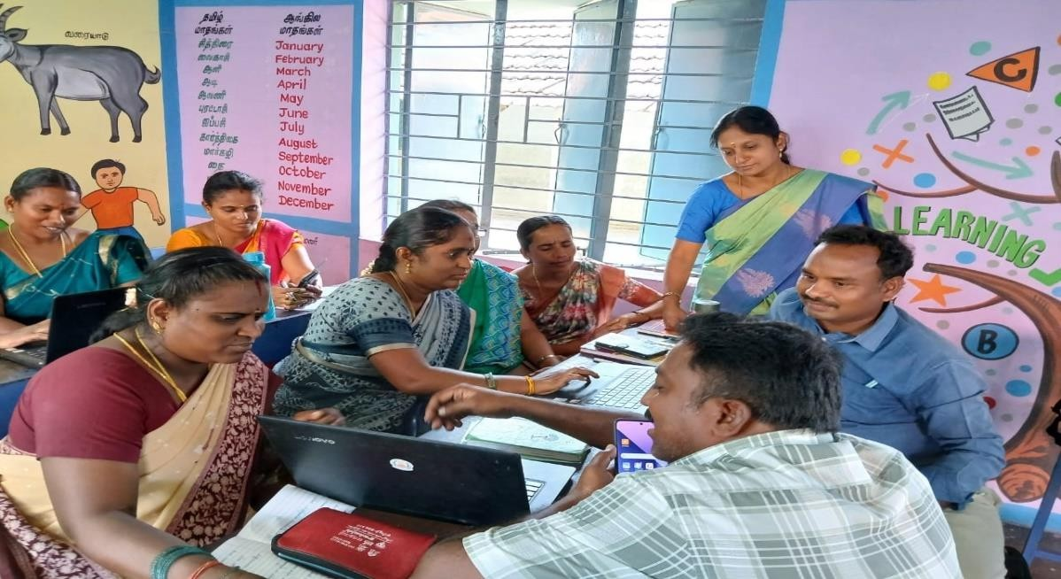

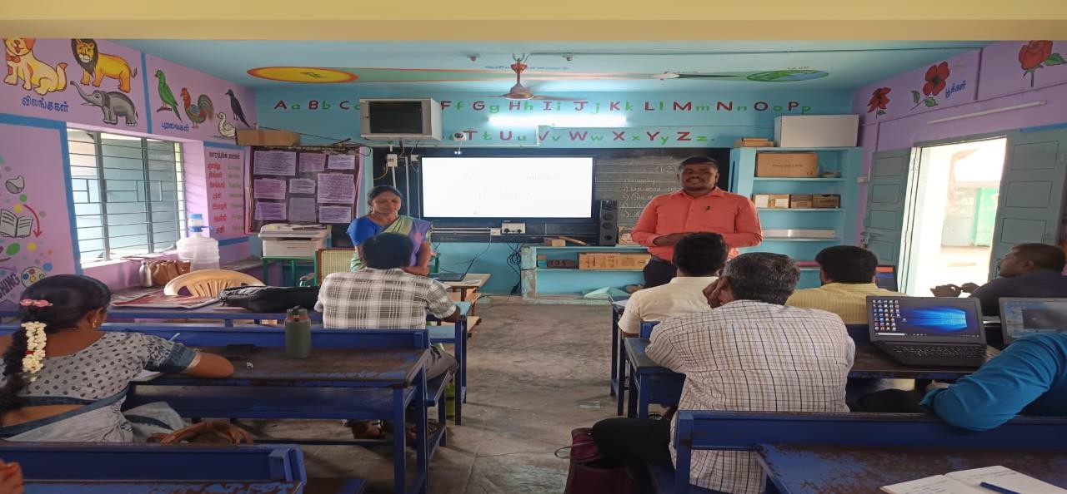

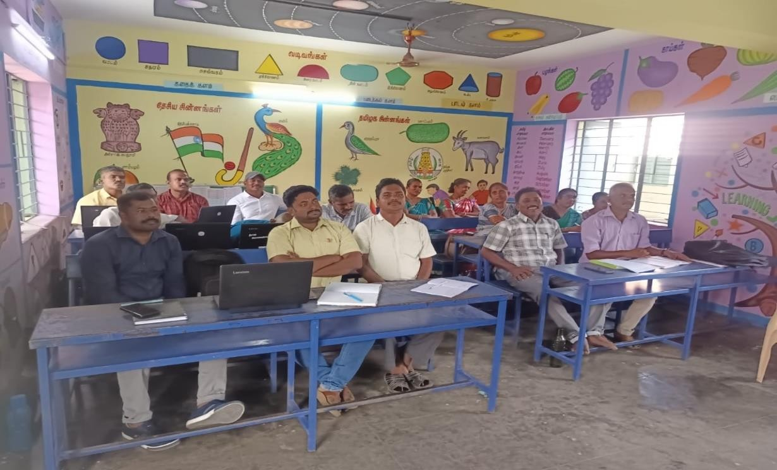

FEEDBACK OF THE TRAINING SESSION
- ​
https://drive.google.com/file/d/1epI202sEYyjdALCf5di2FtConNgPbRdM/view?us p=drivesdk

https://drive.google.com/file/d/1esoE7cOUma- vOu6i6ScsnzLwbp2ri0x6/view?usp=drivesdk

FOLLOW UP OF THE TRAINING
The practitioner follows up ICT Games training in 20 primary schools in Eriyur Block.
The primary children were very interested in Tux math Game in smart board. The Top Math Games and mathplay ground game app is a collection of interactive math games and activities for primary school children. Smoothie maths and funky Mummy game was to create smoothies and to escape from the pyramid by solving

addition and subtraction sums. In the classroom children started with simple games and gradually move to more complex ones. Through this training the children were encourage to work in pairs or groups to promote collaboration and team work. ICT games support to help children overcome challenges and difficulties. Through this training the children experience a joyful learning through ICT Games.

FOLLOW UP ACTIVITIES BY CHILDREN

- https://drive.google.com/file/d/1S0g_aanEL54nO2EqBWsoA7cjWXjrRthT/v iew?usp=drivesdk

https://drive.google.com/file/d/1RzeQNBdsE3boLQQleI2dnFWqPd6O0tKp/vi ew?usp=drivesdk
- https://drive.google.com/file/d/1f1l5bcR- 03sSZywWMsEHUooAJOLTSn0e/view?usp=drivesdk

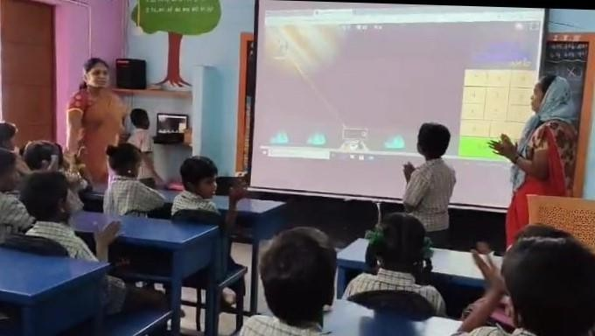

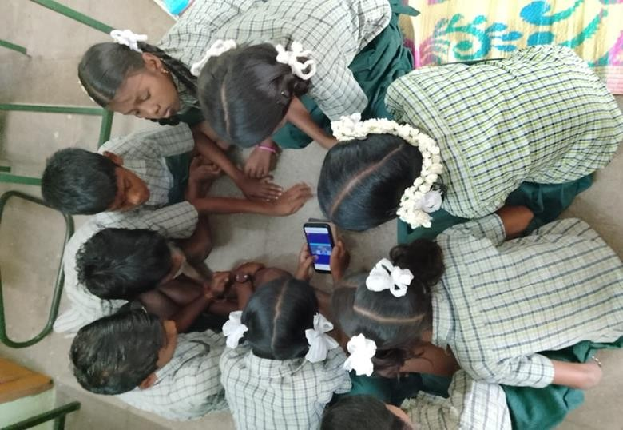

- DATA ANALYSIS
Descriptive Analysis – Mean was adopted for this Action Research.

ANALYSIS AND INTERPRETATION
Tabulation
Table - 1 Comparison of the achievement level of the Teachers

S.No | Name of the teachers and School Address | Pre- test 20  Marks | Pre- test 100  Marks | Post- test 20 Marks | Post- test 100  Marks
1. | Mrs.S. K. SELVI. SG Teacher,  PUMS – Pudur Solappadi. | 09 | 45 | 15 | 75
2. | Mrs.K. SUMATHI. SG Teacher,  PUPS – Ramakondahalli. | 03 | 15 | 07 | 35
3. | Mrs.S. VIMALA. SG Teacher,  PUMS – Siduvampatti. | 05 | 25 | 18 | 90
4. | Mrs.J. RADHA. SG Teacher,  PUPS – Agamarathupatti | 07 | 35 | 14 | 70
5. | Mrs. S. TAMILSELVI. SG  Teacher,  PUPS – Pudhubalasamuthiram | 08 | 40 | 11 | 70
6. | Mrs. M. PAUL THAI. SG  Teacher, | 05 | 25 | 13 | 65

 | PUPS – Singlimedu.
7. | Mr. N. SAKTHI. SG Teacher,  PUMS – Kombadiyur. | 05 | 25 | 16 | 90
8. | Mr. R. SAMUELRAJ. SG  Teacher,  PUMS – K. Puthur | 09 | 45 | 14 | 70
9. | Mr. N. ARULMURUGAN. SG  Teacher,  PUPS – Baipallam. | 07 | 35 | 12 | 60
10. | Mr. V. RAJA. Headmaser,  PUPS- Kottampallam. | 08 | 40 | 20 | 100
11. | Mr.P. SUBRAMANIUM,  Headmaster,  PUPS – Thalavukadu. | 07 | 35 | 12 | 60
12. | Mr. M. JEYAPRAKASH. SG  Teacher,  PUPS – Poochur. | 09 | 45 | 13 | 65
13. | Mr. J. JOHN CLENCY. SG  Teacher,  PUPS – K. Athimarathur. | 06 | 30 | 17 | 85
14. | Mr.K. KARTHIK. Headmaster,  PUPS – Pudukadu. | 09 | 45 | 20 | 100
15. | Mr. A. GOPINATH. SG  Teacher,  PUPS – Eriyur. | 04 | 20 | 17 | 85
16. | Mr. J. DAVIDRAJ. SG Teacher,  PUPS – Oothupalayam. | 04 | 20 | 19 | 95
17 | Mr. C. SAMARASAM. SG  Teacher,  PUPS- Periyar Nagar. | 05 | 25 | 15 | 75
18 | Mr. M. RAMAMOORTHI. SG  Teacher,  PUMS – Alamarathur. | 06 | 30 | 10 | 50

19 | Mr. M. RAVI. SG Teacher,PUPS  – Sellamudi. | 03 | 15 | 11 | 55
20 | Mr. R. MUTHURAMAN, SG  Teacher,  PUMS – Ajjanahalli. | 07 | 35 | 12 | 60
 | Total | 126 | 630 | 286 | 1455

Table – 2
Pre – test & Post- test Achievement level

Interval of marks | Total number of the teachers
Interval of marks | Pre test | Post test
1-10 | - | -
11-20 | 4 | -
21-30 | 6 | -
31-40 | 6 | 1
41-50 | 4 | 1
51-60 | - | 4
61-70 | - | 5
71-80 | - | 2
81-90 | - | 5
91-100 | - | 2
Total | 20 | 20

FINDINGS OF THE ACTION RESEARCH
From the Table 1 and 2 (Fig. 2 - 5),
  - The pretest results shows that among 20 Teachers , 20 teachers got below 45percentages of marks.

Fig – 2 Teachers’s Achievement level in the pre test










PRE TEST -

1 2 3 4
  - In the post test, 6 Teachers scored below 60 percentage and 14 Teachers scored above 60 percentages of marks

Fig – 3 Teacher’s Achievement level in the Post test


Post test

31 to 40 41 to 50 51 to 60 61 to 70 71 to 80 81 to 90 91 to 100

- The pre -test results show that among the 20 primary teachers, maximum of 20 teachers had scored in the class interval between 11- 50, teachers scored between 51 - 70, and 71-80, 81-90, 91-100, are the intervals without any scores.

- In the post- test among 20 teachers, scores in intervals 31-70, 11 teachers had 55% score in intervals 71-80, 2 teachers have10 %, scores in intervals 81-90 and 7 teachers 35 % having scores in intervals 91-100.

- NET GAIN OF THE ACTION RESEARCH
Table - 3
Mean score level of significance achievement in the Pre-test and Post test

S.No | Testing | Teachers | Mean
1. | Pre-test | 20 | 31.50
2. | Post-test | 20 | 72.75

The scores of pre-test was 31.50 and post-test was 72.75 were analyzed quantitatively and qualitatively to arrive at conclusions. After the intervention strategies, it was observed that the performance in the post test was comparatively better. The following graphs show the teachers improvement after the intervention Strategies.

Fig – 4 Comparison of Mean score level in the pre-test and post-test
comparison of Mean score level in the pre-test and post-test
TEACHERS
MEAN SCORE
Pre-test Post-test

 |  |  | 72.75
 | 20
 | 20 |  | 31.5

Fig – 5 Achievement level of the teachers in pretest and post test
Achievement level of the Teachers in PreTest and PostTest

120

100

80

60

40

20

0
1 2 3 4 5 6 7 8 9 10 11 12 13 14 15 16 17 18 19 20
pre Test Post Test

EDUCATIONAL IMPLICATIONS OF ACTION RESEARCH
- The ability to visually portray mathematical ideas for students is another advantage of integrating ICT games into math instruction.
- Students can view mathematical concepts in a visual format using ICT games tools like graphing calculators, spreadsheets, and interactive whiteboards, which makes it simpler for them to comprehend and recall the material.
- ICT games help to teach math and improves students' academic performance.
- ICT games enhance critical thinking, analysis, and problem-solving skills.
- ICT games foster creativity, imagination, and innovation.
- ICT games promote logical reasoning, sequencing, and spatial awareness.
- ICT games can incorporate artificial intelligence, providing real-time feedback and assessment.
- ICT games can utilize virtual and augmented reality, creating immersive and interactive learning experiences.

RECOMMENDATIONS
- Integrating ICT Games in teaching mathematics provides opportunities for personalized learning.
- ICT games such as adaptive learning software and online assessments allow individualized instruction and assessment.
- This games allow students to learn at their own pace and receive immediate feedback on their progress, which can lead to better learning outcomes.
- Teachers can Improve integrate technology into their teaching practices to enhance student engagement and learning.
- Teachers can enhance digital literacy skills, such as using educational software, online resources, and digital tools.
- Teachers can utilized the leisure hour for this ICT game activities
- Teachers motivate the children for self learning process in ICT game App
- Teachers can implemented ICT game App in upper primary level .

CONCLUSION
The implemented the ICT games by the practitioner were very useful for the primary teachers and children. This approach is very useful for Mathematics handling teachers to pay close attention to the difficulties that come with employing in ICT games , such as the requirement for teacher training, the accessibility of technology, and the expense of implementation. ICT games can develop the teaching skills, such as information literacy, critical thinking, and evaluation and developed digital literacy skills, such as using educational software, online resources, and digital tools through ICT Games. The Practitioner suggests. as much at using alternative and innovative methods to teach through ICT games and playing games as part of learning, as at developing the mathematical skills of teachers in extending academic goals to understand, support and include the whole child, not only their academic subject skills but also social, emotional and behavioural skills.

BIBILIOGRAPHY

- Usha Nandhini R. and Dr.P.Senthamizh Pavai,(2023), Dr. M.G.R. Educational and Research Institute, chennai. Innovative teaching techniques using ict – an analysis among primary teachers.
- Csikszentmihalyi, M. (2014). Toward a psychology of optimal experience. In Flow and the foundations of positive psychology (pp. 209–226). Netherlands: Springer. https://doi. org/10.1007/978-94-017-9088-8_14 Dienes, Z. P. (1963). An Experimental Study of Mathematics Learning, Hutchinson, New York.
- Divjak, B., & Tomić, D. (2011). The impact of game-based learning on the achievement of learning goals and motivation for learning mathematics literature review. Journal Information and Organizational Sciences, 35(1), 15-30.

- Dweck, C. (2015). Carol Dweck revisits the growth mindset. Education Week, 35(5), 20-24. Elofsson, J., Gustafson, S., Samuelsson, J., & Träff, U. (2016). Playing number board games supports 5-year-old children’s early mathematical development.The Journal of Mathematical Behavior, 43, 134-147. https://doi.org/10.1016/j. jmathb.2016.07.003.
- Ernest, P. (1986). Games. A rationale for their use in the teaching of mathematics in school. Mathematics in School, 15(1), 2-5.
- Harviainen, J. T., & Meriläinen, M. (2019). Educational gamification: Challenges to overcome and to enjoy. In Neo-Simulation and Gaming Toward Active Learning (pp. 553-560). Springer, Singapore. https://doi.org/10.1007/978-981-13 8039-
- Liu, X., Wachira, P., Koc, S., & Pourdavood, R. (2022). An Exploratory Study of Predictors of pre service Teachers’ Intention to Integrate Computer Games in Mathematics Education. International Journal of Education in Mathematics, Science and Technology, 10(1), 145–161. https://doi.org/10.46328/ijemst.1827.
- Muhtarom, Nizaruddin, & Sugiyanti. (2016). sehingga rataan hasil posttest lebih baik dibandingkan hasil pretest dan peningkatan hasil belajar siswa melalui penerapan permainan matematika dalam kategori sedang dengan nilai N-gain = 0,6563. Kata Kunci : Permainan, Teka-Teki Silang, Perangkat Pembela. Pythagoras, 5(1), 20–31. 10. Muryani, S. (2018). Pengaruh Model Creative Problem Solving Terhadap Kemampuan Berpikir Logis Matematis Siswa di SMA N 3 Banda Aceh. MAJU: Jurnal Ilmiah Pendidikan Matematika, 5(2), 14–28. Natalia, I.G.A Kartika. (2015). Implementasi pandangan ki hajar dewantara pada pembelajaran matematika. Proceedings Seminar Nasional FMIPA UNDIKSHA V Tahun 2015, 184–187.
- www.topmarks.co.uk
- swww.mathplayground.com

ANNEXURE - 1 RESEARCH TOOL
DISTRICT INSTITUTE OF EDUCATION AND TRAINING
DHARMAPURI

Name of the Practitioner : Dr. K.Revathi ,Lecturer

Enhancing Math concepts through ICT Games
among primary School Teachers
Action Research 2024- 2025

Maxmium : 20 Marks
- What is the primary role of ICT in teaching math concepts?

  - To replace teachers in the classroom
  - To make learning interactive and engaging
  - To eliminate traditional teaching methods
  - To focus only on theory without visualization

- Which ICT tool is best suited for teaching basic arithmetic to primary students?

  - PowerPoint presentations
  - Interactive math games and apps
  - Only printed worksheets
  - Whiteboard explanations
- How do ICT-based games enhance mathematical learning?
  - By making learning engaging and interactive
  - By increasing rote memorization
  - By reducing student participation
  - By avoiding visual representations
- How does gamification in ICT tools help in math learning?
  - Eliminates the need ofteachers
  - Makes learning more complicated
  - Reduces conceptual understanding
  - Provides rewards and motivation for learning
- What is the best way to use ICT in a primary math classroom?
  - Integrating digital games with traditional teaching
  - Avoiding technology in the classroom
  - Relying only on textbooks
  - Using ICT without teacher guidance
- Which of the following is an example of an adaptive ICT math learning platform?
  - Khan Academy
  - Microsoft Word
  - Google Docs
  - Social media apps
- What is an important factor when selecting an ICT math game for primary students?
  - The number of advertisements
  - The complexity of coding
  - Age-appropriateness and engagement
  - The cost of the software
- What is the benefit of using online math quizzes in ICT-based learning?
  - Provides instant feedback and assessment
  - Increases manual grading workload
  - Reduces student participation
  - Limits question types

- How does ICT enhance number sense in primary students?

  - By avoiding real-life applications
  - By focusing only on theory
  - By reducing student engagement
  - Through interactive counting and visualization tools

- Which of the following is a disadvantage of using ICT in math education?
  - It eliminates the need for teachers
  - It always improves learning outcomes
  - Over-reliance on technology may reduce problem-solving skills
  - It makes traditional teaching methods unnecessaRY
- What is the main objective of the game Tux Math?

  - To teach programming concepts
  - To practice math skills while saving penguins
  - To learn science concepts through simulation
  - To develop language skills through interactive stories
- How does Tux Math make learning math fun?

  - By using boring worksheets
  - By incorporating games and challenges
  - By watching videos only
  - By reading textbooks only
- What is the benefit of using Tux Math for math practice?

  - Improved math skills and fluency
  - Reduced motivation and engagement
  - Limited access to math resources
  - Increased difficulty in understanding math concepts
- How can Tux Math be accessed?

  - Only through a desktop computer
  - Only through a mobile device
  - Through various devices, including desktops, laptops, and mobile devices
  - Only through a gaming console
- What is the target age group for Tux Math?

  - Only for preschoolers
  - Only for high school students
  - For elementary school students
  - For students of all ages

- What is the main goal of Math Playground?

  - To provide math worksheets for homework
  - To offer online math tutoring services
  - To make math learning fun and engaging
  - To sell math-related products
- What is the benefit of using Math Playground for math practice?

  - Improved math skills and fluency
  - Reduced motivation and engagement
  - Limited access to math resources
  - Increased difficulty in understanding math concepts
- What type of game is "Funky Mummy"?

  - Action-adventure game
  - Educational math game
  - Puzzle game
  - Role-playing game

- How can teachers use "Funky Mummy" in the classroom?
  - As a supplement to traditional math instruction
  - As a replacement for traditional math instruction
  - Only for remediation purposes
  - Only for enrichment purposes

- How does the game "Funky Mummy" make learning math fun?

  - By using boring worksheets
  - By incorporating games and challenges
  - By watching videos only
  - By reading textbooks only

ANNXURE-2 PHOTOS
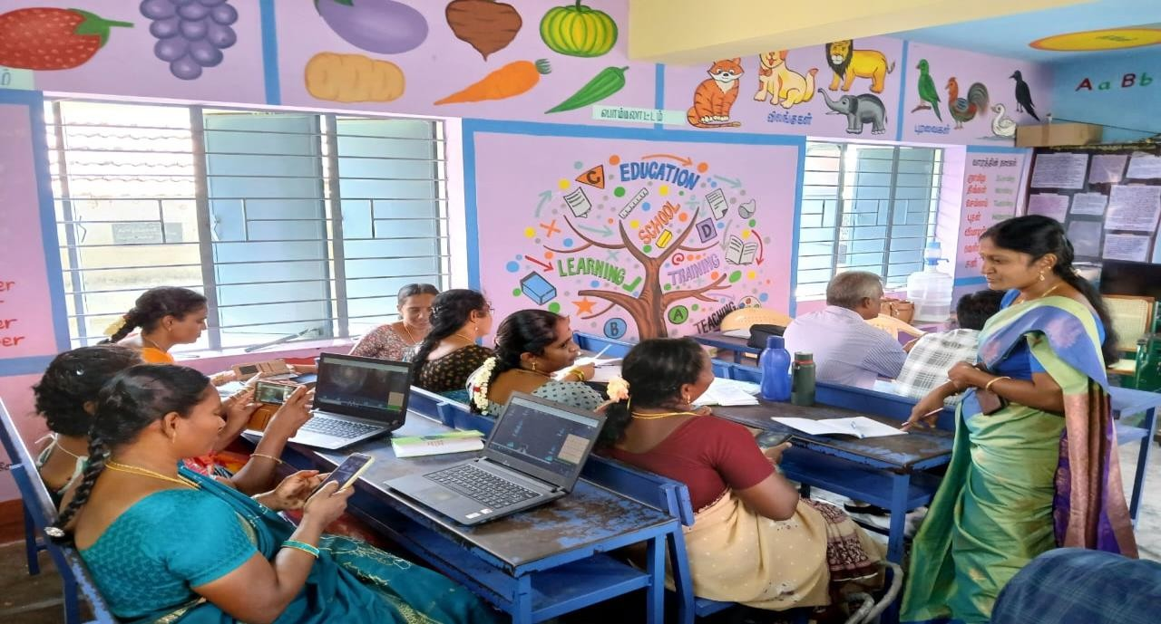
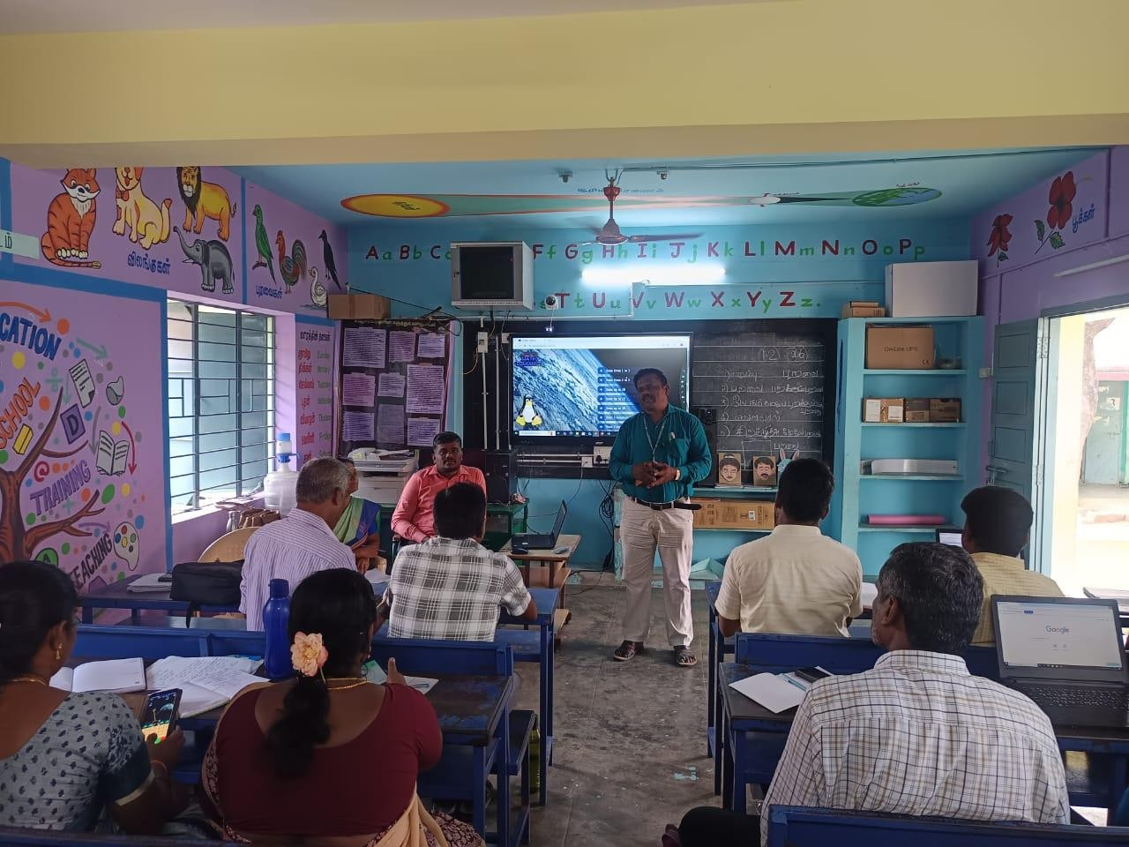
INTERVENTION FOR PRIMARY TEACHERS

ONSITE HANDS ON TRAINING FOR PRIMARY TEACHERS

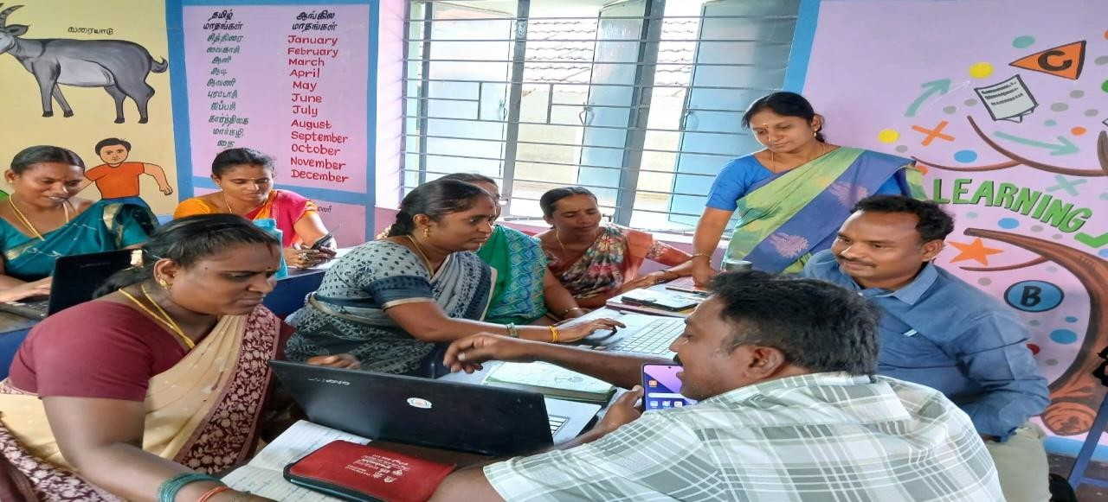

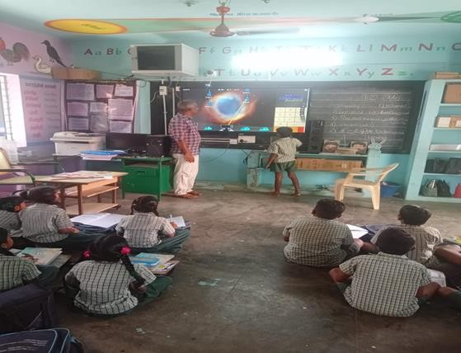
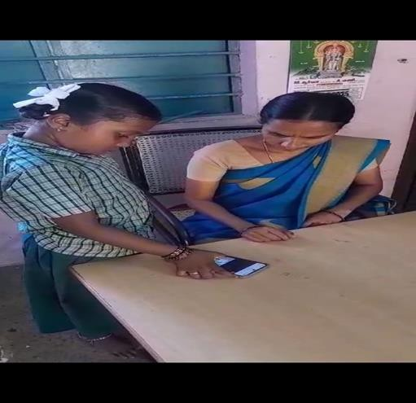
PRIMARY TEACHER EXECUTED THE TRAINING ACTIVITY IN THE CLASSROOM THROUGH SMART BOARD AND MOBILE PHONE

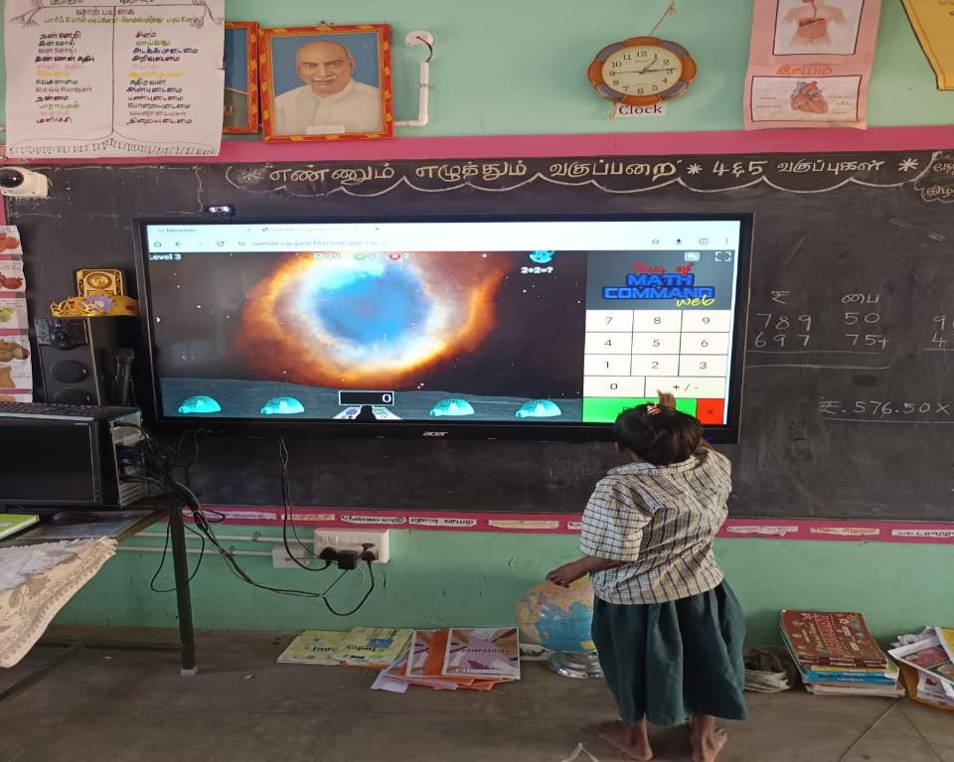
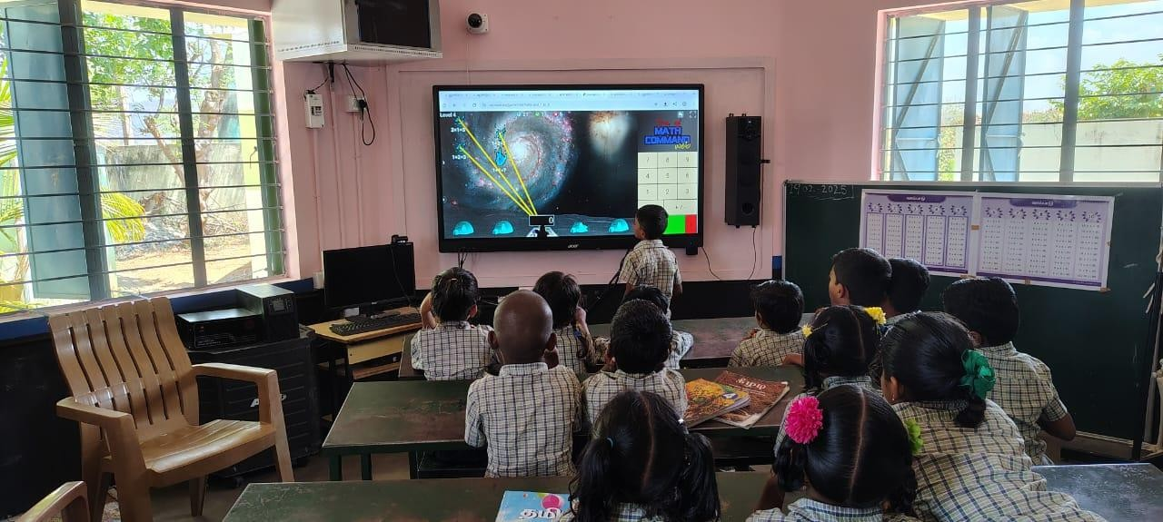
STUDENTS EXECUTED THE ACTIVITY THROUGH SMART BOARD

