1. Introduction:
The concept of sustainability encompasses actions that ensure long-term viability without compromising future generations' opportunities. In this context, financial literacy is a crucial aspect of sustainable development, as it empowers individuals with the knowledge and skills required to manage their resources effectively. A financially literate population contributes to national economic stability, reduces dependency on government welfare programs, and enhances overall economic productivity.
In rural areas, particularly in districts like Dharmapuri in Tamil Nadu, financial literacy is a key factor in empowering communities. Government higher secondary schools in such regions cater to students from diverse socio-economic backgrounds, many of whom come from financially challenged families. Educating these students on financial literacy at an early stage equips them with necessary skills to manage finances efficiently, plan for their future, and make informed economic choices.
1.1 National Perspective on Financial Literacy in Education
The Government of India has recognized the need for financial literacy at the school level and has taken various initiatives to promote it. The Reserve Bank of India (RBI) and the Securities and Exchange Board of India (SEBI) have launched financial literacy programs to educate citizens about banking, investments, and debt management. The National Strategy for Financial Education (NSFE) 2020-2025 emphasizes integrating financial education into school curricula.
The National Centre for Financial Education (NCFE) conducted a survey in 2019, which found that only 27% of Indian adults were financially literate. This statistic highlights the urgency of implementing financial literacy programs at a young age. By ensuring that students are exposed to financial concepts through hands-on training, schools can play a crucial role in improving financial awareness and preparedness for future financial challenges.
1.2 Importance of Hands-On Training in Financial Literacy
While theoretical knowledge of financial concepts is important, hands-on training enhances the learning experience by providing students with practical applications of financial literacy principles. Ninth-standard students are at a stage where they begin to understand the value of money and financial planning. Many students in government schools in Dharmapuri receive financial aid or scholarships to support their education. However, a lack of financial awareness often leads to inefficient use of these funds. The absence of proper financial guidance can result in poor money management, leading students to spend impulsively rather than save or invest wisely.
A structured hands-on financial literacy program can help students develop good financial habits early in life. This includes engaging them in activities such as budgeting exercises, understanding interest calculations, and exposure to digital financial services. By practicing these skills in real-life scenarios, students can gain confidence in managing money effectively, leading to better financial decisions in the future.
Dharmapuri is one of Tamil Nadu’s districts with a significant rural population. The district has a strong agricultural economy, and financial literacy is essential for households dependent on seasonal incomes. Many families in Dharmapuri do not have access to formal financial education, making it challenging for them to make informed financial decisions.
By integrating financial literacy through hands-on training into the school curriculum, government schools in Dharmapuri can play a crucial role in transforming students into financially responsible citizens. Students will not only learn how to manage their personal finances but will also be able to guide their families in making informed financial decisions. This is particularly important in rural areas where financial misconceptions and lack of awareness often lead to poor financial planning and indebtedness.
2. Identification of the Problem
Financial literacy was the foundation of sound decision-making in personal and professional life. In the digital age, young students often faced challenges in managing finances due to a lack of financial education. During school visits, the practitioner observed that secondary school was often the stage when students began to handle money, whether through gifts from relatives, pocket money, or scholarships. Teaching financial literacy at this stage helped them understand how to manage their resources early on. Learning to budget, save, and plan for future expenses helped students develop habits that would benefit them when they became responsible for larger financial decisions, such as paying for higher education, purchasing property, or saving for retirement.
In Dharmapuri district, a rural region of Tamil Nadu, financial literacy among secondary students was crucial, as many received scholarships and had limited exposure to sound financial principles. A lack of awareness often led to mismanagement of funds, excessive spending, and future financial difficulties. This action research aimed to address the need for basic financial literacy among government school students.
3. Need for Action Research:
The practitioner observed that ninth standard students lacked awareness and understanding of basic financial literacy concepts such as budgeting, saving, and responsible spending. It was also noticed that teachers often relied on conventional chalk-and-talk methods without integrating practical or hands-on training related to real-life financial situations.
This lack of experiential learning led to minimal student engagement, especially when abstract financial concepts were discussed without connecting them to their everyday experiences. Many students appeared uninterested or confused when financial topics were introduced in theory-based lessons. As a result, students struggled to relate to the importance of financial decision-making and did not develop essential life skills needed for their future financial well-being.
Research has shown that incorporating hands-on activities, such as role-playing, simulations, budgeting exercises, and interactive games, significantly improves students’ understanding and retention of financial concepts. When students are involved in real-life tasks, they not only understand concepts better but also begin to apply them meaningfully.
There is a pressing need for financial literacy among students, as it can empower them to make informed decisions regarding their finances. Promoting financial literacy will help students become responsible citizens, capable of managing their own resources effectively. This action research will help identify gaps in financial knowledge, explore ways to address these gaps, and implement interventions that could improve financial literacy.
This action research aimed to create awareness of basic financial literacy among ninth standard students through engaging hands-on training activities.
4. Statement of the Problem
The present study is entitled as “Creating an Awareness on Basic Financial Literacy among Ninth Standard Students through Hands on Training.”

5. Objectives of the Action Research:
1. To assess the current level of financial literacy among secondary students
2. To understand the difference between needs and wants
3. To develop and implement an intervention program aimed at promoting basic financial literacy.
4. To evaluate the effectiveness of the intervention in improving students' ability to manage their finances.
6. Probable causes of the Problem
1. Lack of exposure to financial literacy in the school curriculum.
2. Limited parental or community guidance on financial management.
3. The influence of consumerism and peer pressure among adolescents.
4. Poor understanding of the long-term benefits of saving and budgeting.
5. Inadequate school resources to teach financial management skills.
7. Action Hypothesis:
“If financial literacy is introduced to ninth standard students, they will improve their understanding of financial management.”
8. Interventions:
Based on the pre-test results, to effectively promote basic financial literacy among ninth standard students, the practitioner developed a structured, activity-based module that emphasized experiential learning. The intervention was designed to be interactive, student-centered, and focused on real-life applications of financial concepts. The strategies used were aligned to enhance student engagement and understanding. The following interventional strategies were implemented:
- Modular Approach:
The intervention was delivered in the form of a structured four-week module, with two sessions per week. Each week focused on a specific theme in financial literacy:
  - Week 1: Introduction to Money and Financial Literacy
  - Week 2: Income, Expenses, and Budgeting
  - Week 3: Savings and Basic Banking
  - Week 4: Smart Spending and Avoiding Debt
- Hands-on Training:
Practical tasks such as budgeting games, role plays, and financial simulations were used. For example:
  - “Budget Challenge” where students created a ₹1000 monthly budget to shop in grocery shop.
  - “Smart Shopper” game to differentiate between needs and wants within a limited budget.
  - Realistic activities like filling in income-expense tables and goal-setting charts.
- Collaborative Learning:
Group discussions and team tasks were used to encourage peer learning. For instance, students debated topics like “What happens when money is mismanaged?” and participated in group budgeting exercises.
- Real-Life Scenario:
Students were encouraged to relate financial lessons to their own lives. Examples included:
  - Identifying their own spending patterns.
  - Discussing pocket money and scholarship usage.
  - Planning savings goals for small personal needs like buying a cycle or saving for a trip.
- Interactive Worksheets and Reflection:
Students completed worksheets that reinforced key concepts such as fixed vs. variable expenses, budgeting, and financial goal planning. They also wrote short reflective essays like “Why is Financial Literacy Important?”
- Assessment and Feedback:
Each unit concluded with short assessments (MCQs, matching, written reflections), and student understanding was monitored through observation and teacher feedback.
These interventional strategies helped students move beyond rote learning and build practical financial skills that are essential for their personal development and long-term economic well-being. The hands-on, activity-based approach not only made financial education meaningful but also contributed to improved classroom engagement and life readiness.
9. Methodology
This study followed an action research approach with a quasi-experimental design to assess the impact of financial literacy education among ninth-standard students. The research employed a one-group pre-test post-test design, where the same group of students is tested before and after the intervention to measure knowledge improvement.
i) Sample
The sample for this study consisted of 36 ninth-standard students from Government High School (GHS) Pallakollai in Dharmapuri Block by using Convinience sampling technique.
ii) Research Design
This study adopted a quasi-experimental design with a pre-test and post-test approach to evaluate the impact of financial literacy hands on training among Ninth Standard students.
iii) Description of the Research Tool
The research tool used in this study was a self made questionnaire designed to assess the financial literacy of ninth-standard students. The questionnaire consisted of multiple-choice questions (MCQs) that evaluate students' understanding of various financial concepts. These questions covered key areas of basic financial literacy, including:
- Importance of Financial Education
- Budgeting and Financial Planning
- Saving
- Banking Concepts (Passbook, PIN, Digital Payments, etc.)
- Inflation and Its Impact
- Financial Security Measures (Emergency Savings, Insurance, etc.)
The questionnaire was developed in Tamil ensuring clarity and ease of comprehension for students. It consisted of 25 questions, with each question offering four answer choices, allowing students to select the most appropriate response.
This action research tool helped measure students' existing financial literacy levels and identifies gaps in their understanding. The responses guided the intervention strategies to enhance financial awareness through hands-on training.
iv) Description of Research process
The research followed action research approach with the following steps:
Step 1: Identifying the Problem
Step 2: Designing the Questionnaire
Step 3: Administering the Pre- test (Data Collection)
Step 4: Intervention
Step 5: Administering Post Test
Step 6: Data Analysis
Step 7: Finding and Analysis
Step 8: Suggestion and Recommendations
Step 9: Conclusion
10. Data analysis
- Comparison of Pre-test and Post-test Scores
Table - 1
Pre- Test and Post test Score of Students
S.No. | Name of the Student | Pre- Test Mark | Post Test Mark
1 | S.Sanjay | 28 | 56
2 | M.Sabarivaasan | 20 | 62
3 | K.Prakash | 20 | 40
4 | M.Manish | 32 | 72
5 | S.Mithun | 24 | 72
6 | M.Vasanthkumar | 28 | 68
7 | M.Vajjeravel | 28 | 52
8 | T.Mukesh | 32 | 56
9 | M.Tamilarasan | 20 | 52
10 | V.Sham | 16 | 32
11 | S.Sabari | 20 | 68
12 | P.Karthiga | 28 | 72
13 | S.Gokulsri | 24 | 80
14 | K.Saranya | 16 | 64
15 | K.Mithuna | 32 | 84
16 | S.Srividhya | 24 | 84
17 | S.Poornima | 28 | 72
18 | T.Kokila | 20 | 84
19 | S,Mowniya | 24 | 84
20 | S.Kavipriya | 32 | 92
21 | R.Karthiga | 24 | 80
22 | J.Sarvesh | 20 | 88
23 | C.Jainesh | 32 | 92
24 | M.Raguprasanth | 28 | 76
25 | S.Sujeeth | 24 | 80
26 | M.Jeevanantham | 12 | 44
27 | C.Tharunkumar | 32 | 72
28 | M.Sakthivel | 16 | 56
29 | T.Rithick Roshan | 12 | 64
30 | S.Anupriya | 32 | 80
31 | K.Dharshinipriya | 16 | 58
32 | M.Kaviya | 12 | 52
33 | P.Sharmili | 16 | 80
34 | S.Gokulapriya | 32 | 68
35 | S.Kavisri | 28 | 68
36 | S.Anuprabha | 12 | 60

Graph 1

To assess the effectiveness of the intervention on creating awareness of basic financial literacy among ninth standard students, pre-test and post-test data were collected and analyzed.

Table 2
Mean score in the Pre-test and Post test
S.No. | Testing | Number of Students | Mean Score
1 | Pre- Test | 36 | 23.44
2 | Post -Test | 36 | 68.44

Graph 2
Mean score in the Pre-test and Post test

The mean score of the pre-test was 23.44, indicating that the students had limited understanding of basic financial concepts such as budgeting, saving, and responsible spending before the intervention.
After implementing the hands-on training module, the mean score of the post-test increased significantly to 68.44. This improvement reflects a notable gain in students’ knowledge and awareness regarding financial literacy.
11. Analysis and Interpretation
After conducting the pre-test, implementing the financial literacy training, and administering the post-test, the collected data is analyzed to evaluate the effectiveness of the intervention. The findings are interpreted to understand students' improvements in financial literacy and identify areas that need further reinforcement.
A. Pre-Test Analysis
The pre-test results provide a base assessment of students' financial literacy.
Many students lack awareness of budgeting and saving.
Concepts such as compound interest and inflation have lower accuracy rates.
Financial scams show mixed results depending on students' exposure.
B. Post-Test Analysis
The post-test measures the improvement in students’ financial literacy after the training program. The analysis compares pre-test and post-test scores to assess the impact of the intervention.
The comparison between the pre-test and post-test mean scores clearly demonstrates the positive impact of activity-based, experiential learning strategies on enhancing students' financial understanding. The intervention not only improved their academic performance but also encouraged practical thinking and decision-making related to everyday money management.
12. Findings
- Pre-test results showed only 23.44% students understood the importance of financial literacy, but in the post-test, 68.44% of students answered correctly.
- The comparison of pre-test and post-test results validates that the hands-on training helped bridge knowledge gaps.
- Interactive worksheets like Fixed expenses and Variable expenses, Need and want significantly enhanced students' understanding.
- Real-life examples and case studies were more effective than theoretical explanations.
- Students demonstrated a better ability to make informed financial decisions after the training.
13. Educational Implication
- Governments and educational boards need to recognize financial literacy as a core life skill and support its inclusion in school curricula.
- Financial literacy equips students with essential life skills, enabling them to make informed finance decisions

14. Recommendations
- Parent-Teacher Involvement: Educate parents and teachers so that they can reinforce smart money habits at home and in school.
- Use More Practical Activities: Include real-life simulations, budgeting apps, and banking visits for better learning outcomes.
- Regular Reinforcement: Conduct follow-up sessions to ensure long-term retention of financial concepts.
15. Conclusion
The research study successfully assessed the impact of hands-on training on students' financial literacy. The findings indicated that students showed significant improvement in their understanding of budgeting, saving, and responsible spending after the intervention. The pre-test results revealed gaps in knowledge, particularly in areas such as compound interest, emergency savings, and digital banking. However, the post-test results demonstrated a notable increase in correct responses, confirming that the training effectively enhanced students' financial awareness. Practical activities, such as budget planning exercises and role-playing financial transactions, proved to be highly effective in reinforcing key financial concepts.
Overall, the study highlighted the importance of integrating financial literacy into the school curriculum. It was evident that interactive and experiential learning methods helped students retain financial knowledge better than traditional teaching approaches. The research suggested that continued reinforcement, real-life financial simulations, and parental involvement could further strengthen students' financial decision-making skills. By equipping students with essential financial skills at an early stage, this research contributes to their economic empowerment and financial independence, preparing them for a secure financial future. By implementing structured financial education programs, schools could ensure that students develop responsible money management habits, ultimately preparing them for future financial independence.

16. Bibliography
1. 9th Social Science, Tamil Nadu Textbook
2. Financial Education Workbook for Class VI, National Institute of Securities Markets (NISM) for National Centre for Financial Education (NCFE), New Delhi
3. Financial Education Workbook for Class VII, National Institute of Securities Markets (NISM) for National Centre for Financial Education (NCFE), New Delhi
4. Financial Education Workbook for Class VIII, National Institute of Securities Markets (NISM) for National Centre for Financial Education (NCFE), New Delhi
5. Financial Literacy Class 6, Central Board of Secondary Education, New Delhi
6. Financial Literacy Class 7, Central Board of Secondary Education, New Delhi
7. Financial Literacy Class 8, Central Board of Secondary Education, New Delhi
8. Personal Finance Supplementary Reading Material, Department of Education in Social Sciences, National Council of Educational Research and Training, New Delhi
9. A study on awareness of Financial Literacy among undergraduate students by Kashish Jain in Aegaeum Journal
10. Mandell, L. (2008), Financial Education in High School, In Handbook of Consumer Finance Research. Springer.

17. Research Tool
மாவட்ட ஆசிரியர் கல்வி மற்றும் பயிற்சி நிறுவனம் செட்டிகரை தர்மபுரி மாவட்டம்
Action Research Title: Creating an Awareness on Basic Financial Literacy among Ninth Standard Students through Hands on Training
Practitioner Name: S.Ramya, Lecturer, DIET Settikarai, Dharmapuri
செயல் ஆராய்ச்சி வினா
மாணவர் பெயர்:
வகுப்பு:
வழி :

நேரம்: 30 வினாடிகள் மொத்த மதிப்பெண்கள்: 25

கீழ்காணும் பலவுள் வினாக்களுக்கு விடையை தேர்வு செய்க

1. மாணவர்களுக்கு நிதி கல்வி ஏன் முக்கியமானது?
அ) அரசு கொள்கைகளை புரிந்துகொள்ள உதவுவதற்கு
ஆ) தனிப்பட்ட நிதிகளை நிர்வகிக்கவும், அறிவார்ந்த முடிவுகளை எடுக்கவும் உதவுவதற்கு
இ) பங்கு சந்தை பற்றிய அறிவை அதிகரிக்க
ஈ) நிதி துறையில் வேலை பெறுவதற்காக தயார் செய்ய

2. மாணவர்களுக்கான நிதி திட்டமிடலின் முக்கிய கூறு எது?
அ) அதிகமாக செலவழித்தல்
ஆ) வருமானம், செலவுகள் மற்றும் சேமிப்பின் முக்கியத்துவத்தைப் புரிந்துகொள்ளுதல்
இ) நிதி அபாயங்களை முழுவதுமாக தவிர்த்தல்
ஈ) உடனடியாக சொத்து முதலீடு செய்தல்

3. பணத்தை சேமிக்க சிறந்த பழக்கம் எது?
அ) மாத இறுதியில் பணம் மீதம் இருந்தால் மட்டுமே சேமித்தல்
ஆ) சிறிய, நிலையான தொகையை முறையாக சேமித்தல்
இ) நிதி அவசர நிலை ஏற்பட்டால் மட்டுமே சேமித்தல்
ஈ) தேவையில்லாத பொருட்களில் அனைத்தையும் செலவழித்தல்

4. கீழ்கண்டவற்றில் எது நிலையான செலவாகும்?
அ) திரைப்படங்கள்
ஆ) வீடு வாடகை
இ) மளிகைப் பொருட்கள்
ஈ) பொழுதுபோக்கு

5. நிதி அவசர நிலை சேமிப்பின் முக்கியத்துவம் என்ன?
அ) பொழுதுபோக்கிற்கு செலவழிப்பதை தவிர்த்தல்
ஆ) எதிர்பாராத செலவுகளின் போது நிதி பாதுகாப்பு பெறுதல்
இ) விலையுயர்ந்த சாதனங்களை வாங்குதல்
ஈ) தங்கள் சொந்த நிதியைப் பற்றிக் கவலைப்படாமல் பிறருக்கு உதவுதல்

6. பட்ஜெட்____________ செய்ய உதவுகிறது.
அ) எந்தளவு வேண்டுமானாலும் செலவழிக்க
ஆ) வருமானத்தையும் செலவுகளையும் கண்காணித்து திட்டமிடல்
இ) பணத்தை மறைத்து வைத்திருக்க
ஈ) பில்களை செலுத்துவதை தவிர்க்க

7. கீழ்க்கண்டவற்றில் நீண்டகால நிதி இலக்கின் உதாரணம் எது?
அ) ஐந்து ஆண்டுகளில் வீடு வாங்குவதற்காக சேமித்தல்
ஆ) ஒவ்வொரு மாதமும் சாதனங்களில் செலவழித்தல்
இ) நண்பர்களிடம் அடிக்கடி கடன் வாங்குதல்
ஈ) அனைத்து பணத்தையும் பொழுதுபோக்கிற்காக செலவழித்தல்

8. சேர்க்கை வட்டி (Compound Interest) எப்படி செயல்படுகிறது?
அ) இது முதன்மைத் தொகையில் மட்டும் வட்டி கணக்கிடுகிறது
ஆ) வட்டி முதன்மைத் தொகையில் சேர்க்கப்பட்டு, அடுத்த வட்டி கணக்கீட்டில் சேர்க்கப்பட்ட வட்டியும் சேர்க்கப்படும்
இ) இது ஆரம்ப கடன் தொகையில் மட்டுமே வட்டி சேர்கிறது
ஈ) இது காலத்தின்போது குறைவாகும்

9. நிதி திட்டமிடலில் (Financial Planning) தேவைகள் (Needs) மற்றும் விருப்பங்கள் (Wants) ஆகியவற்றிற்குள் உள்ள வேறுபாடு என்ன?
அ) தேவைகள் வாழ்விற்குத் தேவையான அடிப்படை பொருட்கள்; விருப்பங்கள் முக்கியமல்ல ஆனால் ஆசைப்படுவது.
ஆ) எந்தவிதமான வேறுபாடும் இல்லை.
இ) விருப்பங்கள் தேவைகளைவிட மலிவாக இருக்கும்.
ஈ) தேவைகள் குறுகிய காலத்திற்கு, விருப்பங்கள் நீண்ட காலத்திற்கு.

10. நிதி கல்வி (Financial Education) நிதி மோசடிகளை (Financial Scams) தடுப்பதற்கு எப்படி உதவும்?
அ) மாணவர்கள் நிதி ஆலோசனைகளை புறக்கணிக்க வேண்டும் என்று ஊக்குவிக்கும்.
ஆ) மாணவர்கள் மோசடிகளை அடையாளம் காணவும், அபாயமான நிதி முடிவுகளை தவிர்க்கவும் கற்றுக்கொடுக்கும்.
இ) மாணவர்களுக்கு மிகுந்த அபாயம் உள்ள முதலீடுகளில் முதலீடு செய்ய கற்றுக்கொடுக்கும்.
ஈ) எந்தவொரு நிதி பரிவர்த்தனைகளையும் செய்ய வேண்டாம் என்று பரிந்துரைக்கும்.

11. நிதி திட்டமிடலில் (Financial Planning) காப்பீட்டின் (Insurance) முக்கிய வேலை என்ன?
அ) ஆடம்பரப் பொருட்கள் வாங்க பணம் வழங்கும்.
ஆ) நிதி அபாயங்களை குறைத்து, எதிர்பாராத இழப்புகளிலிருந்து பாதுகாக்கும்.
இ) மக்கள் அதிகம் செலவழிக்க அனுமதிக்கும்.
ஈ) மிகுந்த லாபத்தைப் பெற்று செல்வந்தராக ஆக உதவும்.

12. ஆண்டுக்கான வட்டி விகிதம் 8.05% ஆக இருக்கும்போது, மாதாந்திர வட்டி எவ்வளவு?
அ) 67 பைசா ஆ) 80 பைசா இ) 50 பைசா ஈ) 90 பைசா

13. பணவீக்கம் (Inflation) என்றால் என்ன?
அ) பொருட்கள் மற்றும் சேவைகளின் விலை காலத்திற்கேற்ப அதிகரித்தல்
ஆ) ஒரு நிதி நெருக்கடி
இ) சேமிப்பை அதிகரிக்க அரசு செயல்படுத்தும் திட்டம்
ஈ) பணத்தின் மதிப்பு தற்காலிகமாக குறைதல்

14. வங்கி பாஸ்புக்கின் (Bank Passbook) நோக்கம் என்ன?
அ) வங்கி கணக்கில் பரிவர்த்தனைகளை கண்காணிக்க உதவும்
ஆ) பணத்தை எடுத்துக் கொள்ள உதவும்
இ) கணக்கு இருப்பை அதிகரிக்கும்
ஈ) கடைகளில் பயன்படுத்த உதவும்

15. தினசரி பணப்பரிவர்த்தனைகளுக்காக எந்த வங்கி கணக்கு பயன்படுத்தப்படுகிறது?

அ) நிலையான வைப்பு கணக்கு

ஆ) மாதாந்திர வைப்பு கணக்கு

இ) சேமிப்பு கணக்கு

ஈ) கூட்டு கணக்கு

16. வங்கியில் PIN எதற்காக பயன்படுத்தப்படுகிறது?

அ) சமூக ஊடகங்களை அணுக

ஆ) வங்கி கணக்குகளை பாதுகாப்பாக திறக்க

இ) விளையாட்டுகள் விளையாட

ஈ) திரைப்பட டிக்கெட்டுகள் பார்க்க

17. பட்ஜெட் என்றால் என்ன?

அ) வருமானம் மற்றும் செலவுகளின் பட்டியல்

ஆ) வங்கிக் கணக்கின் ஒரு வகை

இ) பணத்தை வீணடிக்கும் முறை

ஈ) மொபைல் பயன்பாடு

18. நாம் ஏன் பட்ஜெட் உருவாக்க வேண்டும்?

அ) நாம் சம்பாதிப்பதை விட அதிகம் செலவழிக்க

ஆ) செலவுகளை கண்காணித்து நிர்வகிக்க

இ) ஆடம்பர பொருட்களுக்கு பணத்தை வீணடிக்க

ஈ) அதிக கடன் பெற

19. கீழ்க்கண்டவற்றில் எது அவசியமான செலவினம்?

அ) புதிய வீடியோ கேம் வாங்குதல்

ஆ) பள்ளி உடை வாங்குதல்

இ) விலையுயர்ந்த உணவகங்களில் உணவு உண்பது

ஈ) ஆடம்பர பொருட்கள் வாங்குதல்

20. வங்கியில் வட்டி என்றால் என்ன?

அ) கடனில் செலுத்தும் கூடுதல் தொகை

ஆ) வங்கியால் வழங்கப்படும் பரிசு

இ) கணக்கில் உள்ள மொத்த பணம்

ஈ) கடைசியில் கிடைக்கும் தள்ளுபடி

21. டிஜிட்டல் கட்டணம் என்றால் என்ன?

அ) காசு மூலம் செலுத்தும் கட்டணம்

ஆ) இணைய வங்கி அல்லது மொபைல் பயன்பாடுகள் மூலம் செலுத்தும் கட்டணம்

இ) நாணயங்களால் செலுத்தும் கட்டணம்

ஈ) வணிக மையங்களில் மட்டும் செலுத்தும் கட்டணம்

22. கீழ்க்கண்டவற்றில் டிஜிட்டல் கட்டணத்தின் உதாரணம் எது?

அ) டெபிட் கார்டு மூலம் பணம் செலுத்துதல்

ஆ) UPI பயன்பாடு பயன்படுத்துதல்

இ) இணைய வங்கி மூலம் பரிவர்த்தனை

ஈ) மேலே கூறிய அனைத்தும்

23. வங்கி கணக்கை மோசடியில் இருந்து பாதுகாக்க எப்படி முடியும்?

அ) உங்கள் PIN ஐ நண்பர்களுடன் பகிர்வது

ஆ) வங்கி விவரங்களை தனிப்பட்ட முறையில் வைத்திருப்பது

இ) உங்கள் ATM PIN ஐ கார்டில் எழுதுவது

ஈ) OTP ஐ பிறர் அறிய அனுமதித்தல்

24. நாம் ஏன் பொருட்களை வாங்கும் முன் விலைகளை ஒப்பிட வேண்டும்?

அ) நேரத்தை வீணடிக்க

ஆ) சிறந்த தரமான பொருட்களை நியாயமான விலையில் பெற

இ) நண்பர்களை கவர்ச்சி செய்ய

ஈ) மிக விலையுயர்ந்த பொருட்களை வாங்க

25. நாம் செலவுகளை ஏன் கண்காணிக்க வேண்டும்?

அ) நாம் எவ்வளவு பணம் செலவிட்டோம் என்று அறிய

ஆ) செலவை அதிகரிக்க

இ) அதிக கடன் பெற

ஈ) சேமிப்பை நிறுத்த

18. Module
பயிற்சி கட்டகம் - அடிப்படை நிதி கல்வி
அறிமுகம்:
நிதி கல்வி என்பது மாணவர்கள் அறிவார்ந்த மற்றும் பொறுப்பான நிதி முடிவுகளை எடுக்க உதவும் ஒரு முக்கிய வாழ்க்கைத் திறன் ஆகும். இன்றைய மாறிவரும் நிதி சூழலில், டிஜிட்டல் பரிவர்த்தனைகள் மற்றும் பொருளாதார சிக்கல்கள் அதிகரிக்கும்போது, மாணவர்களுக்கு ஒர் உறுதியான நிதி மேலாண்மை அடித்தளத்தை உருவாக்குதல் அவசியமாகிறது. சிறு வயதிலேயே நிதி கல்வியினை அறிந்து கொள்வதால், அவர்கள் அறிவார்ந்த பணப்பழக்கங்களை உருவாக்கி, எதிர்கால பொருளாதார சவால்களை சமாளிக்க தயாராக இருக்க முடியும். இந்த கட்டகம் மாணவர்களுக்கான ஒரு விரிவான கையேடாக செயல்படும். இதில் பாடத்திட்டங்கள், கற்பித்தல் முறைகள் மற்றும் நடைமுறையில் பயன்படுத்தக்கூடிய செயல்பாடுகள் அடங்கியுள்ளன.

நிதி கல்வியின் முக்கியத்துவம்
நிதி கல்வி என்பது வெறும் பணத்தைப் பற்றிய புரிதல் அல்ல; இது ஒரு பாதுகாப்பான எதிர்காலத்திற்காக அறிவார்ந்த நிதி முடிவுகளை எடுக்க உதவுகிறது. மாணவர்கள் தங்கள் நிதிகளை திறமையாக நிர்வகிக்கவும், புத்திசாலித்தனமான செலவுகளை மேற்கொள்ளவும், பொறுப்புடன் சேமிப்பு மற்றும் முதலீடுகளை உருவாக்கவும் வேண்டும்.

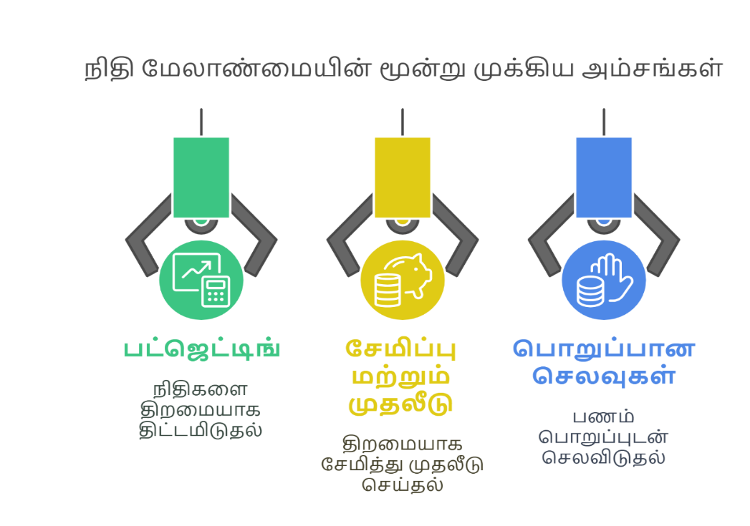

1. பட்ஜெட் (Budget) – பணத்தை திட்டமிடுதல்
பட்ஜெட் என்றால் என்ன?
பட்ஜெட் என்பது வருமானம் மற்றும் செலவுகளை சரியாக நிர்வகிக்க உதவும் ஒரு நிதி திட்டம் ஆகும். இது உங்கள் செலவுகளை கண்காணிக்கவும், தேவையற்ற கடனில் சிக்காமல் இருக்கவும், நிதி நிலைத்தன்மை பெறவும் உதவுகிறது.

பட்ஜெட் திட்டமிடுவதின் அடிப்படை நன்மைகள்:
நிதி இலக்குகளை அமைக்க உதவுதல்: (வீடு வாங்குதல், கல்விக்கான சேமிப்பு போன்றவை)
செலவுகளை கட்டுப்படுத்துதல்: (தேவையில்லாத செலவுகளை குறைத்தல்)
கடன் சுமையைக் குறைக்க உதவுதல்
சேமிப்பை அதிகரிக்க உதவுதல்

மாதிரி பட்ஜெட் கட்டமைப்பு:
வருவாய் (Income) | தொகை (₹)
சம்பளம் | 30,000
கூடுதல் வருவாய் | 5,000
மொத்த வருவாய் | 35,000

செலவுகள் (Expenses) | தொகை (₹)
வீட்டு வாடகை | 10,000
உணவுப் பொருட்கள் | 5,000
பொழுதுபோக்கு | 2,000
பயணச் செலவு | 2,000
சேமிப்பு | 5,000
பிற செலவுகள் | 3,000
மொத்த செலவுகள் | 27,000
மீதம் உள்ள தொகை = ₹35,000 - ₹27,000 = ₹8,000

2. சேமிப்பு மற்றும் முதலீடு


சிறந்த சேமிப்பு வழிமுறைகள்:
- செலவு செய்வதற்கு முன் சேமித்தல்: முதலில் உங்கள் வருமானத்தில் 10%-20% சேமித்த பின் செலவுகள் செய்யவும்.
- தானியங்கி சேமிப்பு: ஒவ்வொரு மாதமும் உங்கள் சேமிப்பு கணக்கிற்கு பணம் செலுத்துவதற்கான தானியங்கி அமைப்புகளை உருவாக்குதல்.
- சிறிய அளவில் சேமிப்பை தொடங்குதல்: சிறிய தொகையுடன் தொடங்கி, மெல்ல மெல்ல அதிகரிக்கவும்.

மாதிரி சேமிப்பு திட்டம்:
சேமிப்பு நோக்கம் | தொகை (₹)
அவசர நிதி | 1,20,000
சுற்றுலா செலவு | 25,000
பைக் வாங்குதல் | 1,00,000
மொத்த சேமிப்பு இலக்கு | 2,25,000

3. பொறுப்பான செலவுகள்
பொறுப்பான செலவு என்பது என்ன?
நிதி குறிக்கோள்களை அடைய உதவுதல்
கடனை தவிர்த்தல்
அவசியமற்ற செலவுகளை கட்டுப்படுத்துதல்
நீண்ட கால நிதி நிலைத்தன்மை பெறுதல்

சிறந்த செலவியல் பழக்கங்கள்:
- தேவையானதை முதலில் வாங்குதல்: உணவு, வீடு, கல்வி போன்ற அடிப்படை தேவைகளுக்கு முதலில் முன்னுரிமை கொடுத்தல்.
- அவசர காலத்தில் மட்டுமே கடன் எடுத்தல்: தேவையில்லாமல் கடன் வாங்குவதால் நிதி சிக்கல்கள் ஏற்படுகிறது.
- சலுகைகள் மற்றும் தள்ளுபடியை பயன்படுத்துதல்: பொருட்களை வாங்கும் முன் சலுகைகளை ஆராய்ந்து செலவுகளை குறைக்கவும்.
- விருப்பம் மற்றும் அவசியம் என்பதை பிரித்தறிதல்: தேவையான செலவுகளை மட்டுமே செய்யவும்.

அவசியம்" மற்றும் "விருப்பம்

"அவசியம்" மற்றும் "விருப்பம்" என்ற சொற்கள் நிதி கல்வியில் முக்கியமானவை. மாணவர்கள் இவற்றை எளிதாக புரிந்து கொள்ளும் வகையில் கீழே விளக்கப்பட்டுள்ளது:

அவசியம் (Need)

இவை வாழ்வதற்குத் தேவையான முக்கியமான செலவுகள். இது இல்லாமல் இருக்க முடியாது.

எடுத்துக்காட்டு:
- உணவு (சாப்பாடு)
- குடிநீர்
- உடை
- வீட்டு வாடகை
- மருத்துவம்
- பள்ளி கட்டணம்

இவை வாழ்வதற்கு அவசியமானதாகும்.

விருப்பம் (Want)

இவை வாழ்வதற்குத் தேவையில்லாத, ஆனால் விருப்பமாக செலவிடப்படும் விஷயங்கள்.

எடுத்துக்காட்டு:
- ஐஸ்கிரீம்
- வீடியோ கேம்
- சினிமா
- புதிய ஆடைகள் (பல வகைகள்)

இவை இல்லாமல் வாழ முடியும். ஆனால் விருப்பத்தால் நாம் செலவு செய்கிறோம். ஆகவே இவை விருப்பம்.

மாணவர் புரிந்து கொள்ள:

"நீங்கள் உணவு சாப்பிடாமல் இருக்க முடியுமா?"
இல்லை – அது அவசியம்.

"நீங்கள் ஐஸ்கிரீம் சாப்பிடாமல் இருக்க முடியுமா?"
முடியும் – அது விருப்பம்.

அவசியம் vs. விருப்பம்
அவசியம் (Needs) | விருப்பம் (Wants)
வீட்டு வாடகை | விலையுயர்ந்த ஆடைகள்
மின்சாரம், நீர், உணவு | கேமிங் சாதனங்கள்
மருத்துவக் காப்பீடு | சினிமா, பொழுதுபோக்கு
பயணச்செலவு | ரெஸ்டாரெண்ட்களில் உணவருந்துதல்

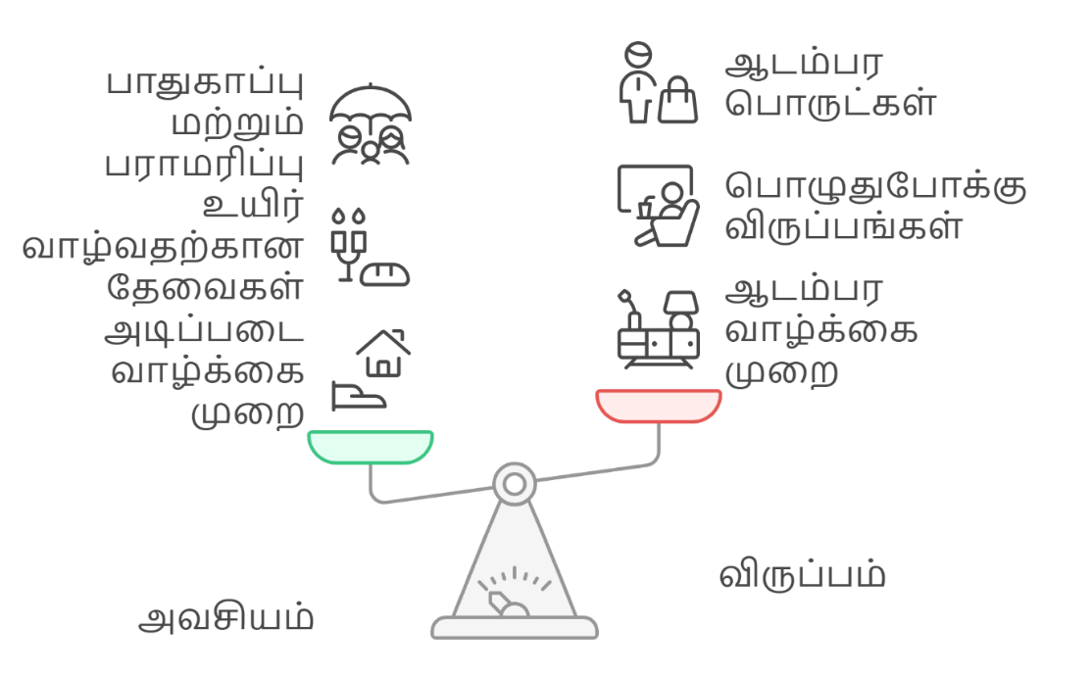

இந்த விளக்கம் மூலம் மாணவர்கள் செலவுகளைப் பிரித்து சிந்திக்கக் கற்றுக்கொள்வார்கள். தேவையை முதலில் முக்கியமாகக் கருதி பணத்தைச் செலவிடும் பழக்கத்தை வளர்க்க இது உதவும்.

பணவீக்கம் (Inflation) – எளிய விளக்கம்
பணவீக்கம் என்பது ஒரு குறிப்பிட்ட காலத்திற்குப் பின் பொருட்கள் மற்றும் சேவைகளின் விலைகள் உயர்வதைக் குறிக்கிறது. இதன் விளைவாக, ஒரே தொகை பணத்தில் நாம் வாங்கக்கூடிய பொருட்களின் அளவு குறைகிறது.

ஒரு எளிய உவமை:
ராகுல் பத்தாம் வகுப்பில் படிக்கும்போது, அவன் தினமும் ₹10-க்குத் தேநீர் மற்றும் சமோசா வாங்கிக்கொள்வான். பல ஆண்டுகள் கழித்து, அவன் வேலைக்குச் சென்ற பிறகு, அதே தேநீர் மற்றும் சமோசா வாங்குவதற்கு ₹30 முதல் ₹40 வரை தேவைப்படுவதை கவனிக்கிறான். ஏனென்றால், பொருட்களின் விலை உயர்ந்து விட்டது – இதையே பணவீக்கம் (Inflation) என்பார்கள்.

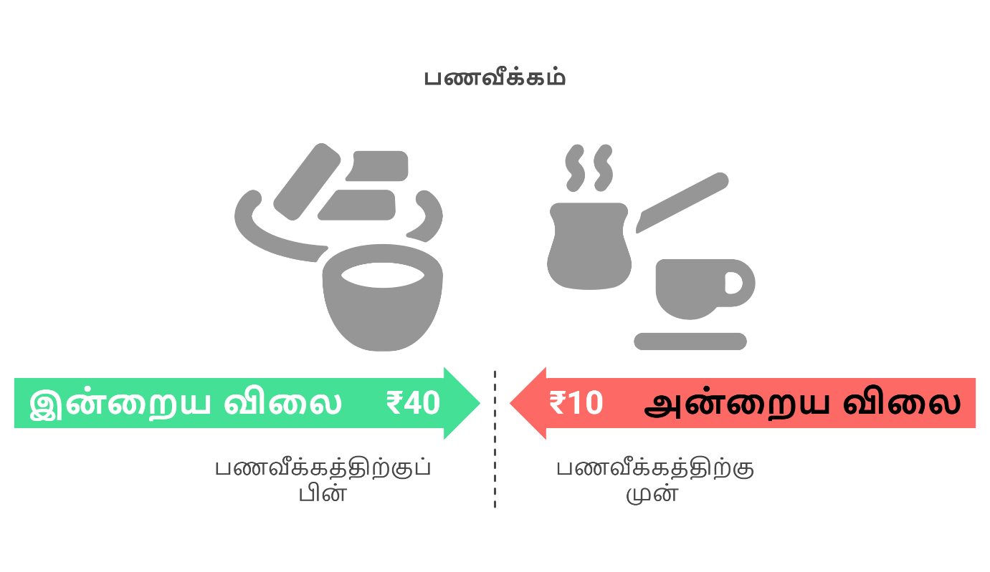

மற்றொரு அனுபவம்:
பாட்டி கூறுவார்கள், "நாங்கள் ₹1-க்கு ஒரு கிலோ அரிசி வாங்கினோம்." ஆனால் இன்று அதே அரிசி ₹50 முதல் ₹60 ஆகிவிட்டது. இது பணவீக்கத்தின் தாக்கமே!

நிலையான செலவு மற்றும் நிலையற்ற செலவு:
பணம் செலவிடும்போது, செலவுகள் இரண்டு முக்கிய வகைகளாக பிரிக்கப்படுகின்றன. அவை

1. நிலையான செலவு (Fixed Expenses)
- ஒவ்வொரு மாதமும் அல்லது குறிப்பிட்ட கால இடைவெளியில் மாறாமல் செலவாகும் பணம்.
- எந்த மாற்றமும் இல்லாமல் தொடர்ந்து செலுத்த வேண்டிய செலவு.

உதாரணங்கள்:
- வீட்டு வாடகை
- கல்வி கட்டணம்
- வாகனக் காப்பீடு
- பழைய கடன் தவணை (Loan EMI)
உதாரணம்:
ரமேஷ் வாடகை வீட்டில் வசிக்கிறார். அவரின் வீட்டு வாடகை மாதம் ₹5,000. இந்த தொகையை மாதந்தோறும் செலவழித்து வருகிறார் அதனால் இது நிலையான செலவு.

2. நிலையற்ற செலவு (Variable Expenses)
- மாதந்தோறும் அல்லது காலத்திற்கேற்ப மாறக்கூடிய செலவு.
- தேவைக்கு ஏற்ப குறையவோ அல்லது அதிகரிக்கவோ வாய்ப்பு உள்ளது.

உதாரணங்கள்:
- உணவு செலவு
- மின்சாரக் கட்டணம்
- வீட்டு வேலைகள் (Repairs & Maintenance)
- சுற்றுலா செலவுகள்
- மருத்துவ செலவு
உதாரணம்:
சீதா மாதத்திற்கு உணவிற்காக ₹3,000 செலவிடுகிறார். ஆனால் சில மாதங்களில் பண்டிகை காலம் வந்தால் உணவுச் செலவு ₹5,000 ஆகலாம். இது நிலையற்ற செலவு ஆகும்.


நிதி இலக்கு
பொருளாதார ரீதியாக முன்னேற, நிதி இலக்குகளை (Financial Goals) வகைப்படுத்தி திட்டமிட வேண்டும். இவை நீண்டகால நிதி இலக்கு மற்றும் குறுகிய கால நிதி இலக்கு என இரண்டு பிரிவுகளாக பிரிக்கப்பட்டுள்ளன.
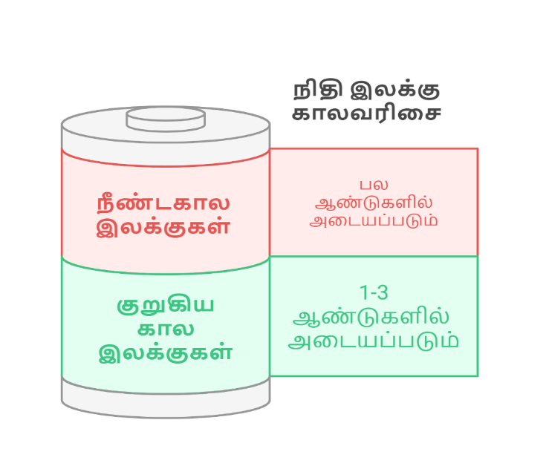

1. குறுகிய கால நிதி இலக்கு (Short-term Financial Goal)
- குறுகிய காலத்திற்குள் (ஒரு சில மாதங்கள், 1 முதல் 3 ஆண்டுகளுக்குள்) அடையக்கூடிய இலக்குகள்.
- இவை சாதாரணமாக அடிக்கடி தேவையான செலவுகள் அல்லது குறைவான முதலீடுகளாக இருக்கும்.

உதாரணங்கள்:
ஒரு புதிய மொபைல் வாங்குதல் (6 மாதங்களில் ₹20,000 சேமித்தல்)
ஓர் சுற்றுலா பயணம் (1 வருடத்திற்குள் ₹50,000 சேமித்தல்)
கடன் தவணை அடைவு (6 மாதங்களில் ₹10,000 செலுத்தல்)
அவசரநிலை நிதி உருவாக்கம் (₹30,000 முதல் ₹50,000 வரை சேமித்தல்)
உதாரணம்:
அனிதா 6 மாதங்களில் ஒரு லேப்டாப் வாங்க விரும்புகிறார். அதற்காக மாதம் ₹5,000 சேமித்து, 6 மாதங்களில் ₹30,000 சேர்ப்பதை இலக்காக வைத்திருக்கிறார். இது குறுகிய கால நிதி இலக்கு ஆகும்.

2. நீண்டகால நிதி இலக்கு (Long-term Financial Goal)
- நீண்டகாலம் (5 ஆண்டுகள் மற்றும் அதற்கு மேல்) அடையவேண்டிய இலக்குகள்.
- பெரிய முதலீடு அல்லது வாழ்க்கையை மாற்றக்கூடிய நிதி இலக்குகள்.

உதாரணங்கள்:
- வீட்டுக் கடனை அடைத்தல் (10 ஆண்டுகள் முதல் 15 ஆண்டுகள் வரை உள்ள திட்டம்)
- குழந்தைகளின் கல்விக்காக சேமிப்பு (10 ஆண்டுகள் முதல் 15 ஆண்டுகள் வரை)
- ஓய்வூதியம் மற்றும் வாழ்நாள் சேமிப்பு (20 ஆண்டுகள் முதல் 30 ஆண்டுகள் வரை)
- சொந்த வீடு (5 ஆண்டுகள் முதல் 10 ஆண்டுகள் வரை)
உதாரணம்:
ரமேஷ் 15 ஆண்டுகளுக்குள் தனது சொந்த வீட்டை வாங்க நினைக்கிறார். அதற்காக, அவர் மாதம் ₹10,000 சேமித்து, லட்ச கணக்கில் நிதியை உருவாக்குகிறார். இது நீண்டகால நிதி இலக்கு ஆகும்.

சுருக்கமாக:
குறுகிய கால இலக்கு | நீண்டகால இலக்கு
1 ஆண்டுகள் முதல் 3 ஆண்டுகளில் அடையக்கூடியது. | 5 ஆண்டுகளுக்குப் மேல் அடையக்கூடியது.
சிறிய முதலீடுகளுக்கானது. | பெரிய முதலீடுகளுக்கானது.
மொபைல், சுற்றுலா, கடன் அடைத்தல். | வீடு வாங்குதல், ஓய்வு திட்டம்.

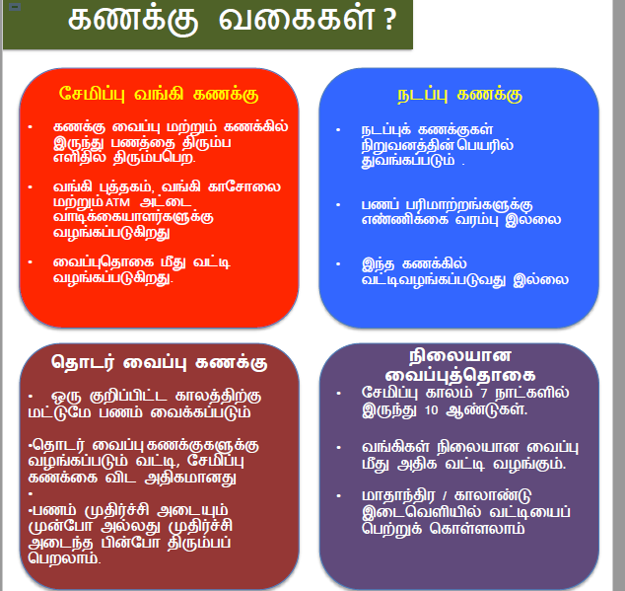

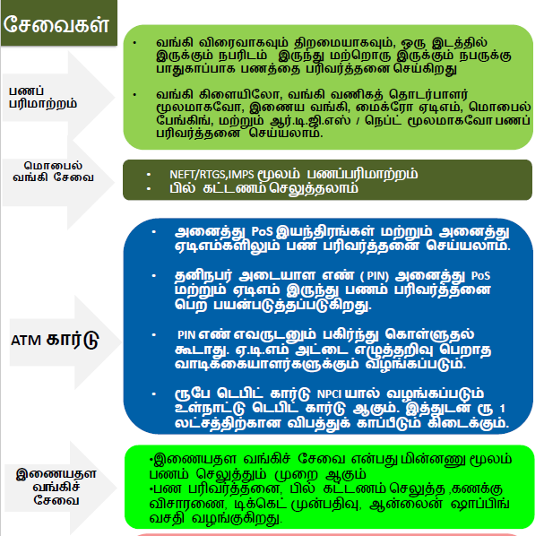

நிதி மோசடிகளைத் தவிர்ப்பதற்கான ஆலோசனைகள்

1. ஆசைக்குப் பலியாகாதீர்கள்!
- "₹500 முதலீடு செய்து ₹5,000 வாங்கலாம்!" போன்ற மோசடி விளம்பரங்களை நம்பாதீர்கள்.
- மிகக் குறுகிய காலத்தில் அதிக லாபம் கிடைக்கும் எனக் கூறும் வாய்ப்புகளைப் புரிந்துகொள்ளாமல் முதலீடு செய்ய வேண்டாம்.
- இலவச பரிசு, லாட்டரி வென்றதாக வரும் அழைப்புகள், SMS, மின்னஞ்சல்களை நம்பாதீர்கள்.
உதாரணம்:
கார்த்திக் ஒரு ஆன்லைன் வேலை சந்தையில் "₹1,000 செலுத்தினால் ₹10,000 சம்பாதிக்கலாம்" என்ற விளம்பரத்தைப் பார்த்தார். அவர் பணம் செலுத்திய பிறகு, அந்த நிறுவனம் முற்றிலும் மறைந்து விட்டது!

2. தனிப்பட்ட தகவல்களை பகிர வேண்டாம்
- வங்கிக் கணக்கு விவரங்கள், OTP, ATM PIN போன்ற தகவல்களை யாரிடமும் பகிர வேண்டாம்.
- போலி வங்கி எண்கள், மின்னஞ்சல்கள் மூலம் வரும் கோரிக்கைகளை நம்பாதீர்கள்.
- வங்கி அல்லது அரசு நிறுவனம் யாராவது அழைத்தால், அதிகாரப்பூர்வ இணையதளத்தைப் பார்த்து உறுதிப்படுத்துங்கள்.
உதாரணம்:
நித்யாவுக்கு ஒரு அழைப்பு வந்தது – "உங்கள் வங்கி கணக்கு முடக்கப்படும்; உடனே OTP கொடுங்கள்" என்று. ஆனால் இது மோசடி! நித்யா புத்திசாலித்தனமாக வங்கியை நேரடியாக அழைத்து உறுதி செய்தார்.

3. ஆன்லைன் பரிவர்த்தனைகளில் கவனம்
- Verified ஆன வலைதளங்களில் மட்டுமே பணம் செலுத்தவும்.
- ஆன்லைன் கடன் (Online Loan) அல்லது பணம் திரும்ப பெறுதல் (Cashback) எனக் கூறி வரும் மோசடிகளை அடையாளம் கண்டு தவிர்க்கவும்
- HTTPS:// உள்ள பாதுகாப்பான வலைத்தளங்களில் மட்டுமே உங்கள் விவரங்களை உள்ளீடு செய்யவும்.

உதாரணம்:
சுரேஷ் தள்ளுபடி விலையில் லேப்டாப் வாங்க ஆன்லைன் பரிசோதிக்கிறார். ஆனால், போலி வலைத்தளத்தில் வாங்க முயன்றால், பணம் கொடுத்துவிட்டு பொருள் கிடைக்காது!

4. அடையாளமற்ற வேலை வாய்ப்புகளை நம்பாதீர்கள்
- "Work from Home – ₹50,000 சம்பாதிக்கலாம்" என்ற வலைதளங்களை நம்ப வேண்டாம்.
- பணம் செலுத்தி வேலை பெறலாம் என்று கூறும் வேலை வாய்ப்புகளை தவிர்க்கவும்.
- உண்மையான நிறுவனங்களை ஆராய்ந்து மட்டுமே விண்ணப்பிக்கவும்.
உதாரணம்:
திலக் ஒரு ஆன்லைன் வேலைக்காக ₹2,000 செலுத்தினார். ஆனால், அந்த நிறுவனம் பின்னர் தொடர்பு கொள்ளவில்லை! இது மோசடி வேலை வாய்ப்பு.

5. சமூக ஊடகங்களில் எச்சரிக்கை
- இன்ஸ்டாகிராம், வாட்ஸ்அப், ஃபேஸ்புக் போன்ற தளங்களில் பணம் சம்பாதிக்க வாய்ப்பு என்றால், பலமுறை யோசிக்கவும்.
- யாரிடமும் பணம் கொடுக்க வேண்டாம் – அவர்கள் நம்பகமானவர்களாக இருந்தாலும்!
- "சிறிய முதலீடு செய்தால், இரட்டிப்பு லாபம்" போன்ற செய்திகளை பகிர வேண்டாம்.
உதாரணம்:
ரமேஷ் தனது நண்பன் மூலம் "₹500 செலுத்தி, ₹5,000 சம்பாதிக்கலாம்" என்ற வாட்ஸ்அப் குழுவில் சேர்ந்தார். பின்னர், அந்த குழு நீக்கப்பட்டு, அவர் பணத்தையும் இழந்தார்!

6. தவறான கடன் வசதிகளைப் பயன்படுத்த வேண்டாம்
- "இலவச கடன்" என்று வரும் விளம்பரங்களை நம்பாதீர்கள்.
வங்கிகள் மற்றும் நம்பகமான நிதி நிறுவனங்களில் மட்டுமே கடன் வாங்கவும்.
- அதிக வட்டி தரும் கடன் நிறுவனங்களுடன் ஒப்பந்தம் செய்யும் முன்பு ஆராயவும்.
உதாரணம்:
சீதா ஒரு உடனடி கடனுக்கு விண்ணப்பித்தார். ஆனால், கடன் பெறுவதற்கு முன்பாக பணம் செலுத்த வேண்டும் என்று கூறப்பட்டது! இதுவும் ஒரு மோசடி ஆகும்.

7. நம்பகமான நிதி ஆலோசனைகளை கேளுங்கள்
- நம்பகமான நிதி வல்லுநர்கள், பெற்றோர்கள், ஆசிரியர்கள், வங்கி அதிகாரிகள் ஆகியோரிடம் ஆலோசனை பெறுங்கள்.
- பணம் சம்பாதிக்கவும், முதலீடு செய்யவும், சேமிக்கவும் உகந்த முறையான வழிமுறைகளை கற்றுக்கொள்ளுங்கள்.

நிதி மேலாண்மை திட்டமிடலுக்கான பயிற்சி – ஆசிரியர் கட்டகம்

ஒன்பதாம் வகுப்பு மாணவர்களுக்கான அடிப்படை நிதி கல்வி பயிற்சி கட்டகம் ஆசிரியர்களுக்காக உருவாக்கப்பட்டு, மாணவர்களில் நிதி தொடர்பான முக்கியமான வாழ்க்கைத் திறன்களை வளர்க்க தேவையான உத்திகள் மற்றும் கருவிகளை வழங்கும் நோக்கத்துடன் வடிவமைக்கப்பட்டுள்ளது.
இந்த கட்டகம் நான்கு வாரங்களில் கற்பிக்க திட்டமிடப்பட்டுள்ளது, இக்கட்டகத்தில் பணத்தின் வரலாறு, முக்கியத்துவம், வருமானம், செலவுகள், பட்ஜெட், சேமிப்பு, வங்கி அடிப்படைகள், அறிவார்ந்த செலவுகள், மற்றும் கடனைத் தவிர்ப்பது ஆகிய தலைப்புகள் அடங்கியுள்ளன.
பயிற்சி முறைகள் அனுபவ அடிப்படையிலும், மாணவர்கள் ஈடுபாட்டை உயர்த்தும் வகையிலும் அமைகின்றன. கதை சொல்லல், விளையாட்டுகள், குழு விவாதங்கள், நிகழ்கால வாழ்க்கைச் சம்பவங்கள் போன்றவை மூலம் நிதி கருத்துகள் மாணவர்களுக்கு புரிந்துகொள்ளக்கூடிய மற்றும் நடைமுறையில் இருப்பதாக கற்பிக்கப்படுகின்றன. ஒவ்வொரு அலகிலும் இலக்குகள், செயல்பாடுகள், பணித்தாள்கள் மற்றும் மதிப்பீட்டுகள் உள்ளடக்கப்பட்டுள்ளன.
இந்த கட்டகம் ஆசிரியர்கள் பயன்படுத்துவதன் மூலம், மாணவர்களுக்கு சிறு வயதிலேயே பொறுப்புள்ள நிதி பழக்கங்களை உருவாக்க வழிகாட்ட முடியும். இது நிதி சார்ந்த அறிவையும் எதிர்கால நலத்தையும் நிலைநாட்ட உதவும். நிதி கல்வியை பாடதிட்டத்தின் ஒரு பகுதியாக சேர்க்கும் நோக்கத்துடன், நிதி அறிவுள்ள தலைமுறையை உருவாக்கும் கனவை நிறைவேற்ற உருவாக்கப்பட்டுள்ள ஒரு முயற்சி ஆகும்
பாடத்திட்ட விவரங்கள்:
- வகுப்பு: ஒன்பதாம் வகுப்பு
- கால அளவு: 4 வாரங்கள் (ஒவ்வொரு வாரமும் ஒரு அலகு, வாரத்திற்கு 2 அமர்வுகள்)
- கற்பித்தல் முறை: தொடர்பு மற்றும் செயல்பாட்டு அடிப்படையிலான பயிற்சி

அலகு 1: பணம் மற்றும் நிதி கல்வி அறிமுகம்
இலக்கு:
- பணத்தின் வரலாறு மற்றும் நிதி கல்வியின் முக்கியத்துவத்தைப் புரிந்து கொள்ளுதல்.
- பணத்தின் பல்வேறு வடிவங்களை (ரொக்கம், டிஜிட்டல் பரிவர்த்தனை போன்றவை) அடையாளம் காணுதல்.
கற்பித்தல் உத்திகள்:
- கதை சொல்லல்: பரிமாற்ற முறையில் இருந்து தங்கம், வெள்ளி போன்ற மதிப்புமிக்க உலோகங்கள், பின்னர் காகித பணம், வங்கி முறைகள் மற்றும் சமீபத்திய டிஜிட்டல் பரிவர்த்தனைகள் வரை பணத்தின் பரிணாம வளர்ச்சியை பற்றி கூறுதல்.
- உண்மையான வாழ்க்கை உதாரணங்கள்: மாணவர்கள் பாக்கெட் பணத்தைச் (Pocket Money) சேமிக்கலாமா அல்லது செலவழிக்கலாமா என்பதற்கான விவாதங்கள்.
- பொருட்களை வாங்கும் போது விலை ஒப்பிடுதல், செலவுகளை திட்டமிடுதல்.
செயல்பாடுகள்:
- "Money Hunt" விளையாட்டு: மாணவர்கள் கடந்த வாரத்தில் பணம் பயன்படுத்திய அனைத்து வழிகளையும் பட்டியலிடுதல் பற்றி கூறுதல்.
- குழு விவாதம்: "பணம் தவறாக நிர்வகிக்கப்பட்டால் என்ன நடக்கும் என்பதற்கான விவாதங்கள்.
மதிப்பீடு:
- "நிதி கல்வி ஏன் முக்கியம்?" என்ற தலைப்பில் குறுகிய கட்டுரை எழுதுதல்.
பணத்திற்கான பொருத்தப் பயிற்சி:
- பணத்தின் வடிவங்களை அதன் சரியான விளக்கத்துடன் பொருத்துதல் (ரொக்கம், பற்று அட்டை, UPI, கடன் அட்டை, ஈ-பணப்பை, காசோலை போன்றவை).

அலகு 2: வருமானம், செலவுகள் மற்றும் பட்ஜெட்
இலக்கு:
- வருமானம் மற்றும் செலவுகளை வேறுபடுத்திக்காணுதல்.
- பட்ஜெட்டின் முக்கியத்துவத்தைப் புரிந்து கொள்ளுதல்.
செயல்பாடுகள்:
- பட்ஜெட் சவால்: மாணவர்கள் ₹1000 கொண்டு உணவு, சேமிப்பு, பள்ளி செலவுகள் மற்றும் பொழுதுபோக்கு ஆகியவை உள்ளடங்கிய பட்ஜெட்டை உருவாக்குதல்.
- காட்சிப்படுத்தல்: "அதிகமாக செலவழித்தால் என்ன நடக்கும்?" என்ற தலைப்பில் நடிப்பு மூலம் விளக்குதல்.
மதிப்பீடு:
- மாணவர்கள் தங்கள் பட்ஜெட்டை வகுப்பில் விளக்குதல்.
- நிலையான செலவுகள் மற்றும் நிலையற்ற செலவுகளை அடையாளம் காண பணித்தாள்கள் பூர்த்தி செய்தல்.
அலகு 3: சேமிப்பு மற்றும் வங்கி அடிப்படைகள்
இலக்கு:
- சேமிப்பின் முக்கியத்துவத்தை புரிந்து கொள்ளுதல்.
- வங்கியில் உள்ள பல்வேறு கணக்குகள் மற்றும் அதன் பயன்களை அறிதல்.
செயல்பாடுகள்:
- சேமிப்பு சவால்: மாணவர்கள் ஒரு மாதத்திற்குள் ₹500 சேமிக்கத் திட்டமிடுதல்.
- வங்கி வருகை (இயன்றால்): வங்கி அதிகாரியை அழைத்து உரையாடுதல்.
அலகு 4: அறிவார்ந்த செலவு மற்றும் கடனை தவிர்ப்பது
இலக்கு:
- அறிவார்ந்த செலவழிப்பு பழக்கங்களை உருவாக்குதல்.
- கடன்கள், வட்டிகள், மற்றும் தவிர்க்க வேண்டிய நிதி தவறுகள் பற்றிய அறிவைப் பெறுதல்.
செயல்பாடுகள்:
- "Smart Shopper" விளையாட்டு: மாணவர்கள் ஒரு குறிப்பிட்ட பட்ஜெட்டிற்குள் தேவையான மற்றும் தேவையில்லாத பொருட்களை கண்டறிதல்.
- கடன் ஒப்பந்தம்: மாணவர்கள் ₹1000 கடன் வாங்கினால், வட்டி விகிதம் மற்றும் திருப்பிச் செலுத்தும் தொகையை கணக்கிடுதல்.
மதிப்பீடு:
- "நாம் தேவையற்ற செலவுகளை எப்படி தவிர்க்கலாம்?" என்ற தலைப்பில் மாணவர்கள் கட்டுரை எழுதுதல்.
- "அதிக கடன் வாங்கினால் என்ன நடக்கும்?" என்ற தலைப்பில் குழு விவாதம்.
முடிவுரை
இந்த கட்டகம் மூலம் மாணவர்கள் நிதி கல்வியை மட்டும் அல்லாமல், அதை நடைமுறையில் செயல்படுத்தவும் பயில்கின்றனர். செயல்பாடுகள் மற்றும் பணித்தாள்கள் அவர்களுடைய அறிவை மேலும் வலுப்படுத்த உதவுகின்றன.
பட்ஜெட்டிங், சேமிப்பு, மற்றும் பொறுப்பான செலவுகள் – இவை நிதி மேலாண்மையின் மூன்று முக்கியமான அம்சங்கள்.
மாணவர்களுக்கு சிறிய வயதிலிருந்தே நிதி மேலாண்மை பழக்கங்களை உருவாக்குவது அவசியம்.
நிதி அறிவு பெற்ற சமுதாயத்தை உருவாக்க, நாம் அனைவரும் சேர்ந்து செயல்படுவோம்!

19. Worksheet
நிலையான செலவுகள் மற்றும் நிலையற்ற செலவுகள் பணித்தாள்
மாணவர் பெயர் (Student Name): ____________________
வகுப்பு (Class): ____________________
பள்ளி:_________________________
நிலையான செலவுகள்:
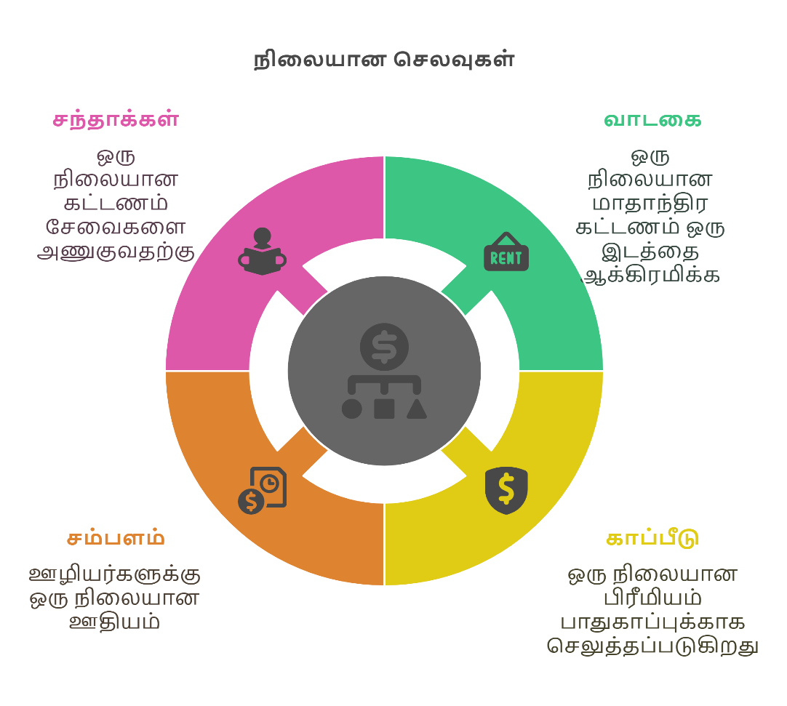
கீழே உங்களுக்கு தெரிந்த நிலையான செலவுகளை பட்டியலிடவும்.
- ______________________________________________________
- ______________________________________________________
- ______________________________________________________
- ______________________________________________________

நிலையற்ற செலவுகள்
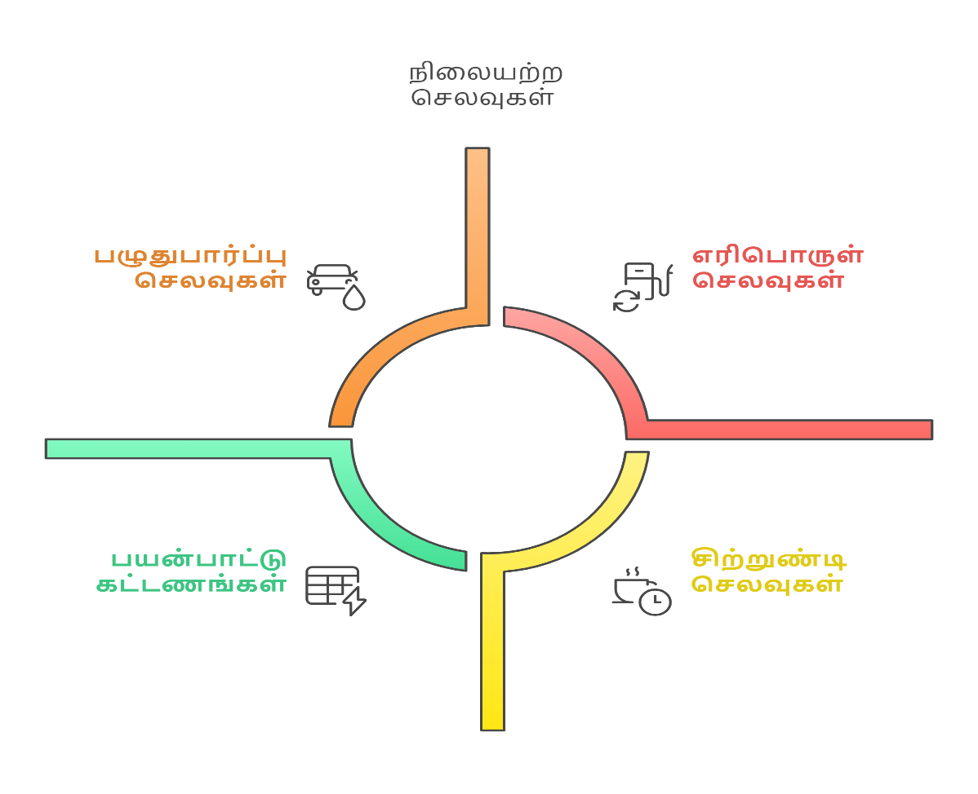
கீழே உங்களுக்கு தெரிந்த நிலையற்ற செலவுகளை பட்டியலிடவும்.
- ______________________________________________________
- ______________________________________________________
- ______________________________________________________
- ______________________________________________________
- ______________________________________________________

செயல்பாடு
- நிலையான செலவுகள் மற்றும் நிலையற்ற செலவுகளை ஒப்பிடவும். உங்கள் கருத்துக்களை கீழே எழுதவும்.
- ______________________________________________________
- ______________________________________________________

தேவை மற்றும் விருப்பம் பணித்தாள்

மாணவர் பெயர்: _____________________
வகுப்பு: ___________________________

பயிற்சி – 1: கீழே உள்ள பொருட்களை ‘தேவை’ அல்லது ‘விருப்பம்’ என வகைப்படுத்துங்கள்:
பொருள் | தேவை / விருப்பம்
உணவு
மொபைல் ஃபோன்
பள்ளி புத்தகங்கள்
உடை
மிதிவண்டி
வீடு
விளையாட்டு பொம்மை
சுற்றுலா செல்வது
விலை உயர்ந்த அணிகலன்கள்

பயிற்சி – 2: கீழே உள்ளவைகளில் நீங்கள் தேவை / விருப்பம் என்பதைக் குறியுங்கள்
தினமும் சாப்பிட உணவு ______
புதிய வாட்ஸ்‌அப் மொபைல் ______
பள்ளிக்குச் செல்ல புத்தகம் ______
சாக்லேட் சாப்பிடுவது ______
பள்ளி சீருடை ______

பயிற்சி – 3: நீங்கள் நினைக்கும் தேவைகள் மற்றும் விருப்பங்களை எழுதுங்கள்
தேவைகள்: விருப்பங்கள்:
1. ___________________ 1. ___________________
2. ___________________ 2.____________________
3.____________________ 3.______________________
20. Photos
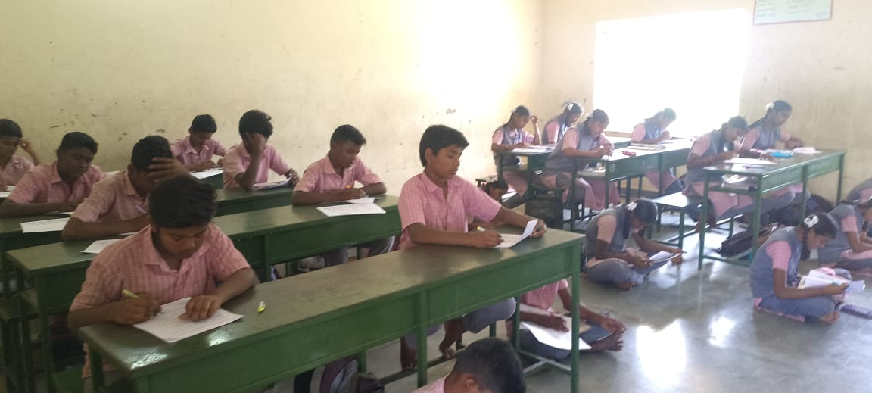
Pre- Test was written by the 9th standard Students
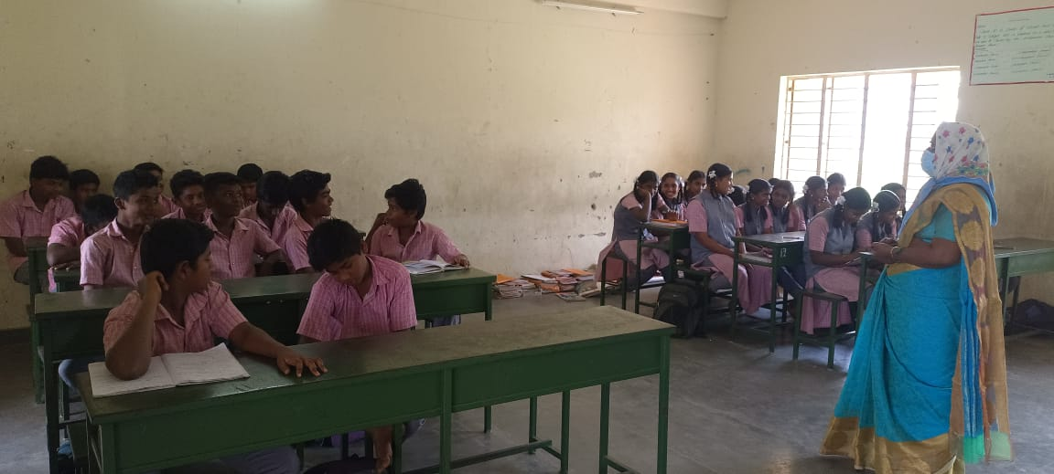
Saving of the students were discussed in the class
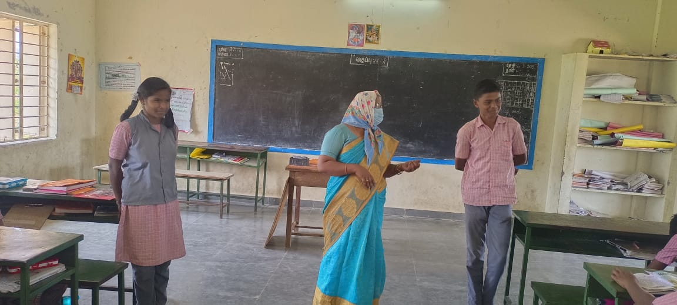
Needs and wants were debated by two of the students in the class
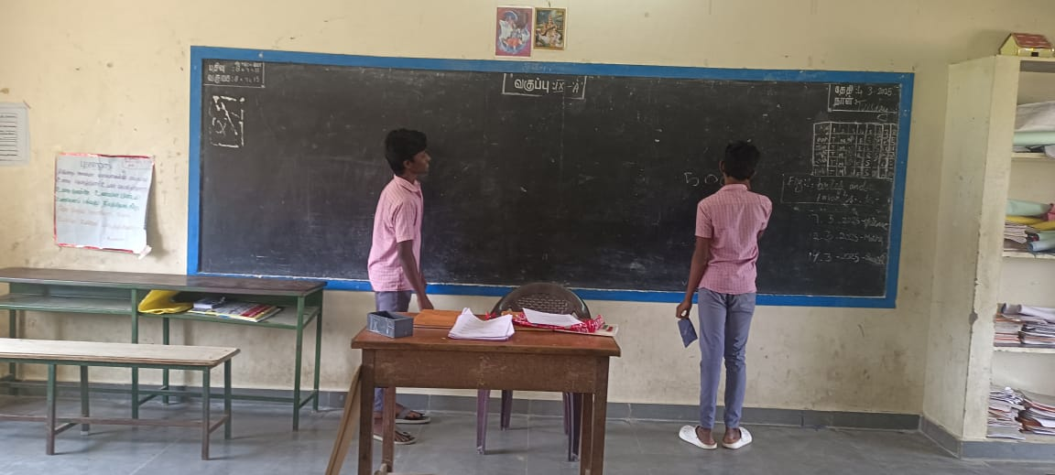
Budget for Picnic was prepared by the students in the class
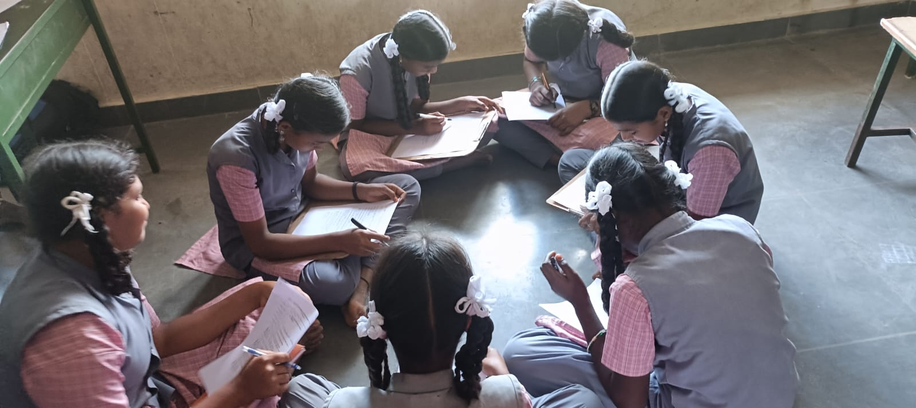
Fixed Expense and Variable expense worksheet were filled by Students
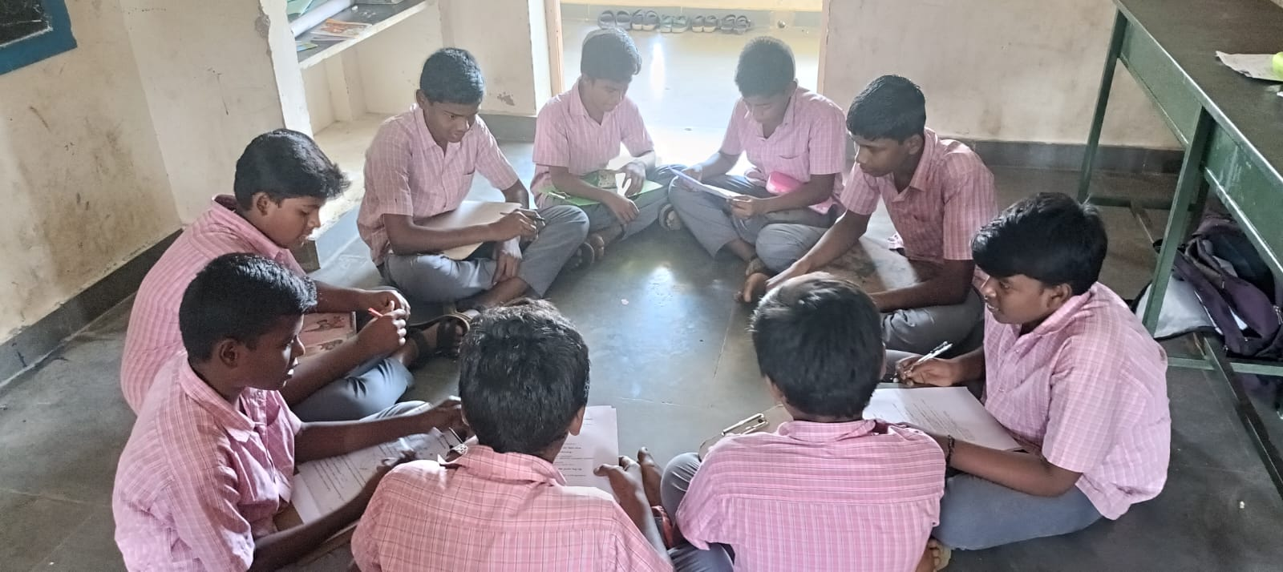
Fixed Expense and Variable expense worksheet were filled by Students

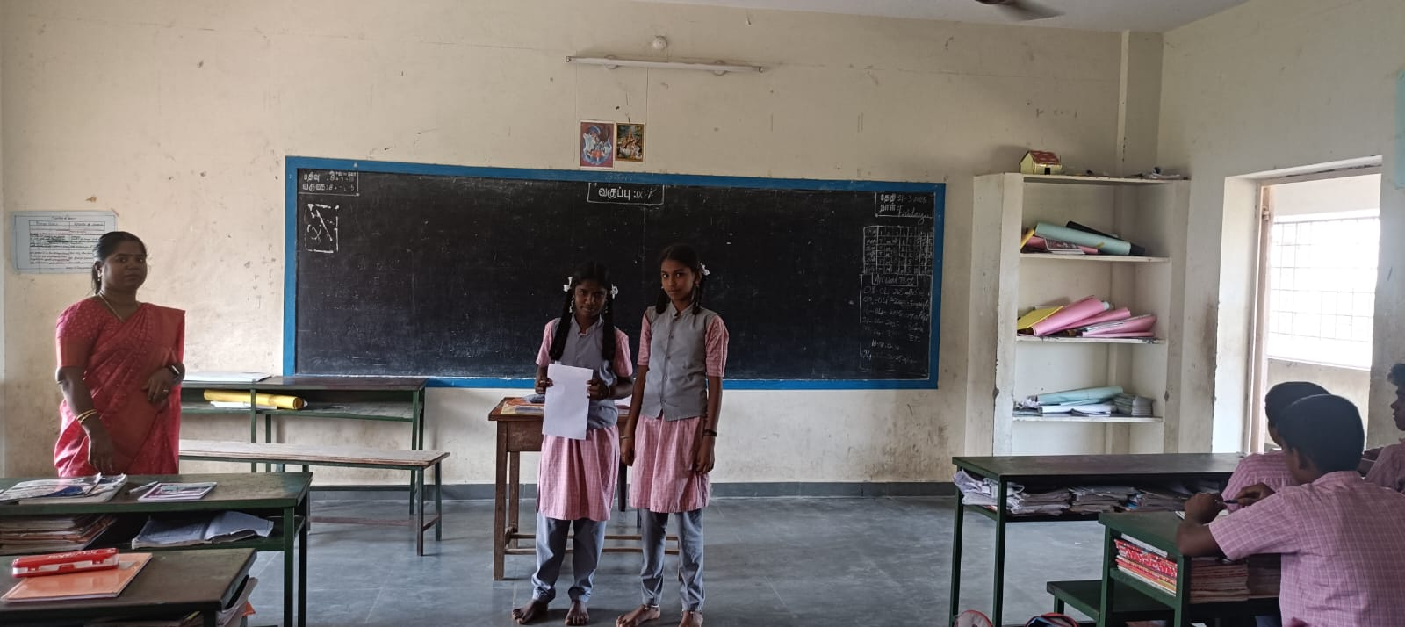
Research co-ordinator Dr. B.Silambarasi overviewed the budget was presented by students
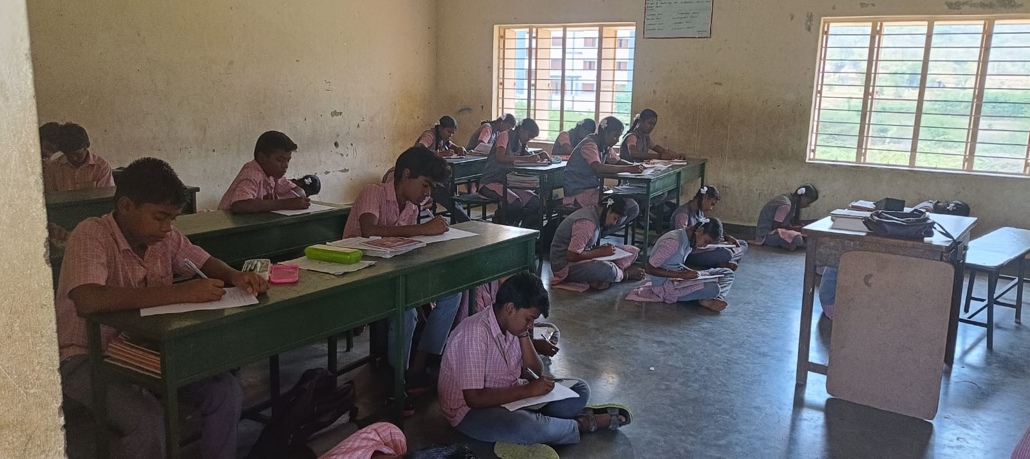
Post Test was written by the 9th standard Students

