TNDPIFAR2410
Name of the Researcher: R.Kavitha, Lecturer
Name of the DIET : DIET, Dharmapuri
Name of the Topic : ENHANCING THE MATH PEDAGOGICAL SKILL
AMONG PRIMARY TEACHERS THROUGH DMT FRAMEWORK
INTRODUCTION:
Mathematics is the foundation for cognitive development as well as many aspects of modern life. It is the language of Science, Technology, Engineering and Mathematics (STEM) fields, and essential for problem-solving, critical thinking and Analytical reasoning. Particularly, Primary Mathematics is the groundwork for future academic success and real-world applications. Primary education lays the groundwork for future learning, and mathematics is a core part of this foundation. By developing mathematical thinking at an early age, children gain the ability to analyse problems, recognize patterns, and make logical decisions. This helps them not only in mathematics but also in subjects like science, technology, and even language learning. Mathematical thinking is more than just performing calculations or memorizing formulas; it is a powerful cognitive process that involves problem-solving, logical reasoning, and the ability to analyse and interpret quantitative and spatial information. Developing mathematical thinking equips individuals with critical skills that extend beyond mathematics, enhancing their ability to approach complex problems, make informed decisions, and think critically in everyday life.
In Educational settings, fostering mathematical thinking helps students build a deeper understanding of mathematical concepts and encourages curiosity and exploration. It promotes a shift from rote learning to engaging with problems creatively and persistently. Whether through pattern recognition, strategic thinking, or abstract reasoning, cultivating mathematical thinking prepares learners to navigate a world increasingly driven by data and technology.
Despite its importance, many students struggle with the basic mathematical concepts this may due to either internal or external factor or both. There are so many external factors which cause the struggle in learning Mathematics. Here, the Researcher consider one of the external factors which cause a math struggle among students is inadequate teaching methods or not adapting a diverse teaching strategy for fostering a deep understanding of the fundamental principles among their students. So, the researcher promoting a framework which is a Developing Mathematical Thinking (DMT) offers a promising approach to optimizing this crucial skill, empowering primary teachers to enhance their capacity to engage students and cultivate a robust grasp of mathematical reasoning. This framework equips primary teachers with the tools necessary to create engaging, inquiry-based learning environments that foster students' mathematical understanding. This action research aims to optimize the use of the DMT framework among primary teachers, ultimately improving students' understanding and engagement with mathematics.
Background of the Action Research:
Mathematics is a fundamental subject which shapes students’ logical reasoning, problem-solving abilities, and critical thinking skills from an early age. In the primary grades, teachers play a crucial role in laying this foundation. However, research and classroom observations have consistently revealed that many primary teachers often rely heavily on traditional, rote-based teaching methods that emphasize procedural knowledge over conceptual understanding. This approach limits students’ ability to develop deeper mathematical thinking skills, which are essential for lifelong learning and application of mathematics in real-life contexts.
One of the key factors contributing to this issue is the gap in teachers’ own pedagogical understanding and confidence in teaching mathematics conceptually. Many primary teachers may have limited exposure to strategies that foster students’ mathematical thinking, such as encouraging exploration, reasoning, conjecturing, and justifying solutions. Therefore, enhancing the pedagogical skills of primary teachers requires a deliberate focus on equipping them with practical frameworks and strategies that promote mathematical thinking in the classroom.
Action research provides a systematic and reflective approach for teachers to identify their own challenges, experiment with new practices, and assess their effectiveness in real-time classroom settings. By developing and implementing a Mathematical Thinking Framework, teachers can gain practical tools and structured methods to shift from traditional instruction to a more student-centered, inquiry-based approach. This, in turn, can lead to improved student engagement, better conceptual understanding, and stronger problem-solving skills. Through this action research, the focus will be on collaboratively designing, implementing, and refining a Mathematical Thinking Framework tailored to the needs of primary teachers. The study aims to empower teachers to become reflective practitioners who continuously enhance their pedagogical practices to foster a culture of mathematical thinking among young learners.

Identification of the Problem:
During school visit the investigator find out that many primary teachers face significant difficulties in developing and applying a structured mathematical thinking framework in their teaching practice. While they often possess the necessary content knowledge to teach basic mathematics, they may lack the deeper conceptual tools and pedagogical strategies to foster higher-order thinking, problem-solving, and reasoning skills in their students. One core issue is that many teacher education and professional development programs do not adequately emphasize the cultivation of mathematical thinking. Instead, they focus largely on procedural fluency and curriculum coverage. As a result, teachers may struggle to engage students in activities that go beyond memorization and repetition. They may find it challenging to design lessons that encourage exploration, question-posing, and meaningful discussion — key components of mathematical thinking. This gap hinders students’ ability to develop critical reasoning, problem-solving skills, and a positive attitude towards mathematics from an early age. So, the researcher envisaged addressing the problem as action research.
Need for the Action Research:
In Primary Education, Primary teachers play a crucial role in developing a Mathematical attitude and ability among students. But, some of the Primary Teachers lack in specific pedagogical strategies like fostering logical reasoning and problem-solving skills. Traditional teaching methods, which focus mainly on procedural knowledge and rote learning, often fail to engage students in meaningful mathematical thinking. The need for this study arises from the growing demand to improve Mathematics education by empowering teachers with effective, research-based strategies that are both pedagogically sound and contextually relevant. By developing and implementing a Mathematical Thinking Framework, this study aims to provide primary teachers with tools to cultivate critical thinking, problem-solving, and a deeper conceptual understanding among their students. Therefore, this action research is significant as it addresses an existing gap in professional development and instructional practice by aligning teacher training on Enhancing the Math Pedagogical skill among Primary Teachers through DMT Framework.
Statement of the Problem:
Mathematical thinking is a cognitive process that involves logical reasoning, problem-solving, abstraction, and the ability to recognize patterns and relationships. It goes beyond mere computation or the application of formulas; rather, it embodies a way of approaching problems, analysing situations, and making decisions based on mathematical principles. Mathematical thinking includes both conceptual understanding and procedural fluency, enabling learners to not only perform mathematical operations but also understand why and how they work. However, in our classroom, Teachers were focused only on concepts this leads to a rote learning among the students. Primary teachers are trying to solve the problem of the student they are may not be familiar with, leading to outdated teaching methods. So, the Investigator envisaged addressing the problem as action research and entitled as “Enhancing the Mathematical Pedagogy among Primary Teachers using of DMT framework”.
Objectives of the Action Research:
- To enhance the mathematical pedagogy among Primary teachers by using of DMT (Developing Mathematical Thinking) Framework.
- To develop a differentiated instruction strategy for diverse learners.
- To Promote effective classroom management and math-specific teaching techniques.
- To develop teachers' ability to design inquiry-based lessons
Probable Causes of the Problem:
Despite the critical importance of effective mathematical pedagogy in primary education, many teachers face challenges in adequately addressing the diverse needs of their students in mathematics. Traditional teaching methods often focus on rote memorization and procedural skills, which can hinder students' conceptual understanding and critical thinking abilities. Moreover, teachers may lack sufficient training in contemporary pedagogical frameworks that promote deeper learning and engagement, such as the Developing Mathematical Thinking (DMT) framework. This gap in pedagogical practice can result in students developing fragmented mathematical knowledge, low confidence in their abilities, and a disengagement from the subject. Therefore, there is a pressing need to enhance primary teachers' understanding and application of the DMT framework to foster more effective and inclusive mathematics instruction. This study seeks to investigate how targeted professional development can improve teachers' mathematical pedagogy, thereby positively impacting student learning outcomes and engagement in mathematics.
Action Hypotheses:
Primary teachers' pedagogical practices will improve and student engagement and achievement in mathematics will increase when they participate in an organised, structured professional development program based on the Developing Mathematical Thinking (DMT) framework.
Methodology:
Sample:
The sample for this research was primary school teachers who are actively engaged in Mathematics Instruction and learning. Participants were selected from Karimangalam block of Dharmapuri district. Purposive sampling technique was adopted to select teachers. To ensure a comprehensive understanding of how mathematical thinking develops in government school students, a sample of 30 Primary Teachers were selected from Karimangalam Block in Dharmapuri District.
Research Design:
For this study, Single-group experimental Design was employed. The study will utilize a pre-test and post-test design to measure the effectiveness of the Developing Mathematical Thinking (DMT).
Description of the Research Tool:
The Developing Mathematical Thinking Questionnaire is designed to assess and explore how teachers were engaged with mathematical concepts, problem-solving strategies, and reasoning skills. It serves as a diagnostic and reflective tool for teachers to understand students' approaches to mathematics, their confidence levels, and the effectiveness of different teaching strategies in fostering mathematical thinking. The questionnaire typically consists of five key sections which are Encouraging Conceptual Understanding, Promoting Problem-Solving Skills, Encouraging Mathematical Communication, Fostering Logical Reasoning and Connections, Reflective Practice and Assessment. Each section consists of three questions and totally there are 15 questions with four-point scale (Always, Often, Rarely, Never).
Description of the Research Process:
The research process for the study on Enhancing Math Pedagogy Skills Among Primary Teachers Through the Developing Mathematical Thinking (DMT) Framework follows a systematic and structured approach. The process includes the following key phases:
- Data Collection:
To investigate the effectiveness of the Developing Mathematical Thinking (DMT) framework in enhancing the math pedagogy skills of primary teachers, a comprehensive data collection process is implemented. For this study, 30 Primary school teachers were selected to participate in the professional development sessions. Pre and Post Test data is collected in-person from each primary schools of the sample.
Pre- and Post-Assessment: Teachers' initial pedagogical skills are assessed before implementing the DMT framework and compared with their performance after intervention.
- Intervention:
The intervention is designed to provide structured activities that enhance primary teachers’ math pedagogy skills by integrating the Developing Mathematical Thinking (DMT) framework. The intervention includes professional development workshops, classroom applications, and collaborative reflection to ensure teachers effectively adopt student-centred, problem-solving-based math instruction. To enhance the mathematical thinking framework one day workshop was conducted to the primary teachers. The sessions are as follows
Workshop Sessions:
Session 1: Introduction to the Developing Mathematical Thinking Framework
- Overview of DMT principles: problem-solving, reasoning, and student engagement.
- Identifying challenges in current math teaching practices.
- Hands-on activity: Teachers solve open-ended math problems and discuss different solution strategies.
Session 2: Encouraging Mathematical Discourse
- Strategies for fostering classroom discussions around mathematical reasoning.
- Role-playing activity: Teachers practice questioning techniques that promote deeper thinking (e.g., “How did you arrive at this answer?”)
- Group work: Teachers develop dialogue scripts to guide discussions in their classrooms.
Session 3: Problem-Solving & Inquiry-Based Learning
- Exploration of real-world problem-solving techniques.
- Activity: Teachers work in groups to design inquiry-based math problems for students.
- Peer feedback session to refine activities.
Session 4: Differentiation Strategies in Math Instruction
- Understanding different learning styles and abilities.
- Hands-on activity: Teachers modify a traditional math lesson to include differentiated instruction.
- Reflection on classroom challenges and solutions.
- Data Analysis:
The Pre-Test and Post-Test scores was analysed and the results was discussed in terms of Descriptive Statistics.
Analysis and Interpretation:
The collected data is analysed using quantitative method to evaluate the effectiveness of the Developing Mathematical Thinking (DMT) framework in enhancing primary teachers' math pedagogy skills. The analysis focuses on changes in teaching practices and student engagement in mathematical thinking. Teachers’ pedagogical skills are assessed before and after the intervention using descriptive statistics (mean, median, standard deviation). The scores of pre-test and post-test are tabulated below

 | N | Mean | S.D
Pre-test | 30 | 32.23 | 3.23
Post-test | 30 | 85.4 | 8.35

The table revealed that the mean pre-test score (M = 32.23) was significantly lower than the mean post-test score (M = 85.4), suggesting notable improvement in teachers' pedagogical skills following the intervention. These findings suggest that training in the DMT framework effectively enhances primary teachers’ ability to implement student-centred, problem-solving-based math instruction.
Figure-I
12.1 MEAN SCORES OF PRE-TEST AND POST-TEST

FIGURE-I indicates that the mean score of the pre-test (32.23) and post-test (85.4) conducted for 30 Primary School Teachers.
FIGURE-II
12.2 INDIVIDUAL MEAN SCORES OF PRE-TEST AND POST-TEST

FIGURE-II indicates the individual mean score of the pre-test and post-test.
Findings of the Action Research:
The findings indicate that the Developing Mathematical Thinking (DMT) framework significantly enhances primary teachers' math pedagogy skills by improving instructional practices, increasing teacher confidence, and fostering student engagement.
Findings revealed that after the intervention, teachers:
- Used more open-ended questions to encourage mathematical reasoning.
- Facilitated student-led discussions, allowing learners to articulate their thinking.
- Incorporated real-world problem-solving activities, making math more engaging and relatable.
- Applied differentiation techniques, ensuring that diverse learners received appropriate support.
- Design lessons that integrate problem-solving and critical thinking.
- Adapt their teaching strategies to meet different student learning needs.
Net gain of the Action Research:
The action research demonstrated significant positive gains for both teachers and students:
Improved Teacher Pedagogy: Teachers’ mean scores increased from 32.23 (pre-test) to 85.4 (post-test), showing a substantial improvement in their understanding and application of the Developing Mathematical Thinking (DMT) framework.
Enhanced Instructional Practices: Teachers shifted from rote and procedural teaching to student-centred, inquiry-based approaches. They now design lessons that integrate problem-solving, reasoning, and open-ended questioning.
Increased Student Engagement: Teachers reported that students showed greater participation, curiosity, and confidence in learning mathematics when exposed to strategies aligned with the DMT framework.
Long-Term Impact: The framework equips teachers to continuously adapt and refine their teaching strategies, ensuring sustainable improvement in mathematical learning outcomes.
Professional Development Culture: The research fostered a culture of reflective practice and collaboration among primary teachers, encouraging ongoing professional growth beyond the intervention.
Overall, the net gain is the transformation of traditional math instruction into a more meaningful, engaging, and effective learning experience, laying a stronger foundation for students’ lifelong mathematical thinking and problem-solving skills.
Educational Implication:
- It shifts the instructional focus from rote learning and procedural fluency to fostering deep conceptual understanding, critical thinking, and problem-solving skills in students.
- Curriculum developers should incorporate open-ended tasks, real-world problem-solving activities, and collaborative learning opportunities in math instruction.
- Schools should combine formative and summative assessments to measure students’ conceptual understanding, reasoning skills, and procedural fluency rather than relying solely on traditional tests.
- The curriculum should support diverse learners by providing strategies for differentiated instruction, ensuring all students receive appropriate support and challenges.
- Future research should examine the long-term impact of the DMT framework on student performance, retention, and attitudes toward mathematics.
Recommendations for Future Implementation:
- Conduct ongoing workshops focused on specific aspects of mathematical thinking, such as problem-solving, reasoning, and inquiry-based learning.
- Create a repository of lesson plans, teaching strategies, and problem-solving activities aligned with the DMT framework.
- Develop grade-specific teaching guides that outline best practices for integrating mathematical reasoning and inquiry-based learning.
- Provide ready-to-use assessment tools to help teachers evaluate students' mathematical thinking skills effectively.
- Implement a structured professional development program centred on a Mathematical Thinking Framework.
- Integrating this approach into classroom practice will not only enhance teachers' pedagogical content knowledge but also nurture students' ability to think mathematically, thereby improving overall mathematics achievement at the primary level.
Conclusion:
Enhancing the mathematical pedagogical skills of primary teachers is essential for fostering a strong foundation in mathematics among young learners. The Developing Mathematical Thinking (DMT) Framework provides a structured approach to improving teachers’ instructional strategies, deepening their mathematical understanding, and cultivating a more engaging and student-centred learning environment. By integrating the DMT framework, teachers can shift from rote memorization to fostering critical thinking, problem-solving, and conceptual understanding. This approach encourages inquiry-based learning, mathematical discourse, and the use of multiple representations, ultimately leading to improved student outcomes. Investing in continuous professional development, collaboration, and reflective teaching practices will further empower teachers to implement the framework effectively. By doing so, we can create a generation of mathematically confident students who can apply their knowledge to real-world situations. Therefore, adopting the Developing Mathematical Thinking Framework is a crucial step toward strengthening primary education and ensuring long-term mathematical success.
BIBLIOGRAPHY
- Polya, G. (2004). How to solve it: A new aspect of mathematical method. Princeton University Press.
- Mason, J., Burton, L., & Stacey, K. (2010). Thinking mathematically (2nd ed.). Pearson.
- Tall, D. (2013). How humans learn to think mathematically: Exploring the three worlds of mathematics. Cambridge University Press.
- Boaler, J. (2016). Mathematical mindsets: Unleashing students' potential through creative math, inspiring messages, and innovative teaching. Journal of Mathematics Education, 7(1), 1–20.
- Schoenfeld, A. H. (1992). Learning to think mathematically: Problem solving, metacognition, and sense-making in mathematics. Journal for Research in Mathematics Education, 23(4), 334–370.
- Burton, L. (1999). The practices of mathematicians: What do they tell us about coming to know mathematics? Educational Studies in Mathematics, 37(2), 121–143.
- https://digitalcommons.unl.edu/cgi/viewcontent.cgi?article=1030&context=mathmidsummative
- https://curriculumprogresstools.education.govt.nz/lpfs/understanding-the-mathematics-framework/
- https://ride.ri.gov/instruction-assessment/curriculum/curriculum-frameworks/mathematics-curriculum-frameworks
- https://study.com/academy/lesson/teaching-mathematical-thinking-processes.html
- https://www.sciencedirect.com/topics/computer-science/mathematical-thinking

ANNEXURE-I: QUESTION PAPER
DISTRICT INSTITUTE OF EDUCATION AND TRAINING
SETTIKKARAI, DHARMAPURI
PRE-TEST/ POST- TEST QUESTIONNAIRE
Title of the action research: Enhancing the Math Pedagogical skill among Primary
Teachers through DMT framework
Name of the Teacher and Designation:
School Address :
S.No | STATEMENT | Rarely | Sometimes | Often | Always
 | Encouraging Conceptual Understanding
01 | I encourage students to explain their reasoning rather than just providing an answer.
02 | I use multiple representations (visuals, models, real-world examples) to teach mathematical concepts
03 | I design activities that help students discover mathematical principles rather than just memorizing formulas.
 | Promoting Problem-Solving Skills
04 | I provide opportunities for students to solve open-ended or real-world mathematical problems.
05 | I encourage students to explore different problem-solving strategies and compare their effectiveness
06 | I guide students in reflecting on their mistakes and learning from them.
 | Encouraging Mathematical Communication
07 | I facilitate discussions where students explain their thinking and justify their solutions.
08 | I ask open-ended questions that promote critical thinking rather than only focusing on correct answers.
09 | I create a classroom culture where students feel comfortable questioning, debating, and defending their mathematical ideas.
 | Fostering Logical Reasoning and Connections
10 | I challenge students to critique and evaluate different mathematical arguments and solutions
11 | I encourage students to recognize patterns and generalize mathematical ideas.
12 | I help students make connections between mathematical concepts and their applications in different contexts.
 | Reflective Practice and Assessment
13 | I regularly reflect on my teaching practices to identify areas where I can improve my ability to foster mathematical thinking in my students.
14 | I use formative assessments (e.g., journals, discussions, projects) to evaluate students’ mathematical thinking.
15 | I provide constructive feedback that helps students refine their mathematical thinking

ANNEXURE-II: PHOTOGRAPH

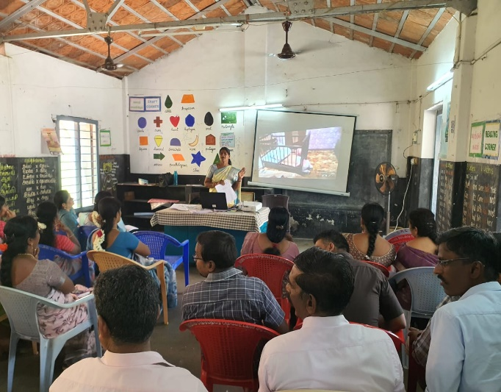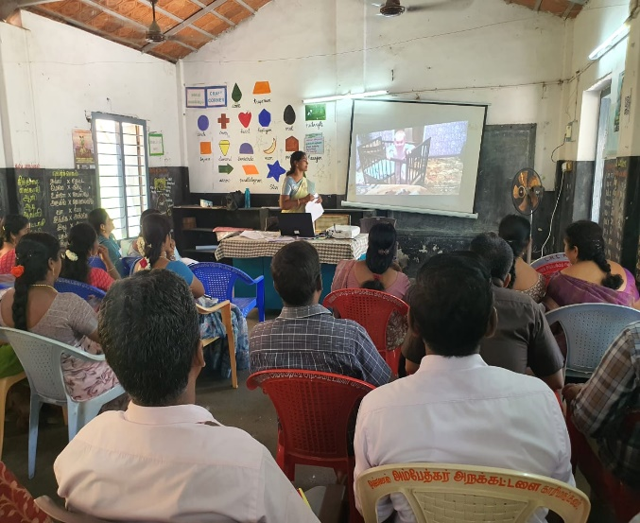
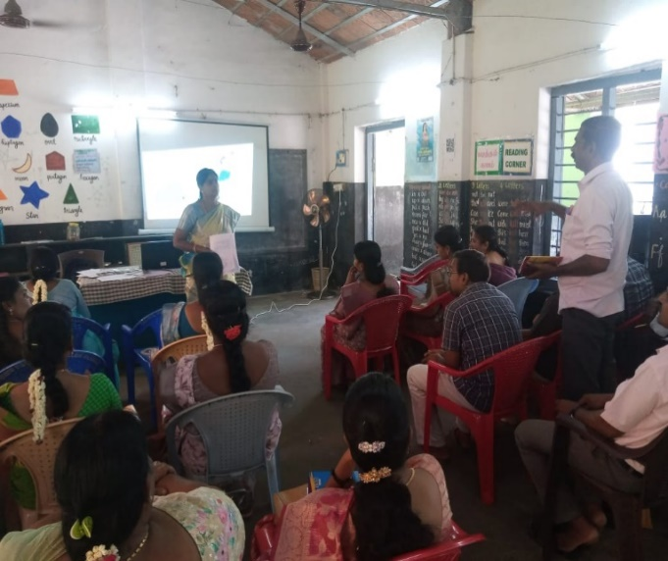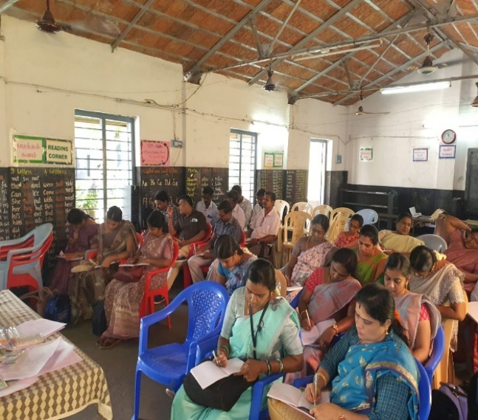
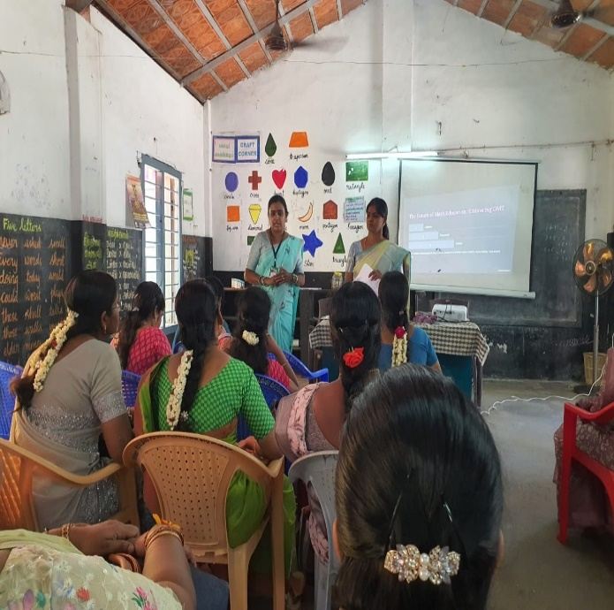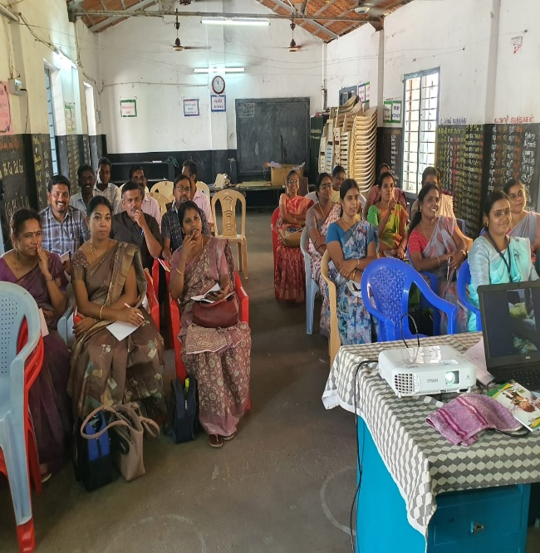
Mrs R.Kavitha, Lecturer, DIET, Dharmapuri gave a lecturer on “Developing Mathematical Thinking (DMT) Framework” for Primary School Teachers at Karimangalam Block.
Impact of the Training
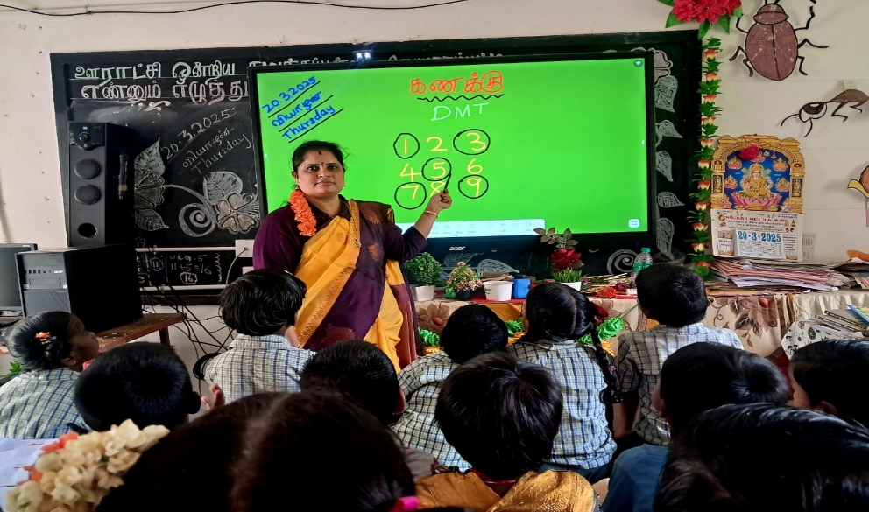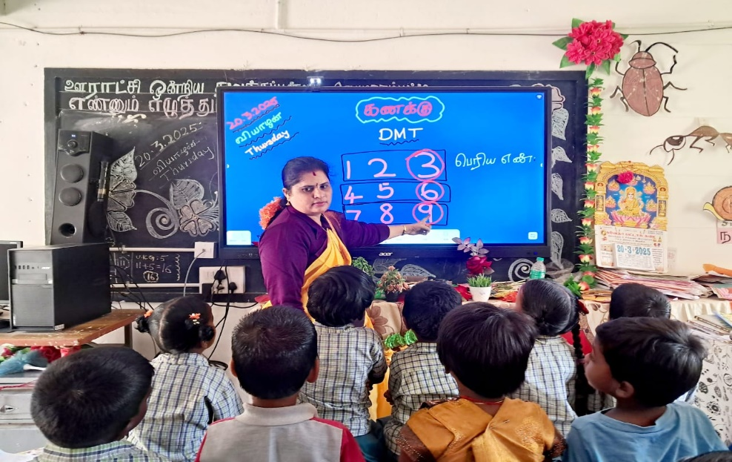
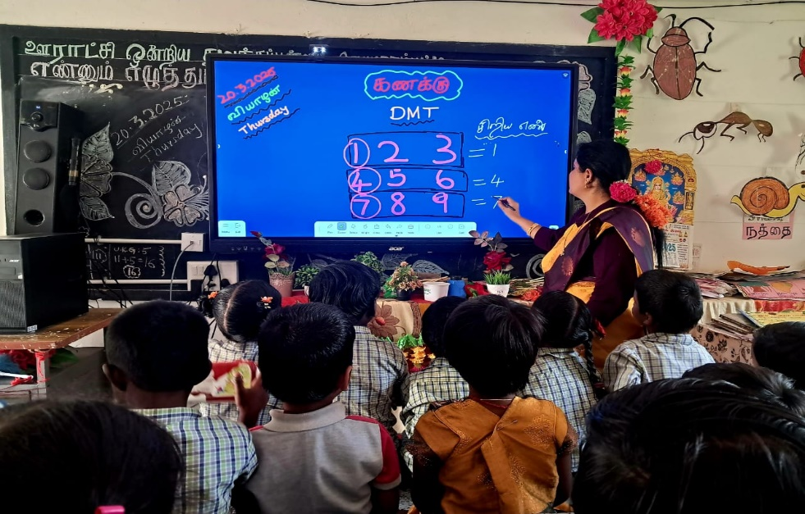
Teacher follows a DMT Framework in her Classroom

