ENHANCING PROJECT-BASED PEDAGOGY SKILLS AMONG MIDDLE SCHOOL SCIENCE TEACHERS THROUGH PROJECT-BASED LEARNING

- INTRODUCTION
Project-based pedagogy is a dynamic, learner-centered teaching approach that emphasizes active student engagement through the exploration of real-world problems and challenges. Rather than relying solely on traditional lecture-based instruction, this method encourages students to investigate, collaborate, and create solutions through hands-on projects that integrate knowledge across subject areas. In the context of science education, project-based learning (PBL) helps students connect theoretical concepts to practical applications, thereby fostering scientific thinking, creativity, and problem-solving skills.
This pedagogy not only deepens students' understanding of scientific principles but also builds essential 21st-century skills such as teamwork, communication, and independent inquiry. As students take ownership of their learning, they become more motivated and invested in the learning process, resulting in improved academic performance and retention of knowledge. However, the successful implementation of project-based pedagogy requires a well-developed set of teaching skills. Teachers must be adept at designing meaningful projects, facilitating inquiry-based learning, managing group dynamics, assessing project outcomes, and aligning activities with curriculum standards. Many educators, particularly at the middle school level, face challenges in adopting this approach due to limited training, time constraints, and lack of institutional support.
This action research focuses on enhancing project-based pedagogy skills among middle school science teachers, with a particular focus on the middle school science teachers who are working in Palacode Block. The objective is to provide targeted professional development and resources that empower teachers to incorporate PBL strategies effectively into their classrooms. Through workshops, collaborative planning, and classroom implementation, this initiative seeks to build teacher capacity, improve instructional quality, and ultimately enhance student engagement and achievement in science.
By addressing the gaps in pedagogical practice and supporting continuous teacher development, this action research aims to create a sustainable model for improving science education through project-based learning.
This study aimed to enhance the project-based pedagogy skills of middle school science teachers in Palacode Block through targeted interventions. By assessing their pre-existing knowledge and providing structured support, this study sought to improve their ability to implement PBL effectively. A quasi-experimental design was used to evaluate the impact of the intervention on teachers’ instructional practices. The findings highlight the significance of professional development in equipping teachers with the necessary skills to foster student engagement and conceptual understanding through project-based learning in science education.
In Palacode Block, the need for effective teaching strategies in middle school science is crucial for fostering student engagement and deeper understanding. Project-based pedagogy (PBP) has emerged as a powerful approach to enhance learning by integrating real-world applications. However, many teachers lack the necessary skills and training to implement PBP effectively. This action research aims to enhance the project-based pedagogy skills of middle school science teachers, providing them with professional development opportunities to improve instructional practices and ultimately elevate student learning outcomes in the classroom.

- IDENTIFICATION OF THE PROBLEM
Many middle school science teachers in Palacode Block face challenges in effectively implementing project-based pedagogy. Despite its proven potential to enhance student engagement and learning, many teachers lack the necessary training, resources, and confidence to design and carry out project-based lessons. As a result, they often rely on traditional teaching methods, which can limit the development of students' critical thinking and problem-solving skills. Recognizing and addressing this gap is essential for improving teaching practices. Well-prepared educators can significantly enhance student learning outcomes and help create a more interactive, experiential, and meaningful science learning environment.

- NEED FOR THE ACTION RESEARCH
The need to enhance project-based pedagogy (PBP) skills among middle school science teachers in Palacode Block is critical for improving educational outcomes. PBP promotes active learning, critical thinking, and collaboration, aligning with contemporary educational standards that emphasize student-centered approaches (Thomas, 2000). Research indicates that teachers who effectively implement PBP can significantly increase student engagement and motivation, leading to improved retention of knowledge and skills (Bell, 2010). Furthermore, equipping teachers with these skills fosters an environment where students can apply theoretical knowledge to real-world problems, thereby strengthening their problem-solving abilities (Bender, 2012).
This action research aims to address the existing gaps in teacher training and support by promoting professional development tailored to the specific needs of educators in Palacode Block. In doing so, the study seeks to establish a sustainable model for continuous improvement in teaching practices, ultimately enhancing student engagement and learning outcomes in science education.
Based on the background information, the practitioner felt that this kind of action research is necessary to enhancing project-based pedagogy skills among middle school science teachers through project-based learning

- STATEMENT OF THE PROBLEM
Hence the Action research is entitled as Enhancing project-based pedagogy skills among middle school science teachers through project based learning.

- OBJECTIVES OF THE ACTION RESEARCH
- To evaluate the existing project-based pedagogy skills of middle school science teachers in Palacode Block and identify specific areas for improvement.
- To design and implement targeted training sessions using hands-on approaches that equip teachers with effective strategies and techniques for project-based learning.
- To facilitate the implementation of project-based pedagogy by supporting teachers through collaborative planning and resource development.
- To measure the effectiveness of the training on teachers’ skills and its influence on student engagement and learning outcomes.

- PROBABLE CAUSES FOR THE PROBLEM
- Lack of Proper Training and Professional Development: Teachers may not have received adequate training in Project-Based Pedagogy Skills in teaching (PBL) methodologies, which limits their ability to effectively implement these strategies.
- Limited Access to Resources: There may be a shortage of materials, technological tools, or infrastructure required to conduct PBL activities, particularly in underfunded schools.
- Traditional Teaching Mindset: Some teachers may rely heavily on traditional teaching methods, such as lecture-based approaches, and be resistant to adopting student-centred pedagogies like PBL.
- Time Constraints: The curriculum may be packed, with insufficient time allocated for project-based activities, making it difficult for teachers to integrate such methods.
- Assessment Pressures: Teachers might feel pressured to focus on preparing students for standardized exams, where the benefits of PBL (e.g., critical thinking, creativity) are not always measured or rewarded.
- Lack of Administrative Support: School leadership may not prioritize or encourage the use of innovative teaching approaches like PBL, making it difficult for teachers to experiment with or adopt these methods.
- Teacher Confidence and Knowledge: Some teachers may lack confidence in their ability to facilitate student-led projects, or they may feel uncertain about how to structure PBL in alignment with science curricula.
- Student Readiness and Engagement: Middle school students might not be adequately prepared for self-directed learning or lack motivation, which could discourage teachers from using project-based approaches.
- Community or Parental Expectations: In some cases, community or parental expectations may favour traditional academic outcomes over experiential or project-based learning, creating external pressure on teachers to stick with conventional teaching methods.
- ACTION HYPOTHESIS
The understanding and knowledge of science teachers in using Project-Based Pedagogy skills to teach science effectively will improve after the intervention.

- INTERVENTION

The practitioner used the following intervention for this action research
- Comprehensive Hands-On Training
- Resource Development
- Collaborative Learning and Professional Learning Communities (PLCs)
- Follow-up and Monitoring
- Assessment Reforms
- Strengthening Teacher Expertise in PBL Practices

- METHODOLOGY

Sample: The study involved a sample of middle school science teachers from the Palacode Block. A total of 20 teachers were selected using convenience sampling, ensuring diverse representation in terms of experience levels, teaching styles, and backgrounds.

Design: A quasi-experimental design using a single-group pre-test and post-test was employed to assess the impact of the intervention on middle school science teachers' skills in utilizing Project-Based Pedagogy Skills in teaching in the teaching-learning process.

Research Tool: Pre-test and post-test questionnaires were used to assess teachers' knowledge, skills, and confidence in using project-based teaching before and after the intervention. The knowledge and skill assessment questionnaires included MCQ questions to gather data. Given in Annexure A
Pre-test: Before the intervention of the study, the pre-test questionnaire was used to test whether the teachers have knowledge and skills in using project-based teaching in their teaching-learning process.

IMPLEMENTED INTERVENTIONS

The practitioner implemented the following interventions focused on equipping middle school science teachers with enhanced Project-Based pedagogy skills through practical application and training in project-based learning methodologies.

Activity 1: Comprehensive Hands-On Training
To ensure that teachers were well-prepared to implement Project-Based Pedagogy Skills in teaching (PBL) effectively, comprehensive Hands-On Training introduced PBL principles, strategies for classroom integration, and techniques for designing student-centered projects. Hands-on sessions allowed teachers to engage in practical exercises, where they developed and executed mini-projects aligned with science topics. Additionally, a mentorship program was established, enabling experienced PBL practitioners to guide and support novice teachers. These initiatives successfully built teachers' confidence and competence in applying PBL methodologies in their classrooms.

Activity 2: Resource Development
Providing teachers with adequate resources was a crucial step in facilitating PBL implementation. Schools were supplied with essential materials, including science kits, project tools, and access to digital technology such as computers and internet services. Digital repositories were created, offering templates, guides, and sample projects to assist teachers in structuring their lessons effectively. Furthermore, partnerships with local organizations, and educational institutions were established to secure additional resources and support. These measures ensured that teachers had the necessary materials to foster hands-on learning experiences for students.

Activity 3: Collaborative Learning and Professional Learning Communities (PLCs)
Collaboration among teachers was encouraged to strengthen PBL practices. Professional learning communities (PLCs) were established, allowing teachers to share best practices, challenges, and innovative ideas related to PBL. Regular meetings and webinars were organized to provide opportunities for educators to discuss strategies and gain insights from one another. Peer observation sessions were also facilitated, allowing teachers to observe PBL lessons conducted by their colleagues and provide constructive feedback. This collaborative approach created a supportive learning environment and enhanced the overall effectiveness of PBL instruction.

Activity 4: Assessment Reforms
Traditional assessment methods were redesigned to align with the objectives of PBL. Alternative assessment strategies, including project presentations, portfolios, and peer reviews, were introduced to evaluate student learning comprehensively. Teachers were trained on effectively assessing PBL outcomes and providing constructive feedback to enhance students' problem-solving and collaboration skills. Formative assessments were also implemented to track student progress throughout their projects, ensuring that continuous feedback was provided to facilitate improvement. These reforms shifted the focus from rote memorization to deeper conceptual understanding.

Activity 5: Strengthening Teacher Expertise in PBL Practices
This study focused on developing and deepening teachers' expertise in project-based pedagogy by actively engaging them in Project-Based Learning (PBL) practices. The goal was to empower educators with the knowledge, strategies, and confidence needed to design and implement effective PBL lessons. By doing so, teachers can create more engaging, student-centered learning environments that promote critical thinking, collaboration, and real-world problem-solving skills.

Activity 6: Follow-up and Monitoring
To ensure the sustainability of PBL implementation, follow-up and monitoring mechanisms were put in place. Post-training follow-up sessions were conducted to assess how effectively teachers applied PBL strategies in their classrooms. Classroom observations and teacher feedback surveys were used to track progress, identify challenges, and address areas that required further support. A system of continuous professional development was also established, offering ongoing coaching and training opportunities to help teachers refine and enhance their PBL skills over time. This continuous support system ensured that PBL practices remained effective and impactful in the long run.

Post-test:
After the intervention, the post-test questionnaire was used to assess the improvement in teachers' knowledge and skills in using project-based learning in enhancing Project based pedagogy skill. The pre-test and post-test scores were recorded and subjected to statistical analysis to determine the findings of the study.

- ANALYSIS AND INTERPRETATION OF THE DATA
SL NO | NAME OF THE SCHOOL | NAME OF THE TEACHER | Pre- test | Post-test
1 | PUMS ATHIMUTLLU | M.Mullaikodi | 6 | 17
2 | PUMS BALAPPANAHALLI | S.Ravi | 5 | 19
3 | PUMS BEDHANAHALLI | N.Vimalraj | 5 | 16
4 | PUMS BELAMARANAHALLI | T.Kowsalya | 4 | 17
5 | PUMS C D BETTAM | M.Arul Rosaline | 7 | 20
6 | PUMS CHANDRAPURAM | V.Ruba | 6 | 18
7 | PUMS CHENNAPPANKOTTAI | S.Nagendiran | 4 | 19
8 | PUMS CHIKARTHAHALLI | C.Bathmavathy | 4 | 15
9 | PUMS CHIKKAMARANDAHALLIPUDUR | P.Sivabagyam | 5 | 17
10 | PUMS DHODARTHANAHALLI | S.jayalkshmi | 6 | 16
11 | PUMS ERRAGUNDANAHALLI | K.Vethavathi | 4 | 15
12 | PUMS ERRANAHALLI | V.Nithya | 4 | 18
13 | PUMS GENGANAHALLI | V.Saravanan | 5 | 18
14 | PUMS GUMMANUR | T.Chandra sekar | 5 | 19
15 | PUMS GUTTALAHALLI | N.Sathiya | 6 | 15
16 | PUMS JERTHALAV | M.Rajeshwari | 4 | 14
17 | PUMS KADAMADAI | P.Shankari | 5 | 18
18 | PUMS KADATHIKOLLU | K.Vadivel | 7 | 18
19 | PUMS KADUKKAPATTI | K.Mathesh | 4 | 17
20 | PUMS KATTAMPATTI | K.Sheeba | 5 | 16

DESCRIPTIVE STATISTICS
Table 1: Table showing the Mean Score of the teachers in their utilization of project-based learning in enhancing Project Based Pedagogy Skill in pre-test and Post-test.
 | N | Mean
Pre-test | 20 | 25.5
Post test | 20 | 85.5

Graph 1 showing the Mean Score of the teachers in their utilization of project-based learning in enhancing Project Based Pedagogy Skill in pre-test and Post test.

- It is evident that mean value of the pre-test has increased from 25.5 to 85.5 in the post-test respectively.
- FINDINGS OF THE STUDY
- The mean value of the pre-test has increased from 25.5 to 85.5 in the post-test respectively.
- Teachers who participated in the hands-on training sessions demonstrated increased confidence and competence in designing and implementing project-based learning activities.
- The development and distribution of tailored teaching resources supported teachers in effectively integrating PBL strategies into their science lessons, making classroom implementation smoother and more structured.
- Participation in PLCs fostered a collaborative culture among teachers, promoting the exchange of ideas, shared planning, and peer support in applying PBL methods.
- Regular follow-up and monitoring ensured sustained implementation of project-based pedagogy, providing timely feedback and encouraging continuous improvement in teaching practices
RECOMMENDATIONS:
- Organize continuous professional development programs to improve and maintain teachers' skills in project-based pedagogy.
- Provide schools with adequate resources and infrastructure to implement project-based learning (PBL) effectively.
- Encourage administrative support and policy reforms that foster a positive environment for PBL adoption.
- Promote collaboration among teachers through professional learning communities to exchange best practices.
- Prioritize student-centered learning approaches that nurture critical thinking, creativity, and problem-solving skills.
- Involve parents and the community to support and enrich students' learning experiences.
EDUCATIONAL IMPLICATIONS:
- Improved teaching quality through ongoing teacher training and peer collaboration.
- Enhanced student engagement and outcomes by shifting towards experiential, inquiry-based learning environments.
- Creation of supportive school policies and administrative frameworks promoting innovation in pedagogy.
- Better resource allocation ensuring availability of tools and infrastructure for project-based activities.
- Development of 21st-century skills in students, preparing them for real-world problem-solving.
- Strengthened school-community relationships contributing to a more holistic educational experience.

- CONCLUSION
The study demonstrated a significant improvement in middle school science teachers' skills in utilizing project-based pedagogy.
The study confirms that the intervention significantly enhanced the utilization of project-based pedagogy skills among middle school science teachers. The substantial increase in pre-test and post-test scores indicates a notable improvement in teachers' knowledge, skills, and confidence in implementing project-based learning strategies in their classrooms. The rise in the mean score from 25.5 to 85.5, suggests greater consistency and effectiveness in adopting these pedagogical approaches.
The statistical analysis further validates the effectiveness of the training program, highlighting a significant difference in pre-test and post-test scores. This suggests that structured professional development and targeted intervention play a crucial role in equipping teachers with the necessary skills to integrate project-based learning effectively. The study emphasizes the importance of continuous training and support systems to sustain and further enhance the adoption of project-based pedagogy in science education.
Additionally, as a result of this study:
- All the teachers taught with an interest in implementing project-based pedagogy in science education.
- Teachers accessed and utilized academic resources to implement project-based learning in both offline and online modes.
- Teachers motivated students to engage in project-based learning activities for deeper conceptual understanding.
- Parents made aware of project-based pedagogy and its benefits in enhancing students' academic performance in science education.
- The increase in pre-test and post-test scores highlighted the effectiveness of the intervention in enhancing teachers' knowledge, confidence, and instructional practices. Teachers had shown interest in integrating project-based learning and utilizing academic resources effectively. This pedagogical shift was expected to enhance student engagement, critical thinking, and conceptual understanding in science. Continuous professional development and support systems were essential for sustaining these improvements. The findings emphasized the need for ongoing training to empower teachers in delivering effective project-based science education.

REFERENCES
- Bell, S. (2010). Project-Based Pedagogy Skills in teaching for the 21st century: Skills for the future. The Clearing House, 83(2), 39-43. https://doi.org/10.1080/000986509035 like.
- Blumenfeld, P. C., Kempler, T., & Krajcik, J. S. (2006). Situating Project-Based Pedagogy Skills in teaching in larger instructional reforms. Educational Psychologist, 41(3), 193-198. https://doi.org/10.1207/s15326985ep4103_4
- Helle, L.& Olkinuora, E. (2006). Project-Based Pedagogy Skills in teaching in post-secondary education: Theory, practice and improvements. Higher Education, 51(2), 239-258. https://doi.org/10.1007/s10734-004-6386-5
- Blasco, D. (2014). Project-Based Pedagogy Skills in teaching in higher education: A review of the literature. Journal of Education and Learning, 3(2), 104-115. https://doi.org/10.5539/jel.v3n2p104
- Krajcik, J. S., & Blumenfeld, P. C. (2006). Project-based learning. In R. K. Sawyer (Ed.), The Cambridge handbook of the learning sciences (pp. 317-334). Cambridge University Press. https://doi.org/10.1017/CBO9780511816837.020
- D. H. Jonassen (Ed.), Handbook of research for educational communications and technology (pp. 170-198). Simon & Schuster Macmillan.
- Krajcik, J. S., & Shin, N. (2014). Project-based learning. In Encyclopedia of science education (pp. 1-5). Springer. https://doi.org/10.1007/978-94-007-6165-0_79-1
- 21st Century Skills. (2009). Framework for 21st century learning. Retrieved from http://www.p21.org/about-us/p21-framework
- Boss, S., & Krauss, J. (2014). Building a community of self-directed learners: A Project-Based Pedagogy Skills in teaching approach. ASCD.

ANNEXURS

Annexure A
Pre-Test Questions Post-Test Questions

Section 1: Basic Understanding of Project-Based Learning (PBL)
1. What is the primary characteristic of Project-Based Learning (PBL)?

A) Teacher-centered instruction

B) Rote memorization

C) Hands-on, real-world problem-solving

D) Isolated subject learning

2. Which of the following best describes PBL in science education?

A) A method where students work on extended projects to explore scientific concepts

B) A traditional lecture-based approach

C) A focus on memorizing scientific formulas

D) A technique using only textbooks

3. What is the role of the teacher in PBL?

A) Sole provider of knowledge

B) Facilitator and guide

C) Passive observer

D) Primary decision-maker in project topics

4. Which key element is NOT part of PBL?

A) Inquiry and investigation

B) Real-world connections

C) Step-by-step teacher instructions

D) Collaboration

Section 2: Benefits of PBL in Science
5. PBL primarily enhances which of the following skills in students?

A) Critical thinking and problem-solving

B) Rote memorization

C) Copying teacher’s notes

D) Passive listening

6. Which benefit of PBL is most relevant to science education?

A) Encourages scientific inquiry and experimentation

B) Reduces need for hands-on learning

C) Limits student collaboration

D) Focuses only on textbook learning

7. Which of the following best describes a real-world PBL science project?

A) Memorizing elements from the periodic table

B) Designing a model of an eco-friendly home

C) Writing down science definitions

D) Taking multiple-choice quizzes

8. How does PBL impact students' motivation in science?

A) Increases engagement and interest

B) Makes science more difficult to understand

C) Reduces collaboration among students

D) Causes students to rely only on textbooks

Section 3: Implementation of PBL in Science Teaching
9. Which factor is most important for successful PBL implementation?

A) Teacher-led lectures

B) Clear project goals and real-world relevance

C) Memorization techniques

D) Fixed syllabus coverage only

10. Which of the following is a challenge in implementing PBL?

A) Requires extensive planning and time

B) Makes learning easier without effort

C) Eliminates the need for assessments

D) Reduces student participation

11. Which instructional approach is best suited for PBL in science?

A) Lecture-based teaching

B) Inquiry-based learning

C) Rote memorization

D) One-way teacher instruction

12. What should a middle school science teacher do before starting a PBL activity?

A) Design clear objectives and expected learning outcomes

B) Let students decide the entire structure

C) Avoid providing any guidance

D) Focus only on textbook explanations

Section 4: Assessment and Evaluation in PBL
13. Which method is best suited for assessing PBL activities?

A) Only multiple-choice tests

B) Portfolios, presentations, and project reports

C) Standardized testing only

D) True/False quizzes

14. What is a key feature of assessing students in PBL?

A) Focuses on the process and final product

B) Only evaluates memorization

C) Ignores creativity and innovation

D) Uses a single method for grading

15. Why is peer assessment useful in PBL?

A) Encourages collaborative learning and feedback

B) Is not reliable

C) Reduces the teacher’s workload entirely

D) Leads to biased grading

16. What is an example of a formative assessment in a PBL science project?

A) Giving immediate feedback during project work

B) A final exam on the project topic

C) Grading based only on a written test

D) Evaluating the project only after completion

Section 5: Enhancing Science Teaching through PBL
17. How can science teachers improve their PBL skills?

A) Attending professional development workshops on PBL

B) Relying only on textbooks

C) Avoiding student collaboration

D) Using only traditional teaching methods

18. Which strategy helps middle school science teachers integrate PBL effectively?

A) Aligning projects with curriculum standards

B) Reducing hands-on activities

C) Giving students limited autonomy

D) Avoiding real-world applications

19. Why is reflection important in PBL?

A) Helps students and teachers improve their understanding

B) Is an unnecessary step

C) Slows down learning

D) Focuses only on grades

20. What is an example of a PBL project in a middle school science class?

A) Building a working model of the water cycle

B) Copying textbook definitions

C) Watching a video about climate change

D) Memorizing chemical equations

முன்னோட்ட மற்றும் பின் தேர்வுக் கேள்விகள்
தமிழ்
1. திட்ட அடிப்படையிலான கற்றலின் (PBL) அடிப்படை விளக்கம்
1. திட்ட அடிப்படையிலான கற்றலின் (PBL) முக்கிய பண்பு எது?

A) ஆசிரியர் மையக்கல்வி

B) மனப்பாடம் செய்தல்

C) கைகளை கொண்டு செய்முறையாக, பிரச்சினை தீர்க்கும் கற்றல்

D) தனிப்பட்ட பாடக்கருத்து கற்றல்

2. அறிவியல் கல்வியில் PBL ஐ சிறப்பாக விவரிப்பது எது?

A) விரிவாக்கப்பட்ட திட்டங்களில் மாணவர்கள் பணியாற்றும் முறை

B) பாரம்பரிய சொற்பொழிவு முறை

C) அறிவியல் சூத்திரங்களை மனப்பாடம் செய்தல்

D) பாடநூல்களை மட்டுமே பயன்படுத்துதல்

3. PBL-இல் ஆசிரியரின் பங்கை குறிப்பிடுக.

A) அறிவை வழங்குபவர் மட்டும்

B) வழிகாட்டி மற்றும் ஊக்குவிப்பவர்

C) கவனிக்கின்ற பார்வையாளர்

D) திட்டப்பாடத்தினை முழுவதும் தீர்மானிப்பவர்

4. பின்வற்றதில் PBL-இல் எந்த உறுப்பானது இல்லை?

A) விசாரணை மற்றும் ஆராய்ச்சி

B) நிஜ உலக தொடர்பு

C) ஆசிரியர் வழிகாட்டும் முறையான அறிவுரை

D) ஒத்துழைப்புத்திறன்

2. அறிவியல் கற்றலில் PBL-இன் நன்மைகள்
5. PBL முதன்மையாக எந்த திறன்களை மேம்படுத்துகிறது?

A) விமர்சன எண்ணம் மற்றும் பிரச்சினை தீர்ப்பு

B) மனப்பாடம் செய்தல்

C) ஆசிரியரின் குறிப்புகளை நகலெடுத்தல்

D) பயிற்சி இல்லாமல் கேட்பது

6. அறிவியல் கல்வியில் PBL-இன் முக்கியமான நன்மை:

A) அறிவியல் ஆராய்ச்சி மற்றும் பரிசோதனைக்கு ஊக்கம்

B) செய்முறைக் கற்றலை குறைத்தல்

C) மாணவர்களின் ஒத்துழைப்பை குறைத்தல்

D) பாடநூல்களை மட்டுமே பயன்படுத்துதல்

7. நிஜ உலக PBL அறிவியல் திட்டம் எது?

A) மூலக்கூறுகளின் பட்டியலை மனப்பாடம் செய்தல்

B) சுற்றுச்சூழல் நட்பு வீடுகளை வடிவமைத்தல்

C) அறிவியல் விளக்கங்களை எழுதுதல்

D) தேர்விற்காக பல்தேர்வு வினாக்களை செய்வது

8. PBL மாணவர்களின் ஆர்வத்தை எவ்வாறு பாதிக்கிறது?

A) ஈடுபாடு மற்றும் ஆர்வத்தை அதிகரிக்கிறது

B) அறிவியலை புரிந்துகொள்வதை கடினமாக்குகிறது

C) மாணவர்களின் ஒத்துழைப்பை குறைக்கிறது

D) பாடநூல்களுக்கு மட்டும் சார்ந்திருக்க வைக்கிறது

3. அறிவியல் கற்பித்தலில் PBL நடைமுறை
9. PBL வெற்றிகரமாக செயல்பட முக்கியமான காரணி எது?

A) ஆசிரியர் சொற்பொழிவு

B) திட்டத்தின் தெளிவான நோக்கங்கள் மற்றும் நிஜ உலக தொடர்பு

C) மனப்பாடம் செய்தல்

D) குறித்த பாடத்திட்டத்தை மட்டும் பின்பற்றுதல்

10. PBL செயல்படுத்துவதில் சவாலாக உள்ள முக்கியமானது எது?

A) பரந்த திட்டமிடல் மற்றும் நேரம் தேவை

B) கற்றலை எளிதாக்குகிறது

C) மதிப்பீடுகளுக்கு தேவையில்லை

D) மாணவர்கள் பங்கேற்க முடியாது

11. PBL கற்பித்தலுக்கு ஏற்ற தேர்ந்தெடுக்க வேண்டிய முறையானது எது?

A) சொற்பொழிவு முறை

B) விசாரணை அடிப்படையிலான கற்றல்

C) மனப்பாடம் செய்தல்

D) ஒருதரப்பு ஆசிரியர் விளக்கம்

12. ஒரு அறிவியல் ஆசிரியர் PBL செயல்படுத்தும் முன் என்ன செய்ய வேண்டும்?

A) திட்டத்தின் தெளிவான நோக்கங்களை வரையறுக்க வேண்டும்

B) மாணவர்கள் முழுவதுமாக திட்டமிட அனுமதிக்க வேண்டும்

C) வழிகாட்டுதல் வழங்கக்கூடாது

D) பாடநூல்களை மட்டும் சார்ந்திருக்க வேண்டும்

4. PBL மதிப்பீடு மற்றும் மதிப்பீட்டு முறைகள்
13. PBL மதிப்பீட்டுக்கு சிறந்த முறையாகும்?

A) பல்தேர்வு வினாக்கள் மட்டும்

B) மாணவர் புகைப்படம், முன்னேற்ற அறிக்கைகள்

C) பொதுவான தேர்வுகள் மட்டும்

D) சரி/தவறு வினாக்கள்

14. PBL மாணவர் மதிப்பீட்டின் முக்கிய அம்சம்:

A) செயல்முறையும் இறுதி விளைவுகளும் முக்கியம்

B) மனப்பாடம் செய்தல் மட்டும்

C) படைப்பாற்றல் மற்றும் புதுமையை தவிர்த்தல்

D) ஒரே ஒரு மதிப்பீட்டு முறையை பயன்படுத்துதல்

15. PBL-இல் மாணவர் மதிப்பீட்டில் சமபங்கு ஏன் முக்கியம்?

A) மாணவர்களுக்கு எதிர்மறை கருத்து சொல்ல உதவுகிறது

B) தேர்வு மதிப்பெண்களை குறைக்கிறது

C) ஆசிரியரின் வேலைச்சுமையை முழுமையாக குறைக்கிறது

D) ஒத்துழைப்புத் திறனை வளர்க்கிறது

16. PBL-இல் உள்ள தொடர்ச்சியான மதிப்பீட்டு (Formative Assessment) உதாரணம்:

A) திட்டத்தின் போது உடனடி கருத்து வழங்குதல்

B) திட்டத்திற்காக இறுதித் தேர்வு

C) முடிந்த பிறகு மட்டுமே மதிப்பீடு செய்தல்

D) ஒரே ஒரு பரிசோதனை மூலம் மதிப்பீடு செய்தல்

5. அறிவியல் ஆசிரியர்களுக்கு PBL திறனை மேம்படுத்துதல்
17. PBL திறன்களை மேம்படுத்த அறிவியல் ஆசிரியர்கள் என்ன செய்யலாம்?

A) PBL தொடர்பான பயிற்சி வகுப்புகளில் பங்கேற்கலாம்

B) பாடநூல்களை மட்டும் சார்ந்து இருக்கலாம்

C) மாணவர் ஒத்துழைப்பை தவிர்க்கலாம்

D) பாரம்பரிய முறைகளை மட்டும் பின்பற்றலாம்

18. PBL அறிவியல் பாடத்திட்டத்தில் எவ்வாறு பொருந்தும்?

A) பாடத்திட்ட தரங்களைச் சரியாக ஒத்திசைக்க வேண்டும்

B) செய்முறை கற்றலை குறைக்க வேண்டும்

C) மாணவர்களுக்கு முடிவுகள் பற்றிய அதிகாரம் குறைக்க வேண்டும்

D) நிஜ உலக தொடர்புகளை தவிர்க்க வேண்டும்

19. PBL-இல் பிரதிபலிப்பின் (Reflection) முக்கியத்துவம்:

A) மாணவர்கள் மற்றும் ஆசிரியர்கள் புரிதலை மேம்படுத்த உதவுகிறது

B) தேவையற்ற செயலாகும்

C) கற்றலை தாமதமாக்குகிறது

D) மதிப்பெண்கள் மட்டுமே முக்கியம்

20. ஒரு மத்திய பள்ளி அறிவியல் PBL திட்ட உதாரணம்:

A) நீர்சுழற்சி மாதிரியை உருவாக்குதல்

B) அறிவியல் வரையறைகளை நகலெடுத்தல்

C) காலநிலை மாற்றத்தைப் பற்றிய வீடியோ பார்ப்பது

D) வேதியியல் சமன்பாடுகளை மனப்பாடம் செய்தல்

Annexure B
Photo gallery

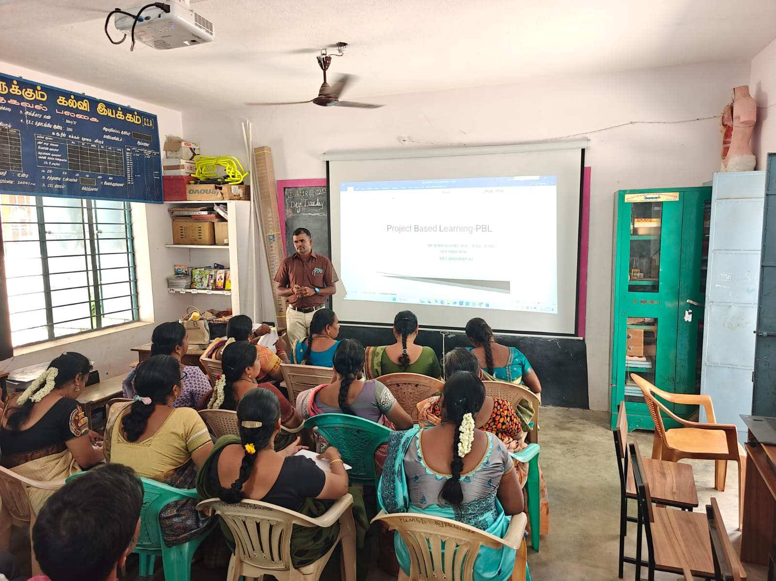
Resource person Explained about PBL Method
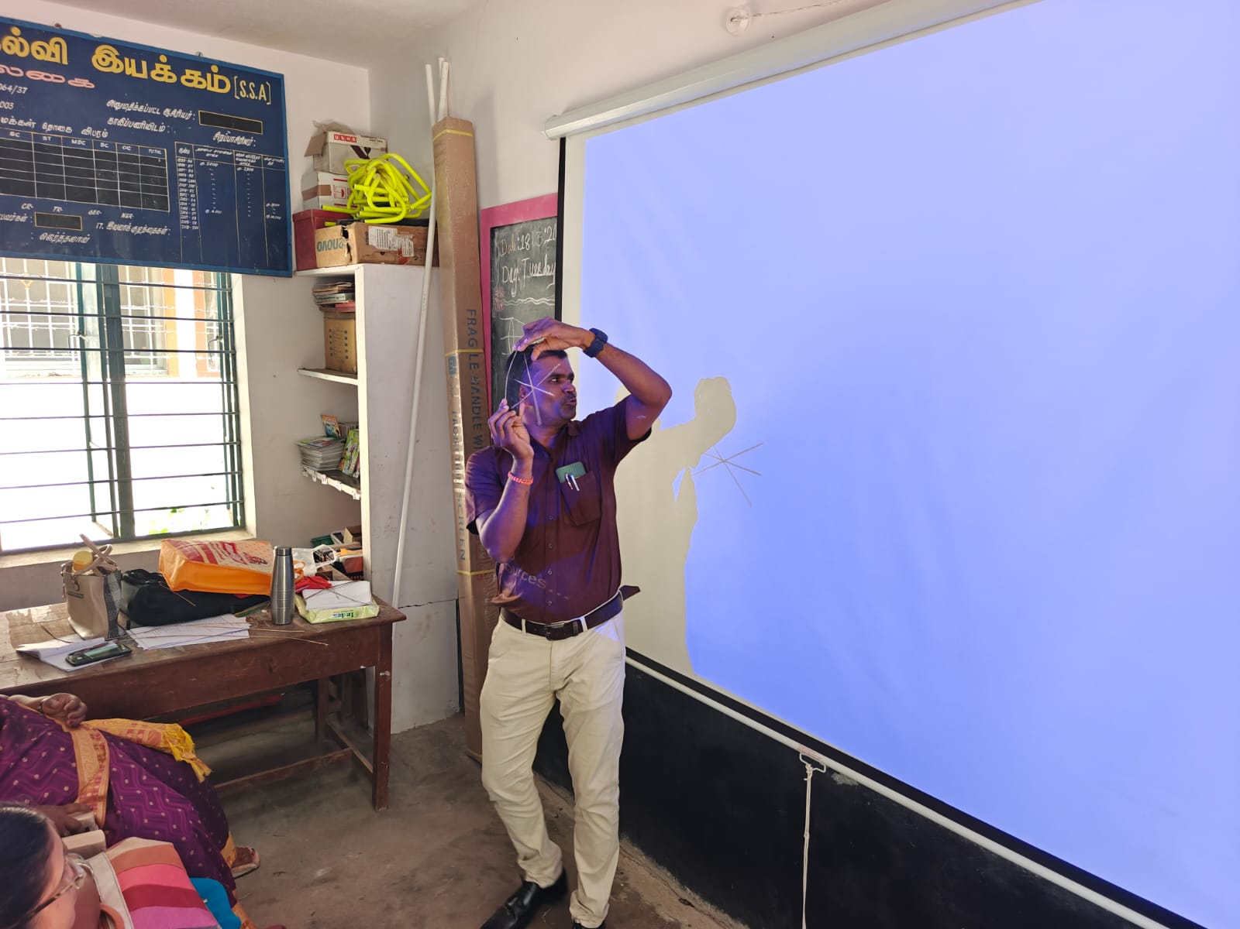
Demonstrated activity

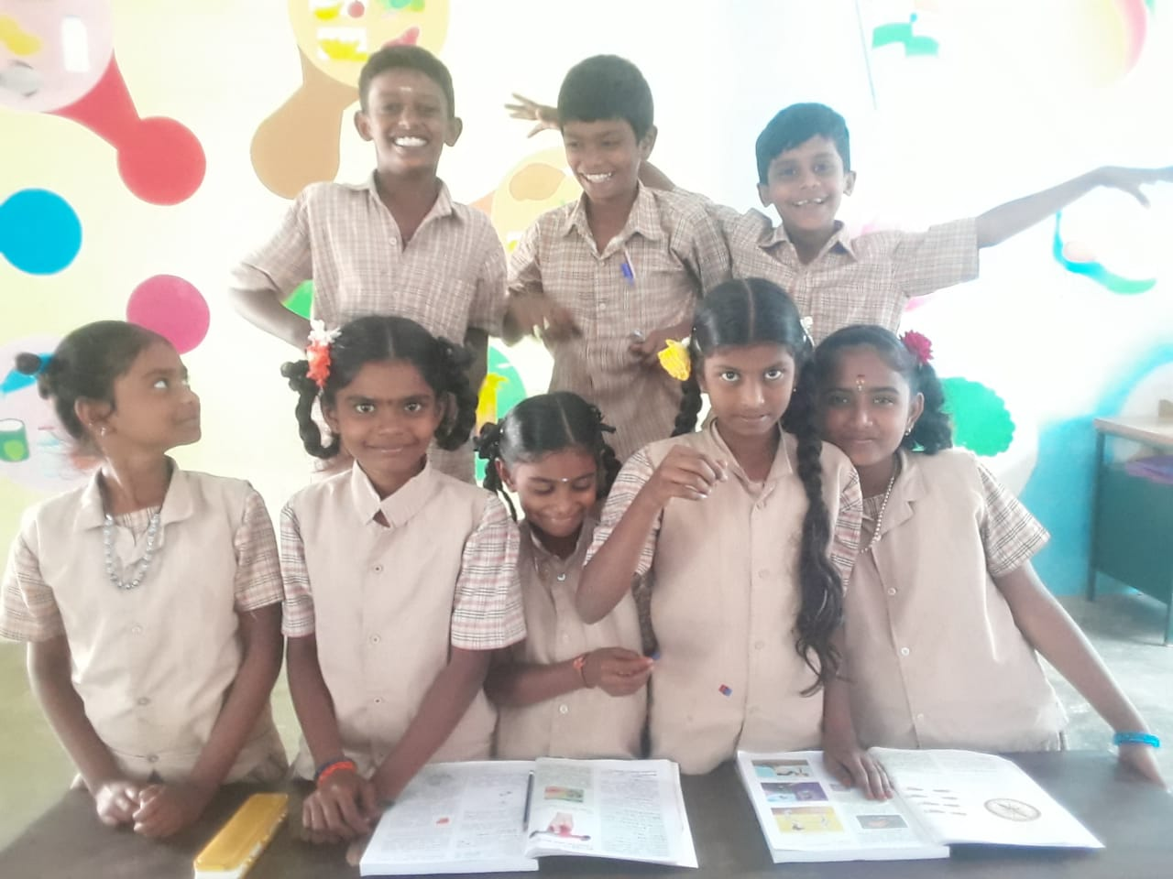

DEMONSTRATED PROJECT- PUMS GUMMANUR
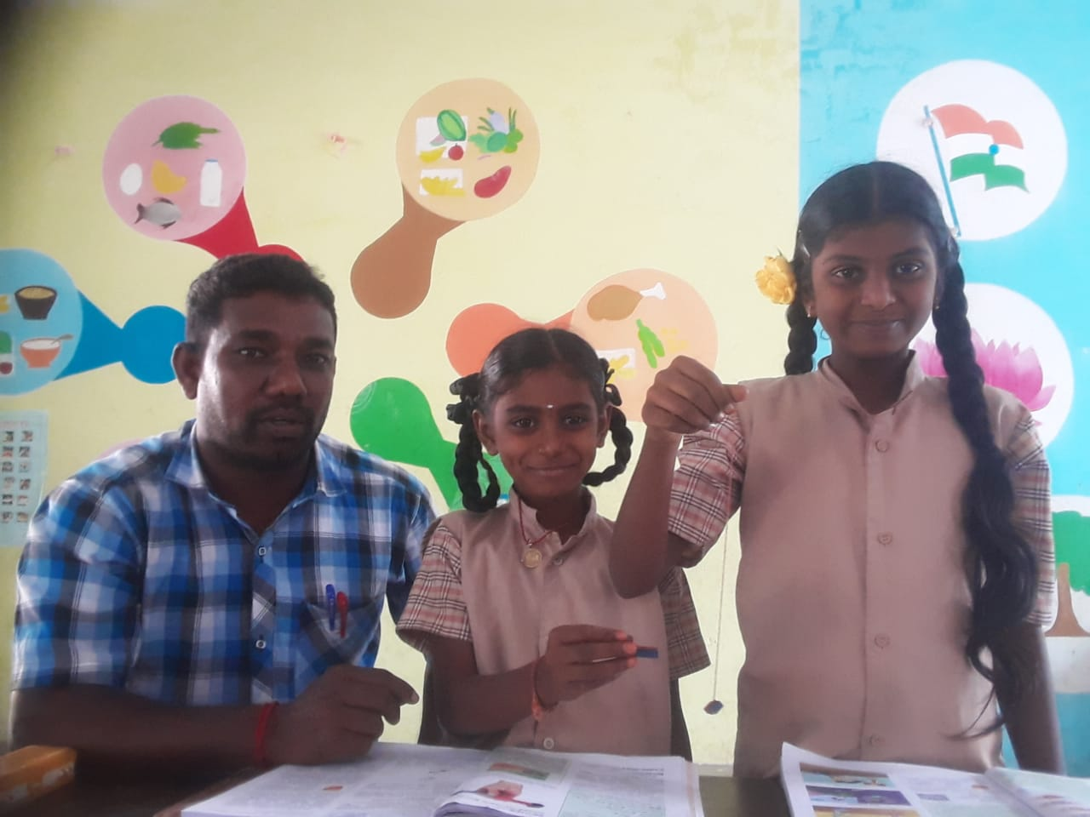

DEMONSTRATED PROJECT- PUMS GUMMANUR

