NAME OF THE RESEARCHER : G.Sasikala
NAME OF THE DIET : Dharmapuri
TITLE: ENHANCING PSYCHOMOTOR SKILL FOR IMPROVING STUDENTS’ WELL-BEING AMONG THE PRIMARY TEACHERS THROUGH SENSORY MOTOR INTEGRATION ACTIVITIES

EVERY EXAGGERATION HAS ITS EFFECT IN THE HUMAN BODY
WALT WHITMAN

1. INTRODUCTION
In all the wonderful work being done in the field of medicine and healing, there is one basic concept that is often dismissed as irrelevant. That is the relationship between the mind and the body, and the possibility that this relationship might have a direct effect on either our state of health or our ability to heal. To understand this body mind connection, we first have to recognise that the mind and body are one. Generally, we regard the body as something that is easily damaged, that needs exercise, regular food and water, a certain amount of sleep and occasional check-ups. There is no separation between what is happening in our minds and what is happening in our bodies. Consider how in the English language we think of someone with great presence as a ‘somebody’, while a person with little significance is a ‘nobody’.
Each part of the body has its own unique function and purpose, and that function corresponds to an aspect of our personality (for instance, our legs are where we express our ability to move, and the direction of that movement). As we experience negativity, the energy associated to that negativity then weakens the area of the body that reflects it, leaving it vulnerable and susceptible to damage or illness. The thought will literally unease the area, thereby causing disease. 'What we put out in thought will always come back and land in the same area where we tightened at that moment,' said Reshad Field in Here to Heal. By understanding the language our bodies are using as they try to tell us what is wrong, we can see the negative thought patterns and attitudes that are being expressed, and we can begin to open ourselves to more positive ones. That will then strengthen the related part of the body, enabling it to build resistance and to begin to heal.
Psychomotor skills play an important role in primary education. Here, learning involves both cognitive and physical activities. Teachers who possess strong psychomotor skills can enhance the quality of their teaching and get positive impacts of the students’ wellbeing. Psychomotor skills include motor coordination, fine motor skills, hand eye coordination and physical movements are essential skills for teachers. Through these skills teachers can demonstrate tasks, develop behaviourism and make the students to engage in classroom learning. However, primary teachers struggle in integrating psychomotor skills into their classroom teaching, it will lead to lack of student engagement and wellbeing.
PSYCHOMOTOR SKILL
Psychomotor is a movement tasks that require both cognitive and motor process. These processes led a person to learn about their surroundings and also able to manipulate the surroundings. Example, A child is learning to hit a baseball, it is a combination of hand eye coordination that allows them to contact the ball with the bat. Through practice the child evaluates how the bat and ball interact. Here, the psychomotor learning takes place.
THE PSYCHOMOTOR DOMAIN TAXONOMY
Bloom’s Taxonomy dates from a 1956 publication by Benjamin Bloom written along with colleague David Krathwohl. In the second principle Leslie Owen Wilson, Ed D., notes that theories on the Psychomotor taxonomies developed out of the work of the two authors on the cognitive and affective taxonomies, the latter of which was developed in 1964. The work underwent a major revision in 2001.
Bloom’s Taxonomy indicates that seven basic skills of the psychomotor are part of the psychomotor domain. Listed from the simplest to the most complex, they are:
- Perception or awareness
- Set
- Guided response
- Mechanism or basic proficiency
- Complex overt response
- Adaptation
- Origination
While each of these psychomotor domain skills are different, they share in common the need for both cognitive and motor skill development. Each also requires practice or experience to master.
The psychomotor domain is sometimes referred to as the kinesthetics domain. It differs significantly from a purely cognitive learning domain where the psychomotor skill set was first described. Physical activities used to support either cognitive or affective functions are not skills that may be labelled purely psychomotor. To label skills as psychomotor, they must clearly have an educational intention whereby some type of growth can occur with repetition. The psychomotor domain includes physical movement, coordination, and use of the motor-skill areas. Development of these skills requires practice and is measured in terms of speed, precision, distance, procedures, or techniques in execution. The seven major categories are listed from the simplest behaviour to the most complex. The Simpson’s and Harrow’s psychomotor domains are especially useful for the development of children and young people, and for developing skills in adults that take people out of their comfort zones like. The Dave’s psychomotor domain is the simplest and generally easiest to apply in the corporate development environment. Both models offer different emotional perspectives and advantages.
This domain is characterized by progressive levels of behaviours from observation to mastery of a physical skill. Several different taxonomies exist.
Simpson (1972) built this taxonomy on the work of Bloom and others
- Perception - Sensory cues guide motor activity.
- Set - Mental, physical, and emotional dispositions that make one respond in a certain way to a situation.
- Guided Response - First attempts at a physical skill. Trial and error coupled with practice lead to better performance.
- Mechanism - The intermediate stage in learning a physical skill. Responses are habitual with a medium level of assurance and proficiency.
- Complex Overt Response - Complex movements are possible with a minimum of wasted effort and a high level of assurance they will be successful.
- Adaptation - Movements can be modified for special situations.
- Origination - New movements can be created for special situations.
Dave (1970) developed this taxonomy:
- Imitation - Observing and copying someone else.
- Manipulation - Guided via instruction to perform a skill.
- Precision - Accuracy, proportion and exactness exist in the skill performance without the presence of the original source.
- Articulation - Two or more skills combined, sequenced, and performed consistently.
- Naturalization - Two or more skills combined, sequenced, and performed consistently and with ease. The performance is automatic with little physical or mental exertion.
Harrow (1972) developed this taxonomy. It is organized according to the degree of coordination including involuntary responses and learned capabilities:
- Reflex movements - Automatic reactions.
- Basic fundamental movement - Simple movements that can build to more complex sets of movements.
- Perceptual - Environmental cues that allow one to adjust movements.
- Physical activities - Things requiring endurance, strength, vigor, and agility.
- Skilled movements - Activities where a level of efficiency is achieved.
- Non-discursive communication - Body language.
The following list is a combination of the above taxonomies

PSYCHOMOTOR DOMAIN
LEVEL | MEANING | EXAMPLE
Observing | Active mental attending of a physical event. | The learner watches a more experienced person. Other mental activity, such as reading may be a part of the observation process.
Imitating | Attempted copying of a physical behaviour. | The first steps in learning a skill. The learner is observed and given direction and feedback on performance. Movement is not automatic or smooth.
Practicing | Trying a specific physical activity over and over. | The skill is repeated over and over. The entire sequence is performed repeatedly. Movement is moving towards becoming automatic and smooth.
Adapting | Fine tuning. Making minor adjustments in the physical activity in order to perfect it. | The skill is perfected. A mentor or a coach is often needed to provide an outside perspective on how to improve or adjust as needed for the situation.

BEHAVIORAL VERBS APPROPRIATE FOR THE PSYCHOMOTOR DOMAIN
- Organizes
- grinds
- handle
- heats
- manipulates
- measures
- mends
- mixes
- operate
- perform
- reach
- relax
- shorten
- sketches
- stretch
- write
DEVELOPMENT OF PSYCHOMOTOR SKILL
Three stages of psychomotor skill are explained below,
Cognitive stage
This stage is characterized by extremely awkward movements. In this stage human beings learning a new skill based on their existing knowledge and they try to develop a ‘big picture’ of what needs to occur. For example, the factory worker in our previous example might move in stops and starts as they learn the new process for interacting with machinery on the factory floor. These halting and inconsistent movements are the result of learning a new task – and needing more practice to do so. At this stage, the factory worker can: observe fellow workers who have mastered the new workflow get instruction from their supervisors even receive instructions from an organizational psychologist All that information is collated into a body of knowledge that will help them work towards making the correct movements in the right sequence. The cognitive stage might be best thought of as a period of huge gains in the performance of psychomotor skills, yet the results are inconsistent. Think of a child learning how to write their name – you might see letters that gain much better form, yet the letters might not be in the correct order.
The associative stage
The movements required to complete a new psychomotor task don’t become automatic until the second stage of psychomotor skill development – the associative stage. This stage is characterized by the conscious performance of the task with much less verbal instruction, yet with small performance gains. Movements might still be: inaccurate, disjointed, awkward. The sequence of movements of a psychomotor skill might take a long time to finish. In other words, the associative stage is all about learning how to perform a new psychomotor skill. Think of the cognitive stage as learning what to do. Using our handwriting example, the associative stage might see the child learning how to string together the precise fine and gross motor movements necessary to write in fluid cursive. The results the child sees will not be perfect by any means. Through much practice, there will be small improvements that will form the basis for accommodating the necessary growth of cognitive and motor skills in the next phase – the autonomous stage.
Final stage -Refinement
This final stage of psychomotor skills development is all about refinement. Not only does someone in this stage develop automatic motor processes, but their cognitive output to complete a psychomotor task is also minimal. In our handwriting example, a child in the autonomous stage will eventually gain the ability to write fluidly without having to think purposefully about what motion they need to do next or what a letter looks like in cursive. Likewise, the child will have a nice, fluid motion that allows them to write in cursive. They will be able to write: words, sentences, paragraphs. They’ll write without long pauses or corrective measures. Now, it’s important to note that these autonomous processes don’t occur at the beginning of the autonomous stage – you don’t enter this stage and automatically have mastery of the skill. Instead, the autonomous stage can take days, weeks, months, or even years to complete, depending on the skill.
FACTORS AFFECT THE DEVELOPMENT OF PSYCHOMOTOR SKILLS
we can discuss these factors in general, First, we have to account for individual differences. Where one person might master a new skill in the workplace, another person with similar experiences and abilities might take much longer to master the same skill. Second, our past experiences must also be considered. Obviously, a worker that has some experience in making complex movements to complete a task is more likely to pick up a new set of complex movements in shorter order than a worker with no experience. Another component of past experience is the amount of practice a person has done. Michael Jordan might be the greatest NBA basketball player of all time, but it wasn’t necessarily because he was the most talented. Instead, he practiced a lot and that practice paid off. Other factors to consider when learning a new psychomotor skill includes, Psychological feedback, or the sensory, emotional, or cognitive information you glean from practicing a new skill. Task complexity, or how cognitively or physiologically taxing the task is. Work distribution, or the relationship between practice and rest, length of practice sessions, and so forth. Motive-incentive conditions, or the combination of motivation and learning that compels one to act. Environmental factors, which might include anything from temperature and humidity to the brightness of lighting to the physical space in which a person is working on a new skill.
MEANING OF SENSORY MOTOR SKILLS
Sensory motor skills refer to the abilities that involve the coordination of the senses i.e., sight, touch, and hearing with muscle movements. These skills are essential for performing everyday tasks that require physical interaction with the environment. Children are not born with fully developed sensory skills, and need to experience new sights, sounds, scents, flavours and textures to develop these skills. In simple terms, sensory motor skills are the ability to take in sensory information and respond with a body movement.

DEFINITION OF SENSORY MOTOR SKILL
Sensory motor skills refer to the coordinated functions of the sensory system like touch, sight, sound, balance, and body awareness and the motor system like movement and muscle control. These skills involve the brain receiving sensory input from the environment and responding with appropriate motor physical actions.

IMPORTANT OF SENSORY MOTOR SKILLS
Sensory motor skills are the foundation of all learning that will take place throughout life. These skills allow children to explore, play, and try more challenging things. If one sensory motor skill fails to develop properly, a child can struggle to continue learning at the same speed as other children their age. For example, if a child struggles with balance or their ability to plan the order of tasks, they may also struggle to develop problem-solving skills. If a child struggles with understanding where their body parts are in space, they may also struggle with learning to write. The toddler years are an important time when sensory motor skills should be developing – toddlers should be putting sensory skills and motor skills together to interact with the world around them. If there are issues in how sensory motor skills are developing, the toddler years are also an important time to work with healthcare professionals and get a child back-on-track for lifelong learning.
EXPLANATION OF SENSORY MOTOR SKILLS:
Sensory motor skills develop from infancy and form the foundation for a child's physical, emotional, and cognitive development. These skills include:
- Gross motor skills : large movements like walking, running, jumping.
- Fine motor skills: smaller movements like writing, buttoning, and cutting with scissors.
- Balance and coordination
- Body awareness
- Hand-eye coordination
These skills rely on input from sensory systems like:
- Visual (seeing)
- Auditory (hearing)
- Tactile (touch)
- Vestibular (balance)
- Proprioceptive (body position)
SENSORY MOTOR ACTIVITIES HELP STUDENTS' WELL-BEING:
Sensory motor activities play a vital role in promoting physical, emotional, and mental well-being in students:
1. Enhances Focus and Attention
Sensory motor activities like jumping, balancing, or squeezing stress balls help regulate sensory input and improve concentration in the classroom.
2. Reduces Anxiety and Hyperactivity
Movements like swinging, crawling, or deep pressure exercises calm the nervous system, reducing stress and improving behaviour.
3. Supports Emotional Regulation
Activities involving sensory feedback help students become more aware of their emotions and better manage them.
4. Improves Academic Performance
When sensory and motor systems work efficiently, children can sit still, write legibly, and participate more fully in classroom tasks.
5. Boosts Confidence and Social Interaction
Children who feel in control of their body and movements tend to engage better with peers and take part in group activities.
6. Develops Physical Health
Sensory motor activities build strength, flexibility, coordination, and endurance—key elements of overall health.
MOTOR SKILLS
A motor skill is a specific movements of body muscles to performing certain task, like walking, running and riding.
FINE MOTOR SKILLS
Fine motor skills are the small, precise movements we make with our hands, fingers, feet and toes. They involve the complex coordination of your muscles, joints and nerves. We mainly think of hand, wrist and finger movements when it comes to fine motor skills, like picking up an object by pinching it with your pointer finger and thumb. But you can also make fine movements with your foot, ankle and toes. These motions are necessary for sports, like dancing and soccer, or for people who use their feet for tasks instead of their hands.
GROSS MOTOR SKILLS
Gross motor skills are the foundation for all movement and include the larger movements of arms, legs, feet, or the entire body such as running, jumping and ball activities. They enable children to explore their environment, participate in learning opportunities and form the basis for all physical activity. Gross motor skills are developed throughout childhood and adolescence, typically through regular active play. As with all areas of child development, children develop these skills at different rates and some require more support than others.
Gross motor skills which are crucial for day-to-day work, sports, and physical fitness like jumping, throwing, catching, kicking, and hitting. In gross motor skills larger muscle groups to perform activities. When we involve smaller muscles, particularly those in the hands and fingers, for precise and delicate tasks, we are using fine motor skills. These skills involve the use of small muscles to write, sketch, draw, pick up small objects, grip, and pinch. Basic motor movements involve both gross and fine motor skills. Encourage your child to be physically active. Sports which help strengthen muscles include swimming, cycling, martial arts, tennis and gymnastics.

BALANCE AND COORDINATION
Balance and coordination in sensory-motor integration activities refer to how the brain and body work together to control movement, maintain posture, and perform tasks smoothly and efficiently. These are foundational abilities that support everything from walking to writing, playing sports, or even sitting still.
BODY AWARENESS
Body awareness is an important component of sensory motor skills. It refers to the ability to understand where your body is in space, how it moves, and how different body parts relate to each other. It helps individuals to recognize their body position, control movements, and interact efficiently with the society or environment.
HAND-EYE COORDINATION
Hand-eye coordination is a vital part of sensory motor skills, it involves the ability to process visual information and used it to guide for hand movements. It allows us to perform tasks where the eyes and hands must work together efficiently and accurately.
THE WAY TO DEVELOP STUDENTS SENSORY MOTOR SKILLS
• Frequent practice - Offer your child regular opportunity to practice their motor skills through active play, physical activity and sporting opportunities. Encourage your child to try some of the suggested activities included in this information sheet.
• Make the practice fun and offer lots of specific praise. Stop when your child is tiring or losing motivation.
• Make the practice purposeful. Discuss with your child what skills they would like to develop so they are motivated to practice. Help set goals/challenges related to those specific skills. Can they beat their personal best?
• Just right challenge. Try to find the level for your child where they are being challenged, but also managing to succeed and progress, allowing them to gain confidence in their motor skills. When your child has mastered the movement, they have been working on, encourage them to set new achievable goals progressing on to the next level.
• Motor learning. You can support your child by encouraging them to think about how they can break down a skill into manageable steps. You can also help by ensuring that they are allowed the time they need to plan their movements and to practice new skills frequently. Once your child has learned a new skill (i.e. catching a ball) help them to consolidate the skill by encouraging them to practice in different contexts ( i.e. with a different ball, catching while moving, as part of a team game)
• Lead by example - Make active choices for your family.
• Always think safety first! Please ensure that activities that you choose are safe and appropriate for your child’s ability and understanding.
2.BACKGROUND OF THE ACTION RESEARCH
In recent years, there has been growing awareness about the importance of holistic development in primary education. Among the different learning domains i.e., cognitive, affective, and psychomotor. Here, the psychomotor domain is often under-emphasized, despite its vital role in shaping a child’s overall development. Psychomotor skills involve physical movement, coordination, strength, and motor control, which are essential for academic readiness, emotional regulation, and daily functioning in children. However, most of the primary teachers, however, lack in structured training on incorporating sensory motor activities into their daily teaching practices. This gap often leads to missed opportunities for enhancing students’ physical and emotional well-being, especially children with aggressive or hurtful behaviour, attention seeking behaviour, learning difficulties, developmental delays, or behavioral challenges. It is the need to bridge the gap between theory and practice in child development. And also, it is important to equip teachers with practical strategies to support sensory-motor integration-based development, especially during the primary stage these skills are rapidly developing and deeply influential in shaping lifelong learning behaviours. This action research is to explore how targeted sensory motor activities, when systematically implemented by the trained primary teachers, can result in measurable improvements in students’ psychomotor abilities and well-being and making the classroom a more inclusive, engaging, and developmentally supportive environment.
3.IDENTIFICATION OF THE PROBLEM
In many classrooms’ teachers may not exploit or develop psychomotor skills to enhance student well-being. Due to this action, result in limited physical activities, students are not able engage in classroom tasks. When teachers stick on in teaching without physical activities students felt boredom. Instead of incorporating movements in teaching keeps the students engaged and retain the content more. Most of the researchers identified that lack of hands-on physical engagement affects students' emotional health. Providing proper guidance of psychomotor skills reduces stress, enhance cognitive function and improve their behaviour. This action research proposal aims to enhance the professional development of teachers by focusing on empowering students with better psychomotor skills to ensure in more engaging and create supportive learning environment.
During on our regular school visit it was observed that few students in each classroom disturbs the teacher through disruptive behaviour. Disruptive behaviour among students in primary classrooms is a common challenge faced by teachers. This behaviour can include talking or shouting out without permission, not following instructions, distracting peers, constantly getting out of their seat, seeking to gain attention inappropriately. Such disruptions not only hinder the learning process for the student involved but also affect the focus and progress of the entire class. These behaviours may be influenced by factors such as lack of attention at home, learning difficulties, or classroom environment. Addressing disruptive behaviour effectively requires a combination of patience, positive reinforcement, clear expectations, and consistent classroom management strategies.

4.NEED FOR THE ACTION RESEARCH
Psychomotor skills contribute emotional, physical and cognitive development of students through teachers. It is essential for primary teachers to enhance student well-being through psychomotor skills. If teachers are equipped with psychomotor skills and puts them into practice from primary education leads to discipline such as daily development of the students. Enhancing these skills in teachers can lead to more classroom management, increased student participation and improved student learning.
5.STATEMENT OF THE PROBLEM
Students exhibit challenges in coordination, focus, and motor skills due to insufficient sensory-motor stimulation in the learning environment. Addressing this can enhance their overall well-being and learning outcomes. This action research entitled “ENHANCING PSYCHOMOTOR SKILL FOR IMPROVING STUDENTS’ WELL-BEING AMONG THE PRIMARY TEACHERS THROUGH SENSORY MOTOR INTEGRATION ACTIVITIES”
6.OBJECTIVES OF THE ACTION RESEARCH
1.To assess the level of psychomotor skills among primary teachers.
2. To practice fine and gross motor skills activities.
3. To provide mind and body coordination activities to primary teachers.
4.To train primary school teachers to implement sensory motor integration activities effectively in their classrooms.
5. To prepare a module based on psychomotor skill
7. PROBABLE CAUSES OF THE PROBLEM
- Lack of professional development opportunities for teachers focused on psychomotor skills.
- Insufficient understanding of the importance of psychomotor skills in the learning process.
- Teachers concentrate on teaching methods.
- Limited time allocation for physical activities.
8. ACTION HYPOTHESES
Providing psychomotor skills to primary teachers through targeted interventions would improve as a result of increased engagement, motor skill development and physical health in the classroom.
8.INTERVENTIONS

A practitioner developed a specialized module in psychomotor skills based on “A package on C-Square for Primary teachers”, which C emphasizes “Coordination and Concentration’. Based on the module practitioner conducted one day training to primary teachers to develop skill in preparing sensory-motor activities, such as balance exercises, coordination tasks, and fine motor skill games, integrated into their daily classroom routines.

9. METHODOLOGY
This action research would adopt a single group experimental design for the development of students through teachers before and after interventions.
a. SAMPLE
The sample included 20 primary school teachers from Pennagaram block of Dharmapuri district.
b. RESEARCH DESIGN
A pre-test and post-test design with intervention was conducted to assess changes in psychomotor skills and well-being.
c. DESCRIPTION OF THE RESEARCH TOOL
Practitioner prepared a self-reliant questionnaire consisting of 20 multiple choice questions. This questionnaire was used to assess primary teachers’ knowledge in the usage of psychomotor skill in classroom activities. Through the responses from teachers would get clear idea in providing intervention strategies through proper training. The questions were framed on the areas like Gross motor skills, Fine motor skills, Balance and coordination, Body awareness and Hand-eye coordination
d. DESCRIPTION OF RESEARCH PROCESS
DATA COLLECTION
In this action research data was collected after questionnaires have been completely designed. The designed data was given to 20 primary school teachers for both pre-test and post-test. Based on the pre-test practitioner prepared to provide training to primary teachers.
INTERVENTIONS

A practitioner provided one day training based on the prepared module in psychomotor skill named as “A package on C-Square for Primary teachers”, which C emphasizes “Coordination and Concentration’. Practitioner integrated a series of structured sensory motor activities in the module which aimed at improving fine and gross motor skills, mind and body coordination, body balance, timing, and attention control. Module consist of step by step instructions, demonstrations and practicing activities for students and teachers. Emphasis was given on observation, imitation and repetition to ensure mastery of the skills.
Activities given in the module are as follows,
1.Basic motor activities
2.Hand-eye and leg-eye coordination activity
3.Eye coordination activity
4.Brain Gym activity
5.Aroma memory activity

DATA ANALYSIS
Questionnaire was given by the practitioner before and after intervention. The questionnaire contains 20 items to check teachers understanding level about the topic. Based on their performance pre-test and post test score was analysed. For this action research Mean score analysis was used to interpret pre-test and post-test score.

Table-1
SL.NO | NAME OF THE TEACHER | PRE-TEST SCORE | POST-TEST SCORE | PRE-TEST SCORE | POST-TEST SCORE
SL.NO | NAME OF THE TEACHER | OUT OF 20 |  | OUT OF 100
1 | Mrs.R.Usha Nandhini  PUPS,Pennagaram | 7 | 12 | 35 | 60
2 | Mrs.P.Manimala  PUMS Balinjirahalli | 9 | 13 | 45 | 65
3 | Mrs.A.Sasikala  PUPS Pauparapatti | 6 | 17 | 30 | 85
4 | Mrs. K.Nirmaladevi  PUMS A.Papparapatti | 9 | 18 | 45 | 90
5 | Mrs.M.Salammal  PUMS Nallappanayakkanahalli | 4 | 11 | 20 | 70
6 | Mrs.V. Indira  PUMS Thotlanahalli | 3 | 13 | 30 | 65
7 | Mrs.R.Devi  PUPS Thirumalvadi | 5 | 10 | 25 | 50
8 | Mrs.B.Shibani  PUPS,Periyur | 6 | 12 | 30 | 60
9 | Mrs.R.Gayathri  PUMS A.Ettiyampatti | 3 | 15 | 15 | 75
10 | Mrs.E.Ambika  PUMS Nagadasampatti | 7 | 16 | 35 | 90
11 | Mrs.A.Thilagavathi  PUMS Chinnapallathur | 9 | 15 | 45 | 75
12 | Mrs.T.Ambika  PUMS Nallampatti | 3 | 10 | 15 | 50
13 | Mr.S.Kamaraj  PUMS Velampatti | 5 | 10 | 25 | 50
14 | Mr.S.Ranjith kumar  PUMS Naganoor | 7 | 13 | 35 | 65
15 | Mr.Suresh  PUMS Bikkampatti | 8 | 17 | 40 | 85
16 | Mrs.R.Krishnakumar  PUPS Bharathipuram | 5 | 11 | 25 | 55
17 | Mr.M.Prabu  PUMS Thithiyoppanahalli | 5 | 14 | 25 | 70
18 | Mrs. Pagutharivu  PUPS Pennagaram | 5 | 12 | 25 | 60
19 | Mrs.G.Sasikumar  PUPS P.Gollapatti | 9 | 18 | 45 | 90
20 | Mrs.R.Deepa  PUMS Kadamadai | 8 | 18 | 40 | 90
TOTAL |  | 117 | 281 | 625 | 1363

10.ANALYSIS AND INTERPRETATION

TABLE - 2
Mean score level of significance achievement in the Pre-test and Post test

S No | Testing | Teachers | Mean
1. | Pre-test | 20 | 31.25
2. | Post-test | 20 | 68.15

The scores of pre-test was 31.25 and post-test was 68.15 were analyzed quantitatively and qualitatively to arrive at conclusions. After the intervention strategies, it was observed that the performance in the post test was comparatively better. The following graphs show the teachers improvement after the intervention Strategies.

FIGURE -1
ACHIEVEMENT LEVEL OF TEACHERS IN PRETEST AND POSTTEST

11.FINDINGS OF THE ACTION RESEARCH
After the intervention strategies, it was observed that the performance in the post test was comparatively better.
1. Sensory motor integration activities significantly improved students' coordination, balance, and fine motor skills.
2. Students participating in these activities demonstrated increased focus, better academic engagement, and reduced behavioral issues.
3. Teachers who were trained to implement these activities reported a higher level of confidence and competence in addressing students’ developmental needs.
4. A structured approach to sensory motor integration helped create a more inclusive and engaging learning environment.
5. In this action research, intervention strategies highlighted its effectiveness as a tool for emotional resilience and mental clarity.
12. NET GAIN OF THE ACTION RESEARCH
1.Teachers those who have undergone this experience has gained practical knowledge about sensory motor strategies.
2.Teachers reported that students who participated in sensory motor activities showed, increased involvement in academic tasks.
3. Teachers noticed that students with behavioural disruptions are cooperative during both learning and playtime.
4. The treatment period for teachers and students of the school concerned to take special care on understanding of student participation and classroom management to teachers.
13.EDUCATIONAL IMPLICATION OF THE ACTION RESEARCH
1. Incorporating sensory motor integration activities into the school curriculum can help promote holistic development.
2. Regular workshops and professional development programs should be conducted to equip teachers with the necessary skills and knowledge.
3. These activities can benefit students with developmental delays or learning disabilities, fostering inclusivity in classrooms.
4. Engaging students in sensory motor integration activities can lead to better classroom dynamics and increased participation.
14.RECOMMENDATIONS
1. Schools should adopt a structured program for sensory motor integration activities as part of their daily schedule.
2. Government and educational policymakers should prioritize teacher training in sensory motor integration techniques.
3. Collaboration with experts in child development and occupational therapy can enhance the effectiveness of these programs.
4. Further research should be conducted to explore the long-term impact of these activities on students’ academic and personal growth.
15.CONCLUSION
Enhancing psychomotor skills through sensory motor integration activities is a crucial step toward improving the well-being of primary school students. By empowering teachers with the right tools and techniques, schools can create a more nurturing and effective learning environment. This action research underscores the importance of integrating physical, cognitive, and sensory development strategies into education, paving the way for a more comprehensive approach to child development.
The C- Square package— C standing for Coordination and Concentration is a structured framework designed to enhance focus and collaborative efficiency in action research settings. This package emphasizes the dual pillars of successful inquiry-based practice in mind, eye and hand coordination and the sustained mental engagement of participants concentration. By fostering clear communication channels and shared ideas in coordination ensures that all students are moving in harmony toward a common research goal. Simultaneously, the concentration component nurtures individual and collective focus, promoting deep engagement with data, reflection, and improvement. C-Square thus, serves as a dynamic tool to streamline action research processes, enabling practitioners to address complex problems with clarity and cohesion.Sensory motor skills are essential building blocks in a child’s growth. By engaging in sensory motor activities, students develop not only physical abilities but also emotional stability, better behavior, and academic readiness. Schools and parents should incorporate sensory motor tasks daily to support children’s holistic well-being.
BIBLIOGRAPHY
1.Action Research in Education: a call for action., B.William Dharma Raja, V.Sasikala.
2. Binta Muhammad Yarinchi Challenges of Implementing Psychomotor Skills in Teaching and Learning in Tertiary Institutions in Katsina State: A Case Study of The Department of Educational Psychology, Isa Kaita College Of Education Dutsin-Ma, Katsina State. International Journal of Innovative Psychology & Social Development 12 (2):25-30, April-June, 2024
3. Body Mind workbook., Debbie Shapiro
4. Bloom’s Revised Taxonomy: Cognitive, Affective, and Psychomotor
5. R. J. Armstrong et al., Developing and Writing Behavioral Objectives (Tucson, AZ: Educational Innovators Press, 1970).
6.Harrow, A.J. (1972). A taxonomy of the psychomotor domain. New York: David McKay Co.
7. Manual of Early Childhood Education. Arti Sinha
8.Occupational Therapy Tips, Demonstration Project on In-school and Early Years Therapy Support.

9.Sensory Strategies for the Older Child and Adolescents. Children’s Therapy Department, Children’s Centre, Damers Road, Dorchester.
10.Simpson, E. (1972). The classification of educational objectives in the psychomotor domain: The psychomotor domain. Vol. 3. Washington, DC: Gryphon House.

ANNEXURE – 1 RESEARCH TOOL
மாவட்ட ஆசிரியர் கல்வி மற்றும் பயிற்சி நிறுவனம், செட்டிக்கரை – 636704 தருமபுரி
பெயர் :
பள்ளியின் பெயர்:
நேரம் :
மதிப்பெண் : 20
கீழே கொடுக்கப்பட்டுள்ள வினாக்களை படித்து உரிய பதிலுக்கு நேராக (√) குறியிடவும்
1. உடல் இயக்க செயல்பாடுகள் மூலம் அறிவாற்றல் திறனை மேம்படுத்த எந்த பயிற்சி உதவுகிறது.
அ). சைகை மொழி பயிற்சி
ஆ). கண் ஒருங்கிணைப்பு பயிற்சி
இ) பலூன் பயிற்சி
ஈ). மேற்கண்ட எவையும் இல்லை

2.அறிவாற்றல் திறனை மேம்படுத்த கீழ்கண்ட எந்த பயிற்சி உதவுகிறது
அ) நடத்தல் ஓடுதல் மற்றும் தசை பயிற்சி
ஆ) தொடர்ச்சியாக படித்தல்
இ) தொடர்ச்சியாக எழுதுதல்
ஈ) மேற்கண்ட எவையும் இல்லை

3.நம் பாதங்களில் உள்ள விரல்களின் அடிப்பகுதியை அழுத்துவது மூலமாக நினைவாற்றலை அதிகரிக்க முடியும் எனில் இது எத்தகைய மருத்துவ முறையை சுட்டிக் காட்டுகிறது
அ) ஹோமியோபதி
ஆ) அக்குபஞ்சர்
இ) ரிப்லேக்ஸ்சாலஜி
ஈ) நாட்டு மருத்துவம்

4.உங்களுடைய வகுப்பறையில் எந்த வகையான சைக்கோ மோட்டார் செயல்பாடுகளை பயன்படுத்துகிறீர்கள்
அ) அடிப்படை நுண்ணியக்க செயல்பாடு
ஆ) மூளை ஒருங்கிணைப்பு பயிற்சி
இ) அசைவுகள் சார்ந்த பயிற்சி
ஈ) மேற்கண்ட எதுவுமில்லை

5.உங்களது பள்ளியில் உள்ள மாணவர்களின் புலன் இயக்க செயல்பாடுகளை மேம்படுத்த உங்களுக்கு எவ்வகையான உதவி தேவைப்படுகிறது
அ) அதிகப்படியான கற்றல் கற்பித்தல் பொருட்கள்
ஆ) நிர்வாக ரீதியிலான உதவி
இ) திறன் மேம்பாட்டு பயிற்சி
ஈ) இவற்றில் எதுவுமில்லை

6.சூப்பர் பிரைன் யோகாவை தினமும் செய்யும்போது எவ்வகையான மாற்றம் அதிகமாக காணப்படும்
அ) உடல் அளவில் மாற்றம்
ஆ) உடலில் வலி அதிகரித்தல்
இ) குறைவான தூக்கம் ஏற்படுதல்
ஈ) நினைவாற்றல் மற்றும் கவனத்திறன் மேம்பாடு அடைதல்

7.இவற்றில் எந்த படிநிலைகளை பயன்படுத்தி குழந்தைகள் பென்சில் அல்லது பேனாவை வசதியாகவும் மற்றும் வேகமாகவும் பிடித்து எழுத கூடியதாக அமைகிறது
அ). நிப் பிளிப், கிரிப்
ஆ) பிளிப், கிரிப், நிப்
இ) கிரிப், நிப், பிளிப்
ஈ) பிளிப், நிப், கிரிப்

8. இவற்றில் பெருந்தசை இயக்க திறன் செயல்பாடுகள் எவை
அ) எழுதுதல்
ஆ) கத்திரிக்கோலை பயன்படுத்துதல்
இ) பந்தை உதைத்தல் உதைத்தல்
ஈ) பலூன் தட்டுதல்

9. ஒரு செயல்பாட்டை அல்லது பணியை செய்யச் மூளையின் இரு பக்கங்களை இணைத்து சேர்ந்து செயல்படும் பயிற்சியை எவ்வாறு அழைக்கிறோம்.
அ) இருபக்க உடற்பயிற்சிகள்
ஆ) இருபக்க மூளை செயல்பாடு
இ) இருபக்க தூண்டுதல்
ஈ) இவற்றில் எதுவுமில்லை

10. எத்தனை செயல்முறைகளை உள்ளடக்கியது கண் ஒருங்கிணைப்பு பயிற்சி
அ) ஒரு செயல்முறைகளை உள்ளடக்கியது
ஆ) இரண்டு செயல்முறைகளை உள்ளடக்கியது
இ) மூன்று செயல்முறைகளை உள்ளடக்கியது
ஈ) நான்கு செயல்முறைகளை உள்ளடக்கியது

!1. ஆங்கில எழுத்துக்களில் எந்த எழுத்துக்களை பயன்படுத்தி கண்விழிகளை நகர்த்தி வரையும் பயிற்சியை மேற்கொள்கிறோம்.
அ) E
ஆ) B
இ) N
ஈ) X

12. அணிநடைப் பயிற்சியின் முக்கியத்துவத்தை நீங்கள் எவ்வாறு மதிப்பிடுகிறீர்கள், இது தனிநபரின் ஒட்டுமொத்த வளர்ச்சிக்கு எவ்வாறு பங்களிக்கிறது,
அ) இது ஒழுக்கத்தையும் நேர நிர்வாகத்தையும் மேம்படுத்துகிறது,
ஆ) இது உடல் வலிமையையும் மன வலிமையையும் வளர்க்கிறது,
இ) இது ஒரு ஒருங்கிணைந்த ஆளுமையை உருவாக்குகிறது மற்றும் நல்ல தோற்றத்தை அளிக்கிறது.
ஈ) மேற்கூறிய அனைத்தும்

13. ஐந்து புலன் உறுப்புகளில் எதனை அடிப்படையாக கொண்டு சிந்தனை தொப்பி செயல்பாட்டினை மேற்கொள்கிறோம்.
அ) கண்
ஆ) காது
இ) மூக்கு
ஈ) வாய்

14.சைக்கோ மோட்டார் டோமைனில் உள்ள எந்த நிலை உடல் இயக்க செயல்பாடுகளை வலியுறுத்துகிறது
அ) நிலை ஒன்று
ஆ) நிலை இரண்டு
இ) நிலை மூன்று
ஈ) நிலை நான்கு

15. ஒரு விளையாட்டு வீரர் அல்லது ஒரு அவசரநிலை பணியில் உள்ள ஒருவருக்கு எதிர்வினைப் பயிற்சியின் பயன்கள் என்னவாக இருக்கலாம்?
அ) இது சிக்கலான சூழ்நிலைகளில் விரைவாகவும் துல்லியமாகவும் செயல்பட உதவுகிறது.
ஆ) இது உடல் ஆரோக்கியத்தை மேம்படுத்துகிறது மற்றும் காயங்களைத் தடுக்கிறது.
இ) இது மன அழுத்தத்தை குறைக்கிறது மற்றும் ஒருமுகப்படுத்துதலை அதிகரிக்கிறது
ஈ) மேற்கூறிய அனைத்தும் சரி

16. ஆழ்நிலை தியானப்பயிற்சியில் ஈடுபடும்போது நமது உடலிலிருந்து வெளிப்படக்கூடீய கதிரின் பெயர் என்ன?
அ) ஏ சி
ஆ) ஏ இ
இ) பி ஏ
ஈ) ஏ பி

17. மற்றயோகாசனங்களுடுன் ஒப்பிடும்போது வஜ்ராசனத்தின் தனித்துவமான அம்சம் என்ன?
அ) இது மற்ற ஆசனங்களைவிட கடினமானது
ஆ) இது மூச்சு பயிற்சிக்கு ஏற்ற ஆசனம்
இ) இது உணவு உண்ட பிறகு செய்வதால் வயிற்றுக்கு அதிக அழுத்தம் கொடுக்காமல் செரிமானத்தை ஊக்குவிக்கிறது.
ஈ) மேற்கூறிய அனைத்தும் தவறு

18. உடலின் பல உறுப்புகளை ஒரே நேரத்தில் ஒருங்கிசைவுடன் இயக்குவதற்கான திறனை “ஒருங்கிணைப்பு“ என்று வரையறுக்கிறோம் இந்த திறன் விளையாட்டு வீரர்களுக்கு ஏன் முக்கியமானது.
அ) அவர்களின் உடல் வலிமையை அதிகரிக்கிறது
ஆ) அவர்களின் அசைவுகளை அழகாக காட்டுகிறது
இ) அவர்களின் மனஅழுத்தத்தை அதிகரிக்கிறது
ஈ) அவர்களின் புகழ் மற்றும் வருமானத்தை அதிகரிக்கிறது

19. குதிகால் நடைப்பயிற்சியினால் கணுக்காலில் உள்ள தசைகள் மற்றும் தொடையை வலுப்படுத்துகிறதால் மற்ற பயிற்சி முறையிலிருந்து எவ்வாறு வேறுபடுகிறது.
அ) உடலின் எடையை ஒரு குறிப்பிட்ட பகுதியில் மட்டும் தாங்கச் செய்வதன் மூலம் தசைகளை வலுப்படுத்துகிறது
ஆ)மற்ற பயிற்சிகளை விட குறைவான அழுத்தத்தை மூட்டுகளுக்கு கொடுக்கிறது,
இ) (அ) மற்றும் (ஆ) இரண்டும் சரியான பதில்
ஈ) (அ) மட்டும் சரியான பதில்

20. தொடக்கநிலை மாணவர்களுக்கு சைகை மொழியை கற்றுக்கொடுப்பதன் முக்கிய நோக்கம் என்னவாக இருக்கும் என்று கருதுகிறீர்கள்.
அ)வேகமாக தகவல்களை பரிமாறிக்கொள்வது
ஆ)கேட்கும் திறன் இல்லாதவர்களுடன் தொடர்பு கொள்வது
இ) இரகசியமாக பேசுவது
ஈ) மேற்கூறிய அனைத்தும்

Annexure- 2 Photos on AR and its Interventions

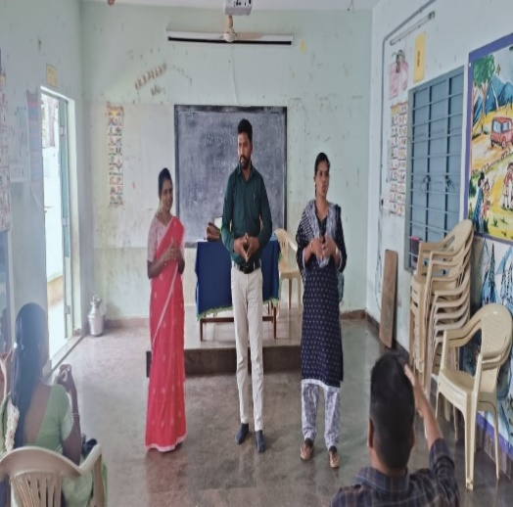

Action Research intervention training to Pennagaram block teachers

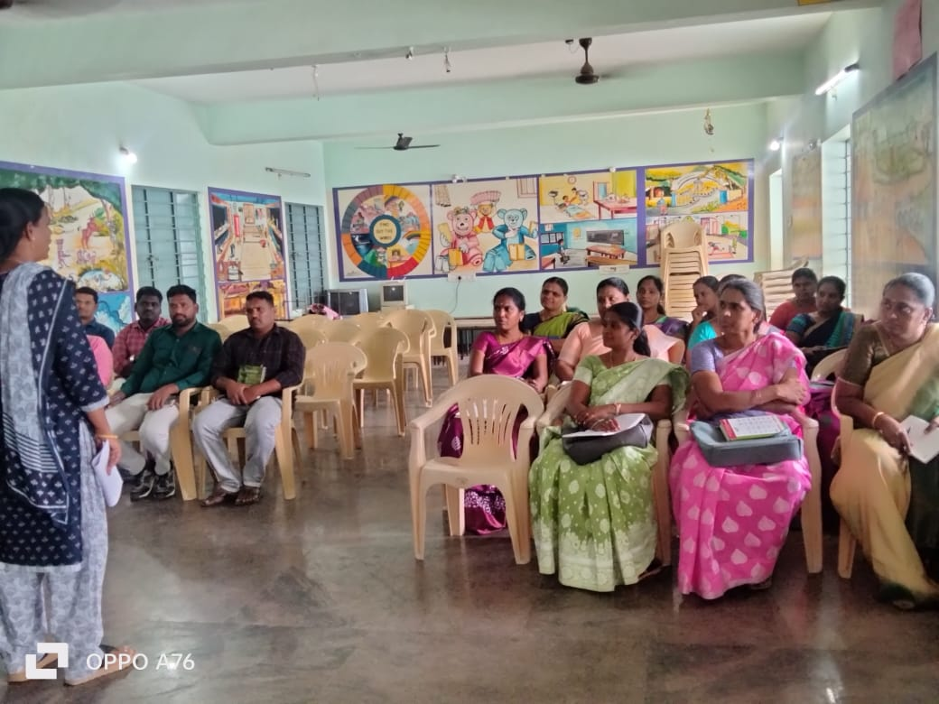

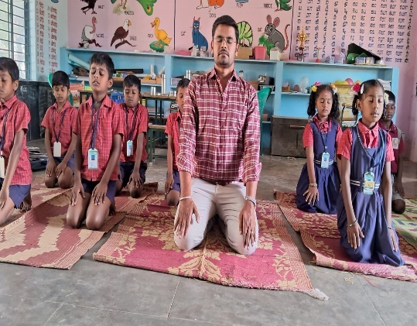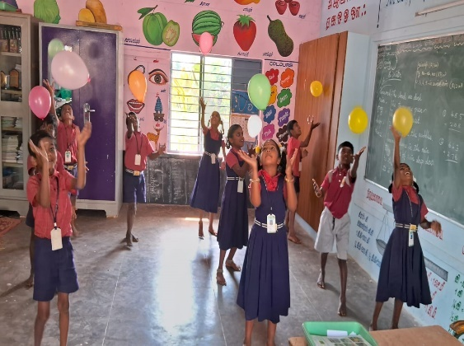

Teachers providing sensory motor skill activities to students

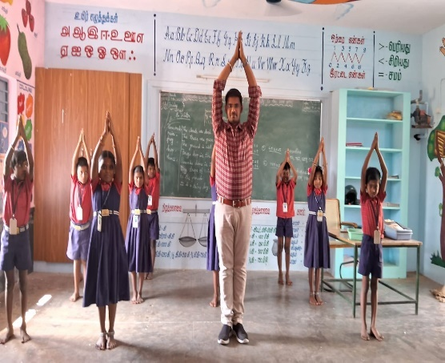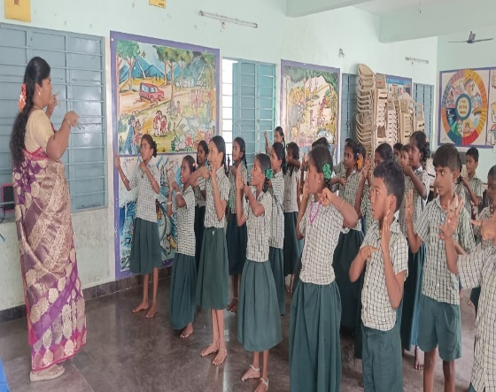

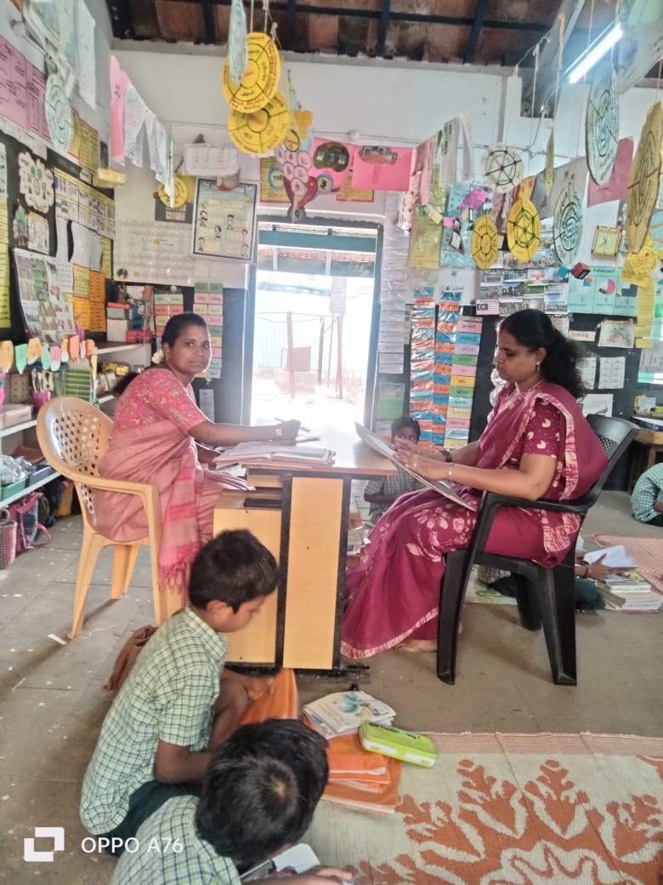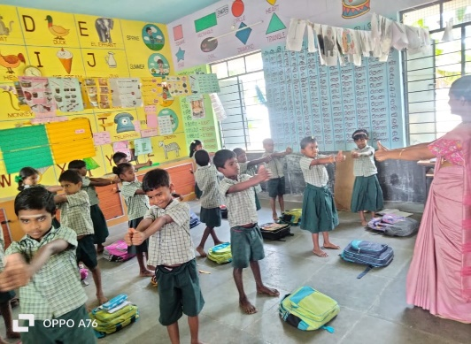
Followup by practitioner in schools

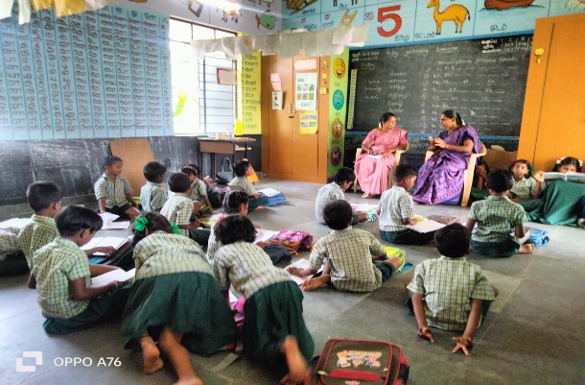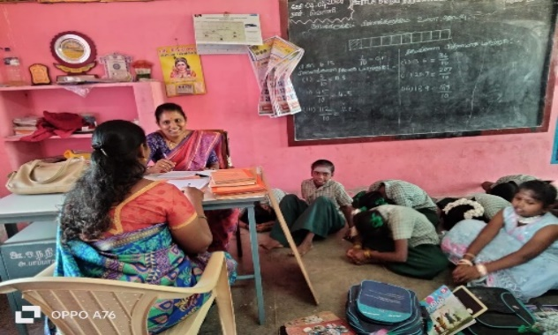

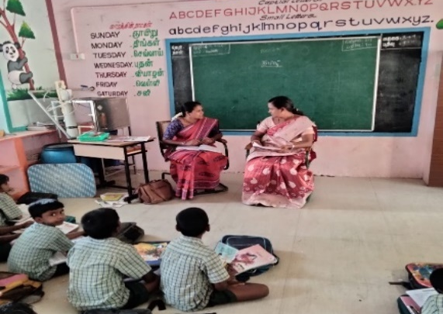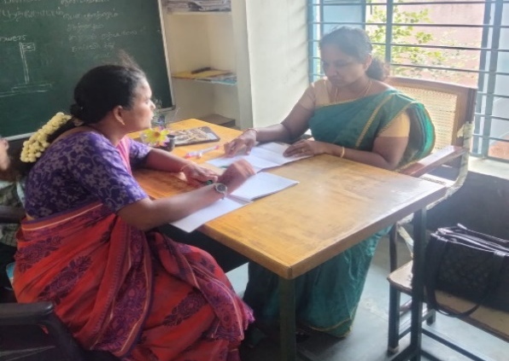

Followup by practitioner in schools

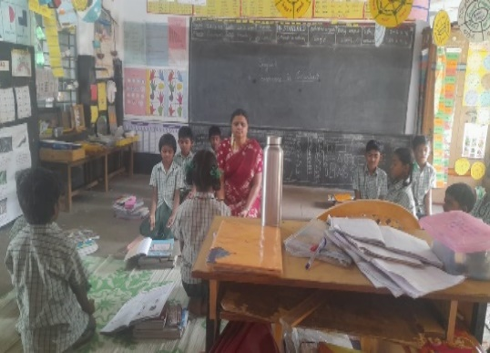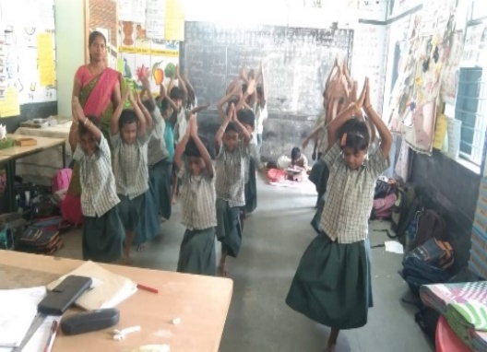
Teachers and students practising the sensory motor skill activities

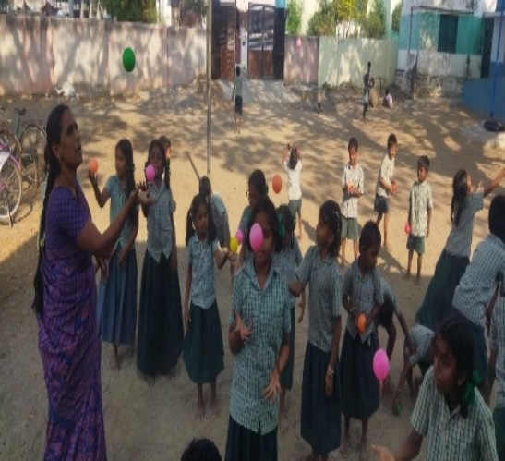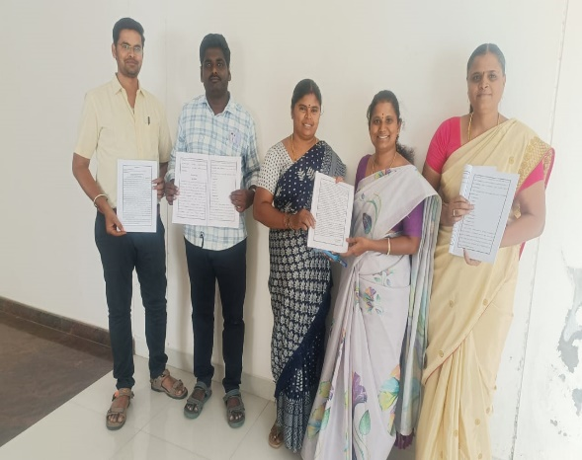
Psychomotor skill based training module provided to teachers

