Action Research Report
Name of the Action Researcher : A.Vijayalakshmi, Lecturer
Title of the Action Research: Educating the Eval Bee App for OMR Sheet Creation and Scanning among Upper Primary Teachers for Assessment through hands on Training
1. Introduction:
Assessment plays a pivotal role in the teaching-learning process, serving as a tool to evaluate student progress, guide instruction, and inform educational decisions. With the growing emphasis on technology-integrated education, there is a pressing need to equip teachers with digital tools that enhance assessment efficiency and accuracy. One such innovation is the EvalBee App, a user-friendly application designed for the creation and scanning of OMR (Optical Mark Recognition) sheets. This action research project, titled “Educating the EvalBee App for OMR Sheet Creation and Scanning among Upper Primary Teachers for Assessment through Hands-On Training”, aims to empower upper primary school teachers with practical skills in using this app effectively for student assessment.
2. Background of the Action Research
In recent years, educational assessment methods have evolved significantly, driven by technological advancements and the need for more efficient evaluation processes. Traditional paper-based assessments can be time-consuming and prone to human error during Evaluation, leading to delays in providing feedback to students. This is particularly relevant in middle school settings, where timely feedback is crucial for student learning and engagement.
The Eval Bee app emerges as a practical solution for educators, offering an efficient way to create and evaluate Optical Mark Recognition (OMR) sheets. This app simplifies the grading process by allowing teachers to scan and analyse answer sheets quickly, thereby saving valuable time and resources. Most of the teachers, who often manage large classrooms with diverse learning needs, the integration of technology like Eval Bee can enhance the assessment experience. By automating the grading process, teachers can focus more on instructional strategies and personalized support for their students.
This action research aims to explore how the Eval Bee app can be effectively utilized for Upper Primary teachers for OMR sheet creation and to train students for NMMS, NAS Exams. It will investigate the impact of the app on grading efficiency, accuracy, and overall teacher satisfaction. Through this Action research, educators can gain a deeper understanding of how to leverage digital tools for assessment, ultimately improving student outcomes and fostering a more effective learning environment.

3. Identification of the Problem
During a school visit, the practitioner observed that many teachers handling 8th standard students face significant challenges related to assessment practices. These teachers are responsible for preparing students for various exams such as NMMS, NAS, SLAS, TRUST. talent exams, and other competitive exams. In these competitive exams, students are required to shade answers on an OMR (Optical Mark Recognition) sheet. However, students often make mistakes while shading the OMR sheets, such as shading two answers for the same question or shading outside the designated circle, which results in incorrect scoring during OMR scanning. Consequently, students face difficulties in passing these exams. In some cases, even well-prepared students fail due to a lack of continuous training in proper OMR shading techniques. To address this issue, the action researcher conducted a training program for teachers on OMR sheet creation and scanning using the Eval Bee app.
4. Need for the Action Research
Traditional methods of grading multiple-choice assessments are often time-consuming and prone to human error. The introduction of OMR (Optical Mark Recognition) technology in assessments helps overcome these challenges by ensuring greater accuracy and efficiency. With the growing reliance on digital assessment tools, training teachers to use the Eval Bee App can facilitate streamlined grading, enhance the reliability of assessments, and improve the overall examination process.
Since many competitive exams utilize OMR sheets, familiarity with them can help students perform better in such tests. The significance of this study lies in its ability to highlight best practices in educational assessment, promote data-driven decision-making, and support the professional development of teachers by equipping them with modern tools and techniques.
5. Statement of the Problem
Eval Bee simplifies the creation, scanning, and analysis of OMR sheets, making it a valuable tool for schools conducting large-scale exams. It integrates with existing educational platforms to provide holistic insights and real-time data. Therefore, the title of this study is: “Educating Upper Primary Teachers on OMR Sheet Creation and Scanning Using the Eval Bee App Through Hands-on Training.”
6. Objectives of the Action Research
- To enhance the OMR Sheet creation and scanning skill of teachers using Eval Bee APP
- To practise the Eval Bee app for preparing self-made OMR sheets for the students.
- To maximize the utilization of Eval Bee APP
7. Probable causes of the Problem
- Inadequate knowledge of using Eval Bee app
- Not aware of using ICT in evaluation process
- Lack of knowledge in using technology
- Poor time management
8. Action Hypothesis
"Hands-on practice intervention will enhance teachers' knowledge of the EvalBee app."
9. Methodology
a) Sample: 20 Upper Primary Teachers (8th standard handling teachers) from Harur Block were taken as sample for the study by using the purposive sampling method.
b) Research Design: Single group experimental design was adopted
c) Description of the Research Tool: 20 Multiple choice questions related to Eval Bee app Questionnaire was prepared by the practitioner to know pre-knowledge of the teachers. A questionnaire was administered to assess teacher’s familiarity with OMR technology and digital assessment tools. The responses helped to identify key areas of focus during training.
d) Description of Research Process
Data Collection:
Pre-test and Post test data was collected to the 20 B.T teachers in person

Interventions
One day training was given to selected B.T Teachers in Harur Block on 7.3.2025 at BRC Harur. Practitioner Mrs.A.Vijayalakshmi, Lecturer introduced the Eval Bee App to teachers and explained its importance, functionality, and benefits. A step-by-step guide on how to introduce the app effectively is given below.
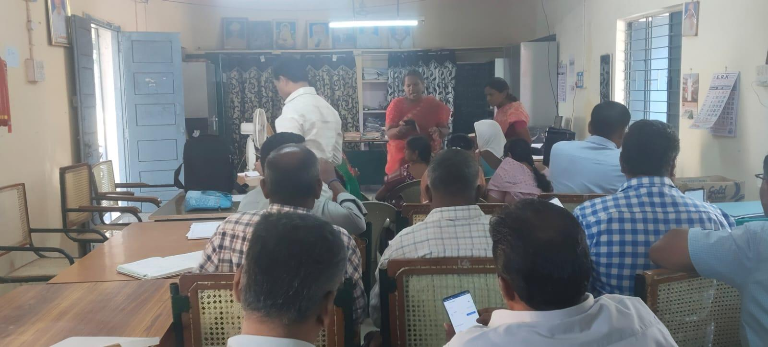
Training was given on Eval bee app for Teachers
Step 1: Explaining the Need for OMR-Based Assessment
The session started with a discussion on traditional assessment methods and their challenges, such as:
- Time-consuming and manual correction
- Human errors in evaluation
- High paper usage and administrative work
- Difficulty in handling large-scale assessments
Introduction was given about OMR (Optical Mark Recognition) technique as a solution that speeds up the evaluation process and increases accuracy.
How Eval Bee App can simplify OMR sheet creation and scanning using a smartphone, eliminating the need for expensive hardware was explained
Step 2: Overview of the Eval Bee App
A brief introduction to the Eval Bee App, highlighting its key features was given:
- Custom OMR Sheet Creation – Design and print OMR sheets easily.
- Mobile-Based Scanning – Use a smartphone camera to scan sheets.
- Automated Grading – Get instant results with accuracy.
- Result Analysis & Reports – View detailed performance reports.
- Cost-Effective & User-Friendly – No special devices required, easy to use.
A short demonstration video about the app interface was given.
Step 3: Step-by-Step Demonstration
The demonstration allows teachers to design customizable OMR sheets with multiple-choice options, a hands-on session was conducted where teachers can:
- Download and Install the Eval Bee App on their mobile devices, and then Sign in Basic Google Inputs
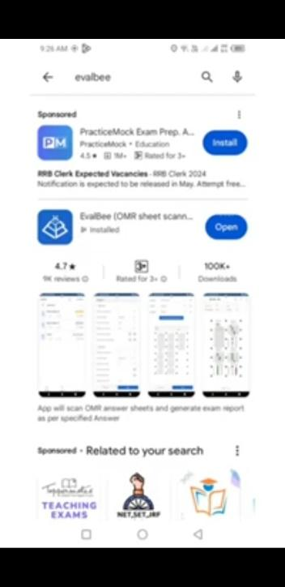
- Create Classes First, add class using + Add class Option


- Create the classes After Adding Students, while adding the students enter name, Roll No, set Minimum 3 digits and Maximum 9 digits for roll number, and then phone no and email.id can be added, which are optional. But Name and Roll No are mandatory and it is important for scanning procedures.
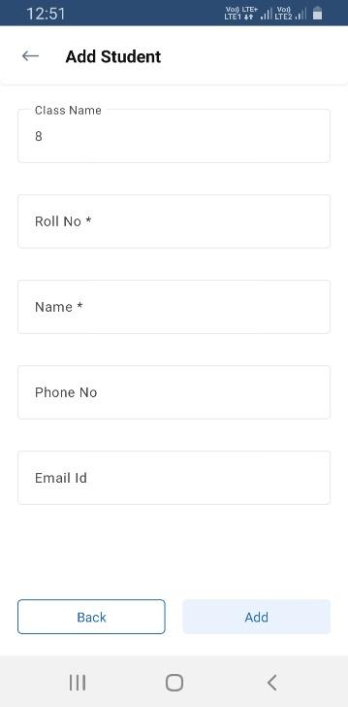

- Next Click Exams and + Add New to create the exams, roll numbers can be added, the digits can be added or decreased, likewise Exam Sets can also be Added or decreased, and then add subjects, the subject and section options are given below the column, add required number of sections for each subject (Ex 3 section for SAT Exam 1. Science, 2, Maths, 3. Social Science, for this purpose use section column and then click next
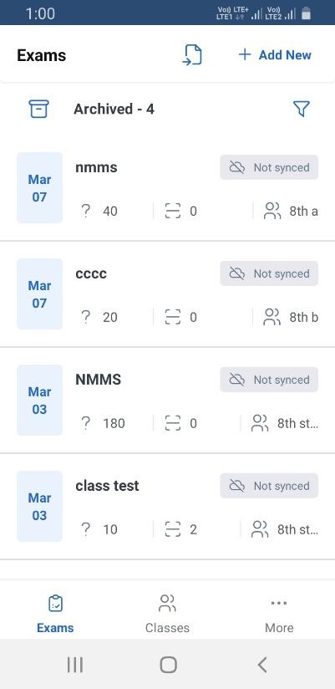

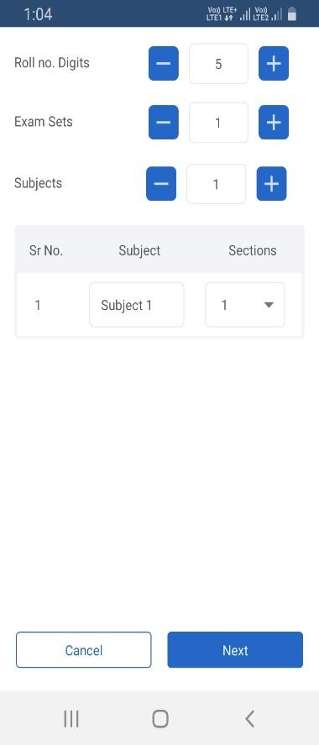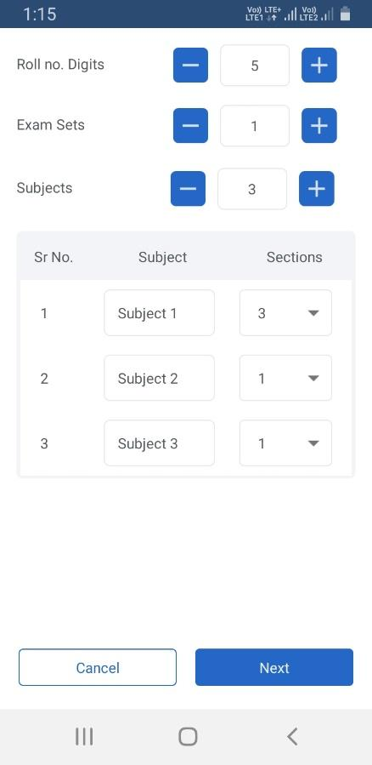

- After setting the Subject and Section the next page will open.
- Set the number of questions you need,
- To select question type, click the drop-down arrow mark and set the options like multiple choice question, true or false, matrix, numerical set
- To set marks for correct answers click the drop-down arrow mark and set the mark to be awarded.
- Follow the same pattern for incorrect answers.
- Partial marks and optional can be allowed by tick marking in the check box. after this click next.
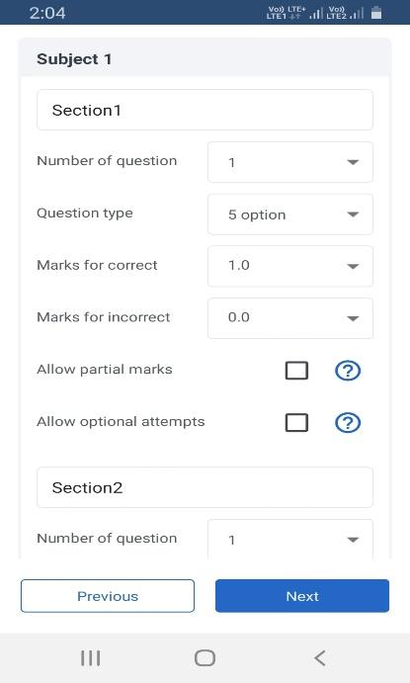

6 Creating a Sample OMR Sheet with multiple-choice questions.
Fix Layout, click down the arrow mark, and select the options
- continuous,
- subject in column,
- add new layout
Creating Layout. Under create layout, the options such as, set grid width, grid height, and set the new layout will be displayed and save the layout.
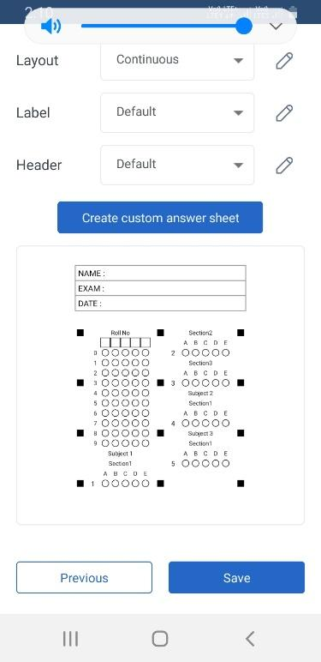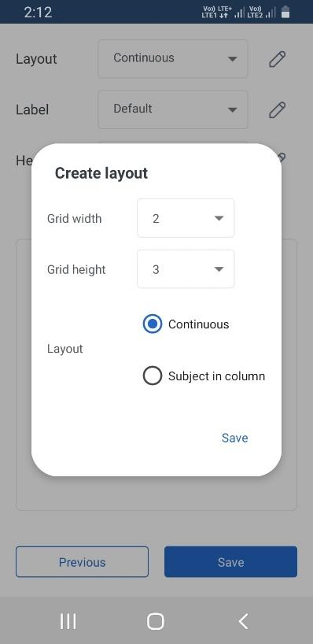
Fixing Label, click down arrow mark, the label option will appear in which two more options will appear such as default and add new. At this stage the default options can be selected, or by the option add new, a new label can be created, name the label and save the label. Follow the same procedure for the header and save the layout. Now a sample OMR is created and save the OMR sheet. On saving the OMR save exam page will open, in which select the class name, exam name, choose exam date and save the exam.
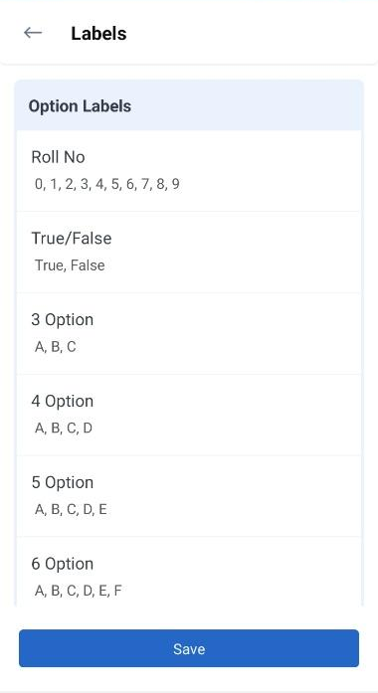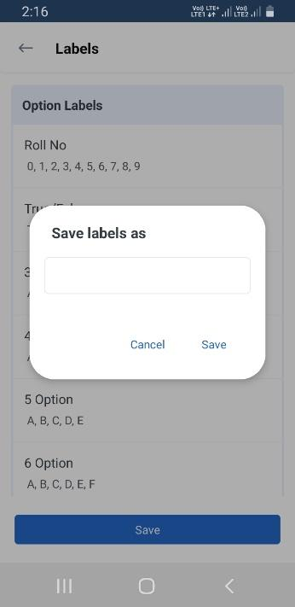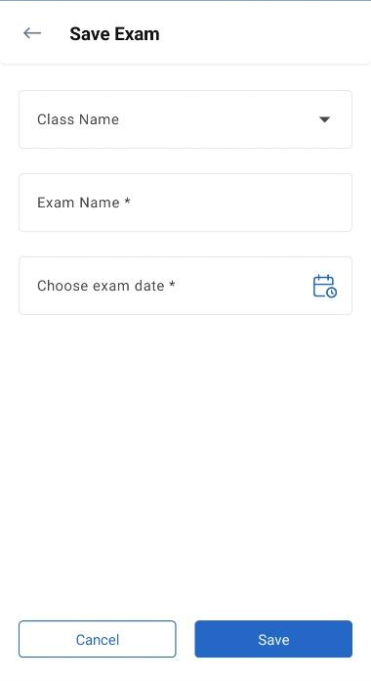
7. After Creating the OMR Sheet for a particular Exam click the Exam Details of the particular exam, before that prepare the questions and Set Answer Key of the exam. Under the exam management section click the answer key and bubble shade the correct answer for all questions and then save the Answer key or reset the answer key.
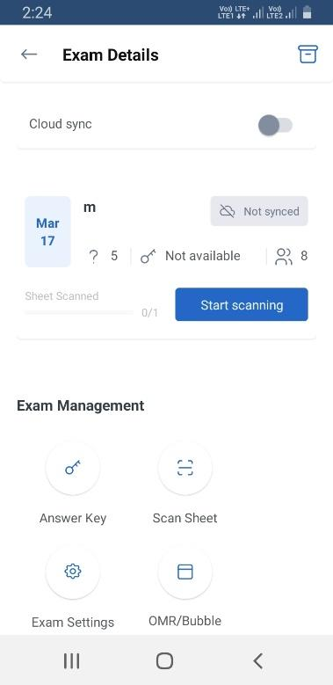
To download or import the key click the 3 dots on the right side. 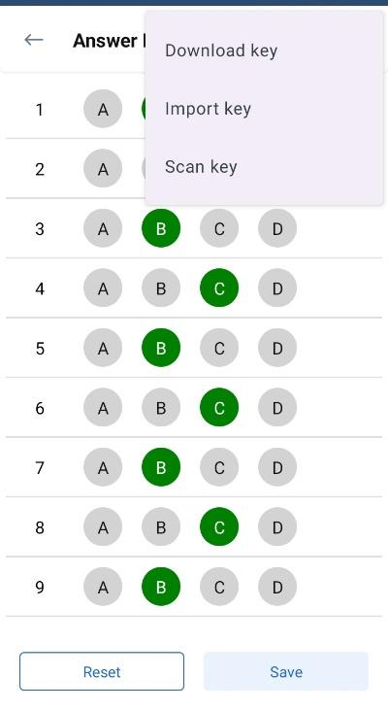

8. Printing of OMR.
Click the OMR/ Bubble sheet page and Print Out can be taken and distributed to the Participants.
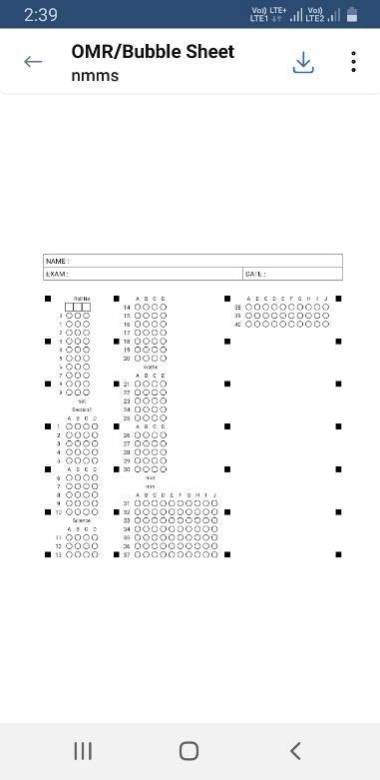

STEP – 4 Scanning of OMR Sheets
Scan the Sheets using the app’s camera feature.
- Open the Eval Bee App and select the "Scan OMR Sheet" option.
- Align the OMR sheet properly within the camera frame.
- Ensure proper lighting and clarity for accurate scanning.
- Capture the sheet using the app’s scanning feature.
- Review the scanned responses for accuracy.

STEP – 5
Analyzing and Exporting Results
- Navigate to the "Results" section in the app.
- View scanned responses and analyze performance.
- Export results in CSV or PDF format for record-keeping.
- Share results with students or stakeholders as needed.
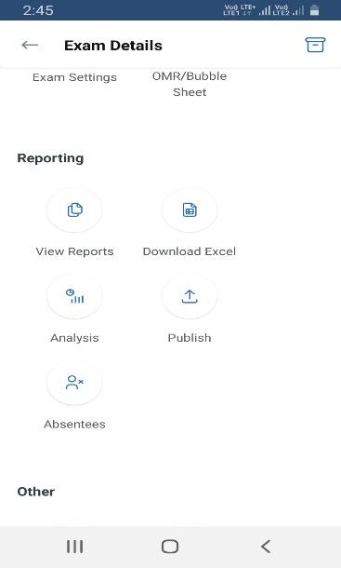
Teachers are encouraged to try scanning their own test sheets for better understanding.
POST-TRAINING ASSESSMENT
After the training, participants completed a post-training assessment to evaluate their understanding and proficiency in using the Eval Bee App. The results were compared with the pre-training assessment to measure the effectiveness of the training program. The Practitioner monitored in the school after the intervention. Teachers were able to prepare the OMR Sheet and download the printable OMR to conduct the exam and then scan the OMR Sheet and analyse the result easily.

Teachers were implemented the EVAL BEE app in their respective School
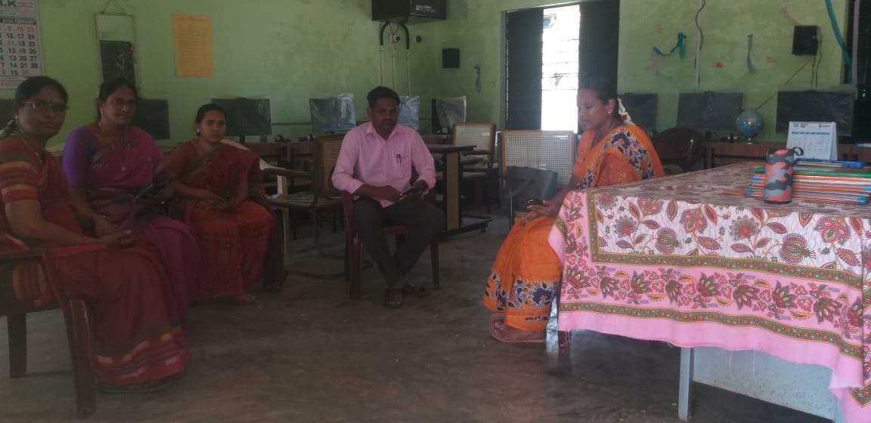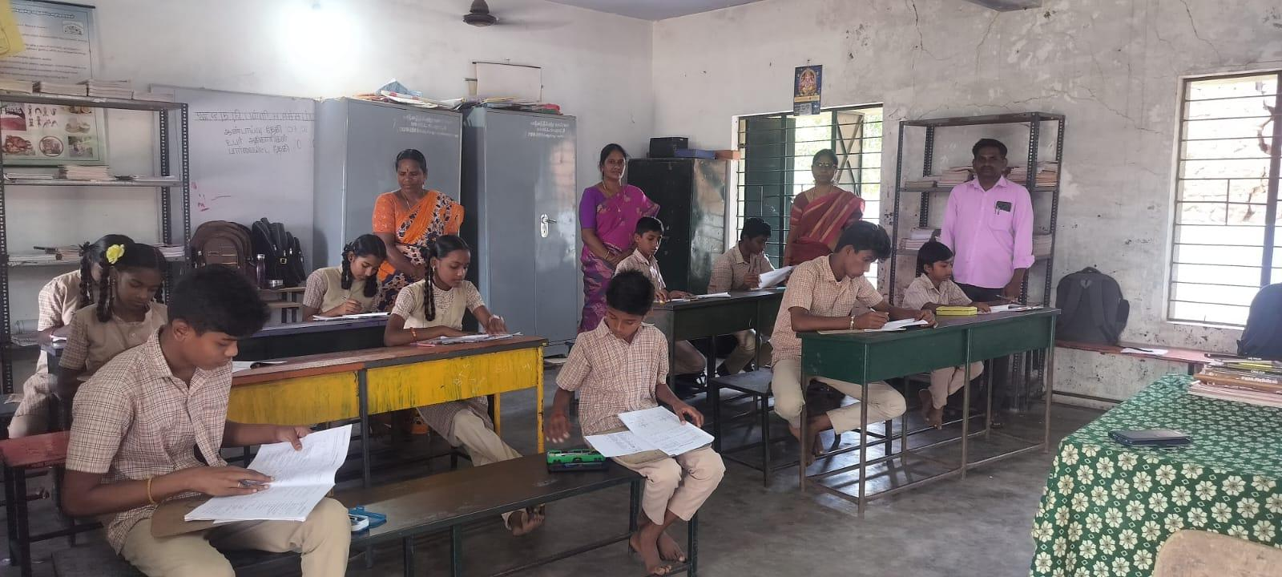
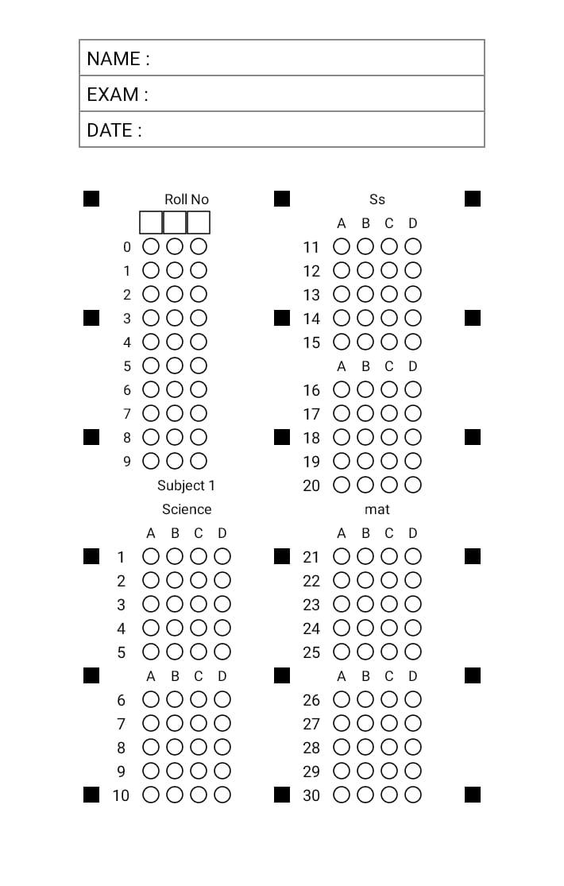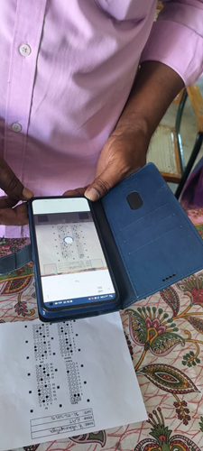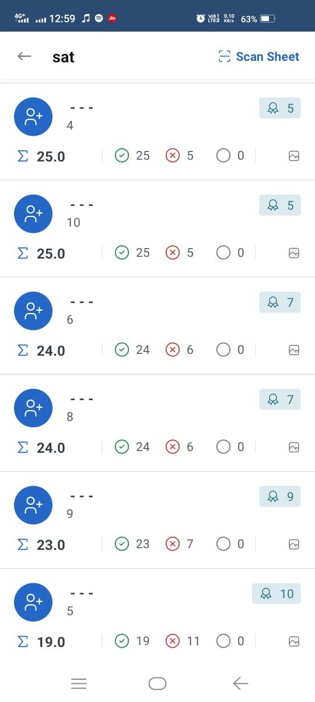
PUMS H.Eachampadi
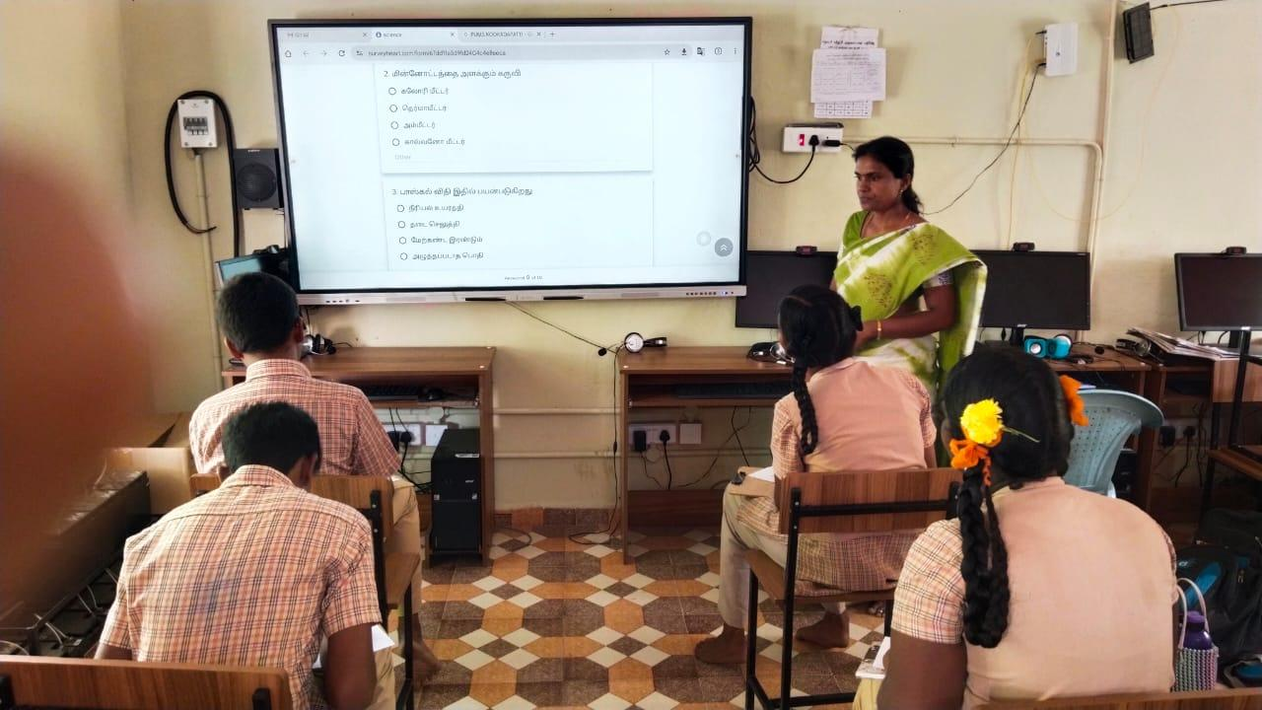
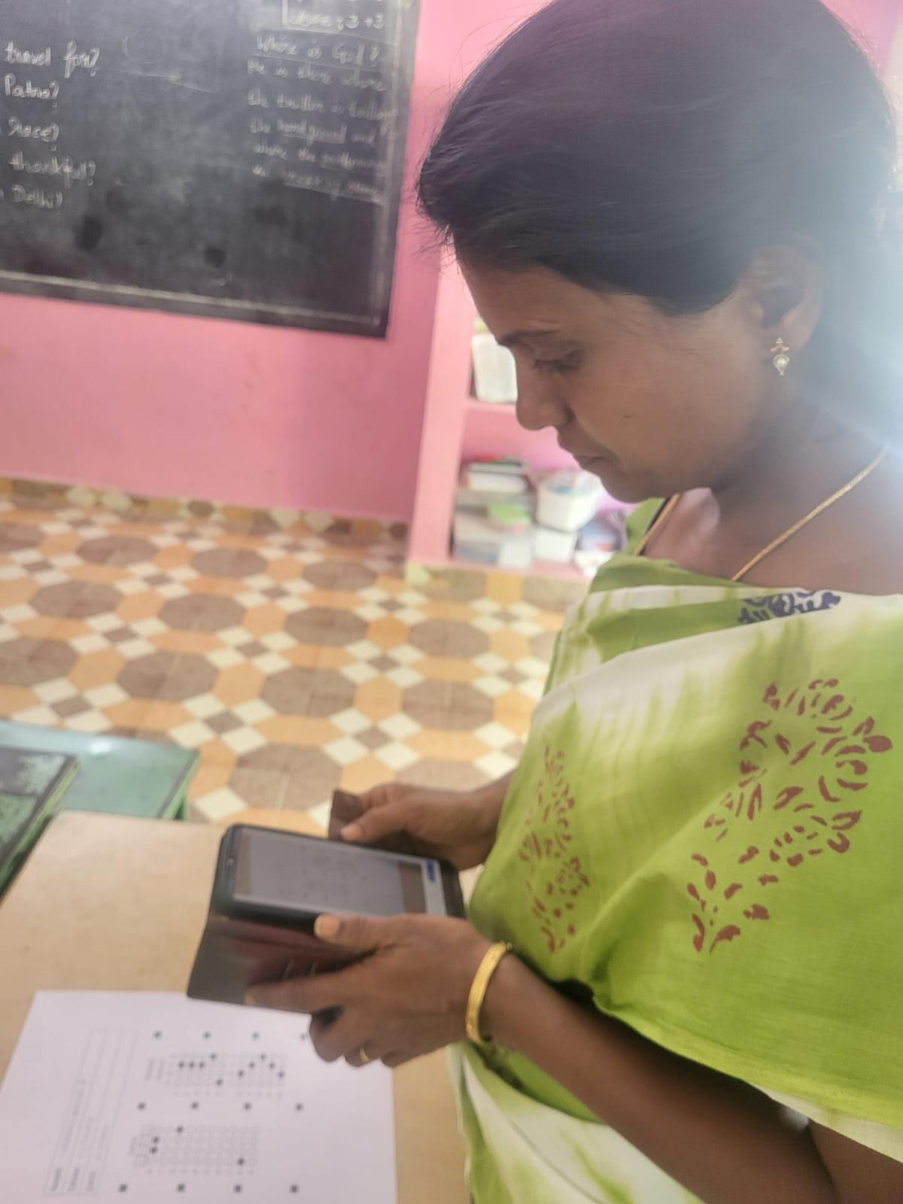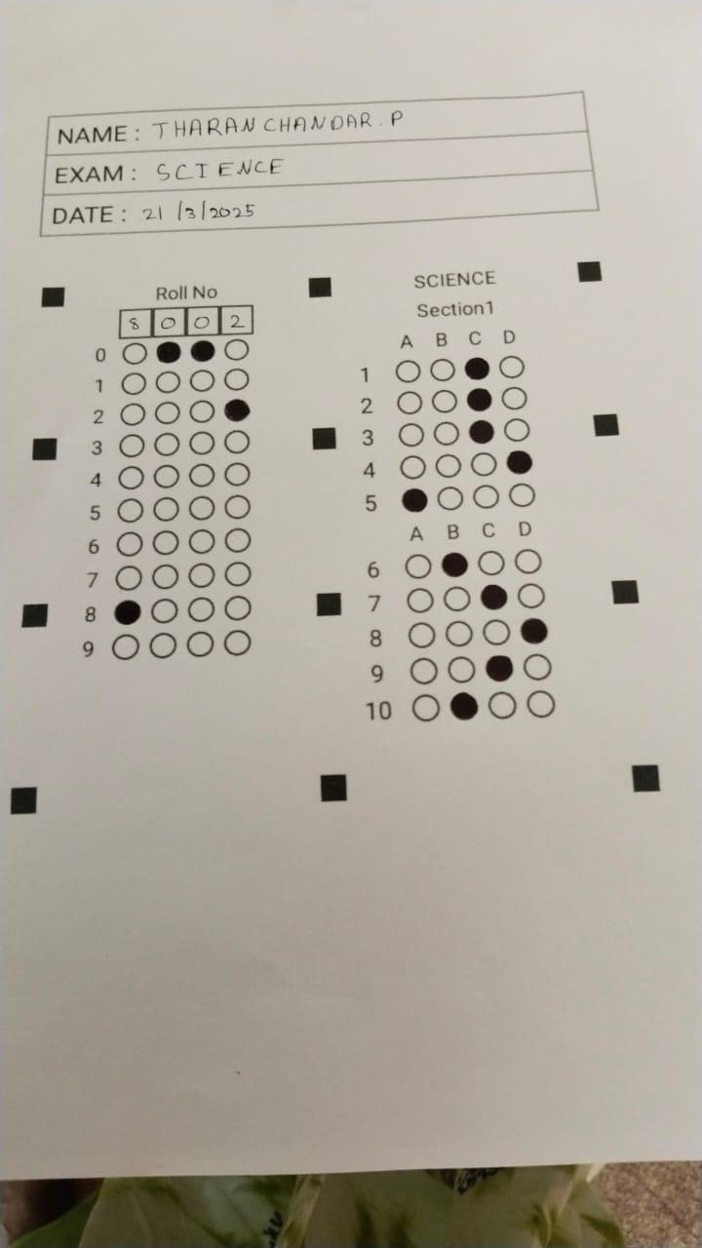
PUMS Kookadapatti

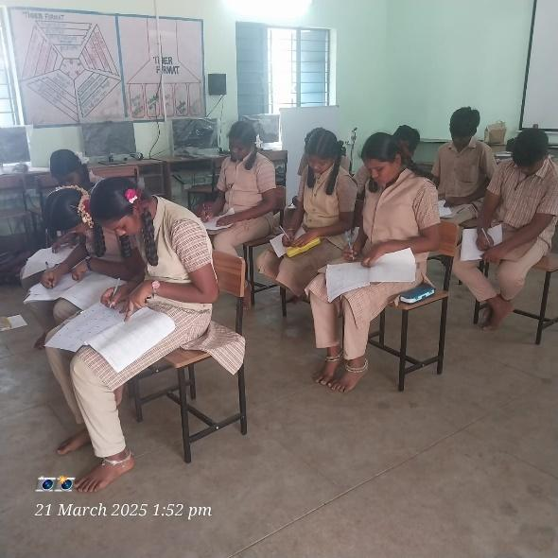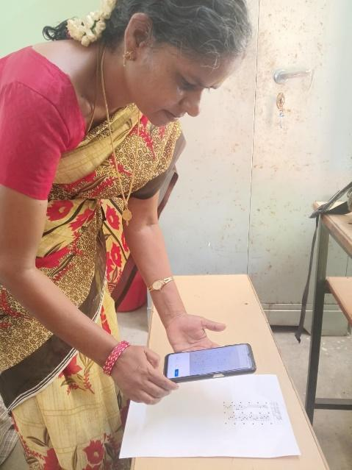
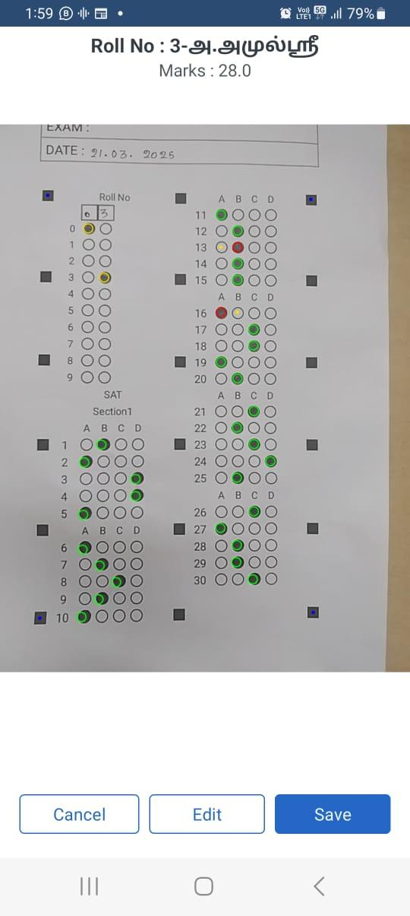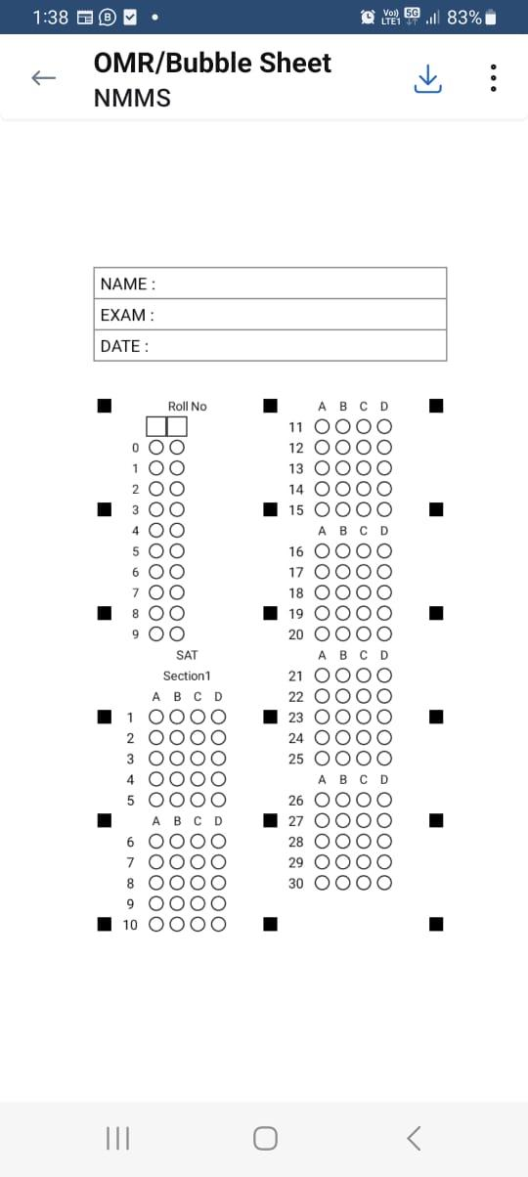
PUMS Nariyampatti
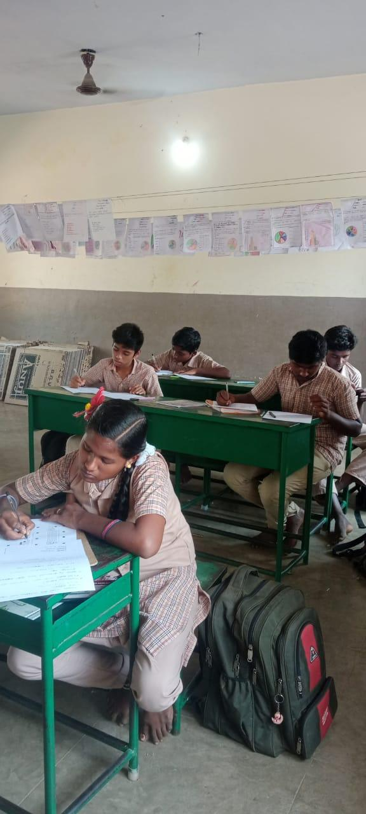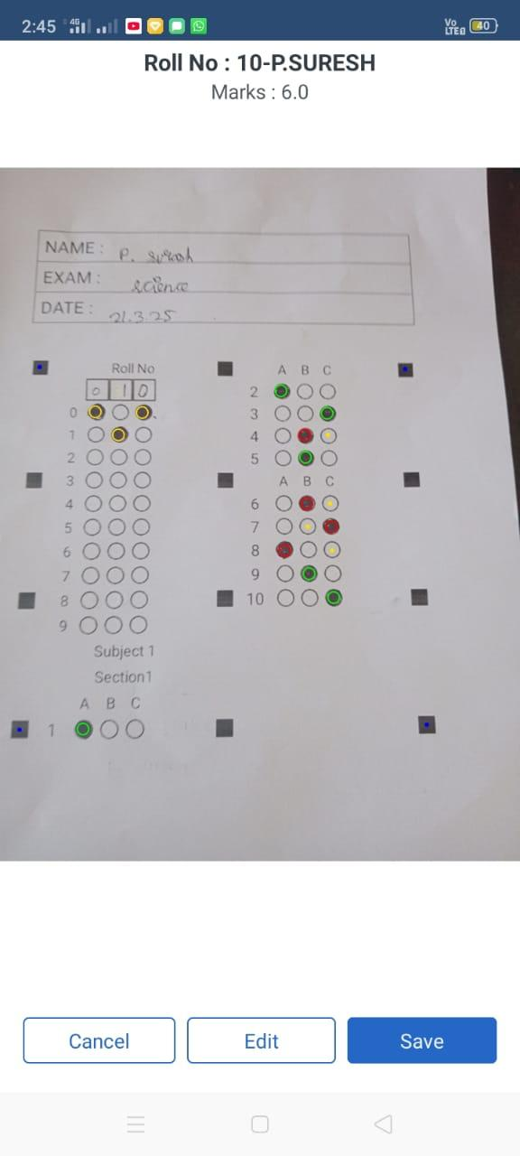
PUMS Sangilivadi
Data Analysis
The pre-test and post test scores were analysed and the results were discussed in terms of Descriptive Statistics
10. Analysis and Interpretation

The table presents the pre-test and post-test mean scores of 20 upper primary teachers before and after being educated on using the EvalBee app for OMR creation and scanning.
No. of Teachers | Pre-test Mean Score | Post-test Mean Score | Mean Difference
20 | 36.25 | 67 | 30.75

Analysis
- Improvement in Scores:
  - The pretest mean score of the teachers was 36.25, indicating their initial knowledge level of OMR-based assessment using EvalBee.
  - After training, the post-test mean score increased to 67, demonstrating a significant improvement in their understanding and application of the tool.
- Mean Difference:
  - The mean difference of 30.75 points suggests a notable enhancement in teachers' skills and confidence in using EvalBee for OMR creation and scanning.
  - This improvement highlights the effectiveness of the training program in making teachers proficient in digital assessment methods.
Interpretation
- The results indicate that educating teachers about EvalBee significantly enhances their ability to use OMR technology for assessment purposes.
- The increase in mean scores suggests that teachers became more efficient in OMR sheet creation, scanning, and result analysis, which can lead to better implementation of technology-driven assessments in classrooms.
- The use of EvalBee can reduce teachers' workload, improve evaluation accuracy, and provide quicker feedback to students, ultimately enhancing the learning process.
- Such training programs should be encouraged to promote digital literacy among educators, ensuring that they can effectively integrate technology into their teaching and assessment methods.

11. Findings of the Action Research
Based on the analysis of training upper primary teachers on the usage of EvalBee for OMR creation and scanning, the following key findings have been observed:
- There was a mean increase of 30.75 points from the pre-test to the post-test scores. This indicates a substantial improvement in the performance of the 20 teachers after the intervention or training was implemented.
- The large gain in mean scores suggests that the action taken (e.g., training, workshop, instructional strategy) was effective in enhancing the knowledge or skills of the teachers.
- The post-test mean score of 67, compared to the pre-test mean of 36.25, shows that the participants achieved a higher level of competence in the assessed area after the intervention.
- Since the average improvement is quite high, it is likely that the majority of participants benefited from the intervention, not just a few individuals.
12. Educational Implications:
- Familiarity with OMR sheets through classroom use helps students build confidence and accuracy, improving their performance in external and competitive exams.
- The use of OMR technology minimizes human error in grading, ensuring fair and objective evaluation of student performance.
- Training teachers in modern assessment tools equips them with the necessary skills to integrate technology into their teaching and evaluation practices.
13. Recommendations:
- Organize periodic hands-on training sessions for teachers on digital assessment tools like the Eval Bee App to ensure continued proficiency and confidence.
- Encourage teachers to use OMR sheets in regular formative assessments to help students become familiar with the format used in competitive exams.
- Provide schools with the necessary digital infrastructure and technical support to effectively implement OMR-based assessments.
- School administrators should periodically evaluate the use and impact of tools like Eval Bee to ensure they are being effectively utilized for student assessment.

14. Conclusion
The training on “The Eval Bee App for OMR Sheet Creation and Scanning” aims to enhance Teachers assessment skills by introducing them to an efficient digital evaluation tool. The intervention is expected to yield positive results, increasing Teachers proficiency in digital assessment practices. This training will contribute to a more effective and streamlined evaluation system in educational institutions.

Bibliography

• Mishra, P., & Koehler, M. J. (2006). Technological pedagogical content knowledge: A framework for integrating technology in teacher knowledge. Teachers College Record, 108(6), 1017–1054.
• Anitha, R., & Kumar, D. A. (2019). Application of Optical Mark Reader (OMR) in educational assessments: A review. International Journal of Advanced Research in Computer Science, 10(5), 56-60.
• Crompton, H., & Burke, D. (2018). The use of mobile learning in teacher education: A review of the literature. British Journal of Educational Technology, 49(5), 879–895.
• Kolb, D. A. (1984). Experiential learning: Experience as the source of learning and development. Prentice Hall.
• Eval Bee. (n.d.). Eval Bee App [Mobile application software]. Retrieved from https://www.evalbee.com

Annexure – 1
Action Research Tool-2024-2025

Name of the Practitioner
A.Vijayalakshmi
Lecturer, DIET
Settikarai - 636704
Dharmapuri District

Title: Educating the Eval Bee App for OMR Sheet Creation and
Scanning among Upper Primary Teachers for Assessment
through hands on Training

Questionnaire for Science Teachers
Name (Block letters):
Name of the School:
Gender:

I. Choose the correct answer. (20x1=20)

- What is the primary purpose of the Eval Bee app?
a) Automated assessment and evaluation
b) Video conferencing
c) Online shopping
d) Digital marketing
- Which feature of Eval Bee is used for processing answer sheets?
a) Online quizzes
b) OMR (Optical Mark Recognition) scanning
c) Virtual whiteboard
d) Digital attendance
- Eval Bee can be used for evaluating:
a) Multiple-choice exams and surveys
b) Long-form essay writing
c) Spoken language tests
d) Handwritten assignments
- Which of the following is NOT a feature of Eval Bee?
a) OMR sheet scanning
b) Result analysis
c) Video editing tools
d) Performance tracking
- What type of questions does the OMR scanning feature in Eval Bee support?
a) Multiple-choice questions (MCQs)
b) Descriptive questions
c) True/False only
d) Essay-based answers
- Which document format is best for printing OMR sheets for Eval Bee?
a) High-resolution PDF
b) JPEG image
c) Low-quality photocopies
d) Handwritten templates
- What is the key requirement for an OMR sheet to be scanned accurately?
a) Properly filled answer bubbles without extra markings
b) Folded and crumpled sheets
c) Using red or blue ink
d) Handwriting answers instead of marking bubbles
- Which device is used to scan OMR sheets in Eval Bee?
a) Flatbed or ADF (Automatic Document Feeder) scanner
b) Thermal printer
c) Dot matrix printer
d) Barcode scanner
- 9. Which mistake can cause errors while scanning OMR sheets?
a) Using a No. 2 pencil
b) Partially filled bubbles
c) Scanning in grayscale
d) Printing in black and white
- Eval Bee helps teachers by:
a) Automating exam evaluation and reducing manual work
b) Replacing physical textbooks
c) Eliminating student assessments
d) Conducting live video calls
- What should be done if an OMR sheet is not scanned correctly?
a) Check alignment and rescan the sheet
b) Discard the sheet immediately
c) Use a mobile phone instead of a scanner
d) Enter all data manually
- Eval Bee provides analytical reports for:
a) Only correct answers
b) Student performance, accuracy, and trends
c) Internet speed monitoring
d) Email automation
- Which educational institutions can use Eval Bee?
a) Schools
b) Colleges
c) Coaching centers
d) All of the above
- Eval Bee helps in:
a) Handwriting recognition
b) Quick and accurate assessment of OMR sheets
c) Taking attendance
d) Social media marketing
- One of the key benefits of Eval Bee is:
a) Reducing human errors in grading and evaluation
b) Slowing down the assessment process
c) Increasing paperwork
d) Limiting access to student performance data
- What is the best way to mark answers on an OMR sheet for accurate scanning?
a) Completely filling the bubbles with a dark pencil or pen
b) Ticking the correct answer
c) Circling the correct answer
d) Writing the option letter (A, B, C, or D) next to the question
- Why should OMR sheets not be folded or damaged?
a) It makes them difficult to distribute
b) It can cause scanning errors and misalignment
c) It increases printing costs
d) It confuses students
- What should be done if a student makes a mistake while filling an OMR sheet?
a) Use a fresh sheet or correct it according to guidelines
b) Erase it with any eraser
c) Cross out the incorrect answer
d) Leave it as it is and inform the teacher
- Which of the following is a key advantage of using Eval Bee over manual evaluation?
a) Faster and more accurate results
b) Requires no teacher involvement
c) Can evaluate handwritten answers
d) Replaces all classroom assessments
- Eval Bee can generate reports in which formats?
a) Only printed reports
b) Digital formats like PDF and Excel
c) Audio reports
d) Handwritten records

Annexure - 2
Photos
Training was given on Eval bee app for Teachers
Teachers were implemented the EVAL BEE app in their respective School

