TN DPI FAR 2402
Name of the Researcher: S.Senthilkumar
Name of the DIET: DIET, Dharmapuri
Title: Enhancing Lesson Based Poster Creation Skill Among Upper Primary Teachers through Canva App

1. Introduction:
In today's rapidly evolving educational landscape, the integration of Information and Communication Technology (ICT) is essential for school teachers. As classrooms become increasingly digital, educators must harness these tools to enhance teaching and learning experiences. ICT not only facilitates access to a vast array of resources but also supports differentiated instruction, enabling teachers to tailor their approaches to meet diverse student needs.
Moreover, ICT fosters collaboration and communication among teachers, students, and parents. With online platforms and educational software, teachers can share resources, assign tasks, and provide feedback more efficiently, creating a more interactive and engaging learning environment. This collaboration extends beyond the classroom, allowing for real-time communication and support.
Additionally, proficiency in ICT equips teachers with the skills to prepare students for a technology-driven world. By integrating digital literacy into their curricula, educators help students develop critical skills necessary for future academic and professional success. Ultimately, embracing ICT is not just about keeping pace with technological advancements; it is about enriching the educational experience and empowering both teachers and students to thrive in a complex, interconnected society.
2.Background of the Action Research
In today's rapidly evolving educational landscape, the integration of Information and Communication Technology (ICT) is essential for school teachers. As classrooms become increasingly digital, educators must harness these tools to enhance teaching and learning experiences. ICT not only facilitates access to a vast array of resources but also supports differentiated instruction, enabling teachers to tailor their approaches to meet diverse student needs.
Teaching through posters in schools is an effective pedagogical approach that engages students and enhances their learning experience. Posters serve as a visual tool, making complex concepts more accessible and easier to understand. They can make vast amounts of information into concise, digestible formats, allowing students to grasp essential ideas quickly.
One of the primary benefits of using posters in education is their ability to foster visual learning. Many students are visual learners, i.e., they comprehend and retain information better when it is presented visually. Posters can include diagrams, charts, and illustrations that clarify intricate processes, such as the water cycle or cellular respiration. By integrating visuals with textual information, posters cater to diverse learning styles, ensuring that all students can engage with the material effectively.
In addition to their educational benefits, posters can enhance classroom environments. A visually stimulating poster can inspire curiosity and encourage discussions. They can act as constant reminders of what students have learned, sparking interest and reinforcing concepts as students pass by.
By incorporating visual communication in education, educators prepare students for a world increasingly driven by technology and information. Understanding how to convey ideas visually is a crucial skill in various fields, including research, engineering, and education.
Teaching through posters in schools is an invaluable strategy that supports diverse learning styles, fosters creativity, encourages collaboration, and enhances classroom environments. By integrating posters into education, educators can create a dynamic and engaging learning experience that not only deepens students’ understanding of scientific concepts but also equips them with essential skills for the future.
Based on this background information, the practitioner felt that this kind of study is necessary to enhance the teaching skill among the upper primary teachers using posters in teaching.

3.Identification of the Problem
Schools are equipped with ICT equipments, training on ICT is also provided to graduate teachers, hence there is a need to use ICT for teaching learning purpose. Based on the observation during school visits the practitioner felt that teachers have to be motivated to use the ICT for teaching learning purpose and they have to use the technology that they have learnt in the ICT training. Through this action research the inputs given in the ICT training can be strengthened among the graduate teachers.

4.Need for the Action Research
Teaching through posters in schools is an effective pedagogical approach that engages students and enhances their learning experience. Posters serve as a visual tool, making complex concepts more accessible and easier to understand. They can make vast amounts of information into concise, digestible formats, allowing students to grasp essential ideas quickly.
One of the primary benefits of using posters in education is their ability to foster visual learning. Many students are visual learners, i.e., they comprehend and retain information better when it is presented visually. Posters can include diagrams, charts, and illustrations that clarify intricate processes, such as the water cycle or cellular respiration. By integrating visuals with textual information, posters cater to diverse learning styles, ensuring that all students can engage with the material effectively.
In addition to their educational benefits, posters can enhance classroom environments. A visually stimulating poster can inspire curiosity and encourage discussions. They can act as constant reminders of what students have learned, sparking interest and reinforcing concepts as students pass by.
By incorporating visual communication in education, educators prepare students for a world increasingly driven by technology and information. Understanding how to convey ideas visually is a crucial skill in various fields, including research, engineering, and education.
Teaching through posters in schools is an invaluable strategy that supports diverse learning styles, fosters creativity, encourages collaboration, and enhances classroom environments. By integrating posters into education, educators can create a dynamic and engaging learning experience that not only deepens students’ understanding of scientific concepts but also equips them with essential skills for the future.
Based on this background information, the practitioner felt that this kind of study is necessary to enhance the teaching skill among the upper primary teachers using posters in teaching.

5.Statement of the Problem
Visual learning plays a crucial role in enhancing students’ understanding and engagement in the classroom. Posters serve as an effective tool to simplify complex concepts, provide visual reinforcement, and encourage interactive learning. However, many upper primary teachers face challenges in effectively creating and utilizing lesson-based posters due to a lack of adequate training, limited exposure to design principles, and insufficient integration of posters into their teaching strategies.
This study aims to identify the current level of poster-making skills among upper primary teachers, explore the challenges they face in designing effective educational posters, and develop strategies to enhance their poster creation skills. By improving teachers' ability to design and use lesson-based posters, the study seeks to foster a more interactive and visually enriched learning environment, ultimately benefiting student comprehension and retention. Hence, the problem is stated as, “Enhancing Lesson Based Poster Creation Skill Among Upper Primary Teachers Through Canva App”.

6. Objectives of the Action Research:
- To explain the importance of using lesson-based posters in teaching. The action research emphasizes the benefits of incorporating posters into teaching, such as their ability to make complex concepts more accessible and support diverse learning styles.
- To train the teachers to use the Canva App. Canva is a graphic design platform that can be used to create posters and other visual materials. The proposal prioritizes orienting teachers on Canva and providing a module for its use.

- To train the teachers to create lesson-based posters, mind maps, and worksheets using Canva App. This objective focuses on equipping teachers with practical skills to create engaging and informative teaching materials using the chosen ICT tool.

- To encourage the teachers to use lesson-based posters in teaching. The action research aims to motivate teachers to implement the poster-creation skills they learn during the intervention and incorporate posters into their teaching practices.

- To enhance the teaching skill among the upper primary teachers thereby improving the quality of learning among the students. This overarching objective aims to improve student learning outcomes by improving teachers' teaching skills through the use of posters and the Canva app.

These objectives highlight the professional development in promoting the use of ICT tools and innovative teaching methods. The action research aims to equip teachers with the necessary skills and resources to effectively integrate lesson-based posters into their teaching practices, ultimately leading to improved student learning outcomes.
7.Probable causes for the problem
ICT training has been provided to graduate teachers, but they are not implementing what they have learnt in the training immediately in the teaching learning process, this may be due to the lack of time, lack of interest, non availability of ICT facilities in their schools, lack of sufficient time for preparation. Most of the teachers follow the conventional method of teaching, they rarely go for the methods like usage of posters in their teaching learning process which will be more effective than the conventional method. The practitioner considered these factors may be the probable causes for the problem. The probable causes are prioritised as given below
- Teachers may be comfortable with the conventional method of teaching
- Lack of time for creating activities such as posters creation
- Reluctant to use ICT tools
- Lack of sufficient practice to use ICT tools
- Lack of motivation to use ICT tools

8.Action Hypothesis
Teaching skills of Upper primary teachers will be enhanced after the intervention of the action research.

9.Methodology

a.Sample
33 Upper primary school teachers handling English, Mathematics, Science and Social science subjects from Morappur block were selected as the sample for the action research.

b.Reaearch Design
Pre-analysis, Intervention, Post-analysis method was followed as the design for the action research.
c.Description of the Research Tool
Tool for the pre-analysis - During the pre analysis details related to usage of posters in teaching, the type of posters created by teachers for teaching, how often posters are used for teaching were collected through a questionnaire containing 10 items.
Tool for post analysis - During the post analysis the experience of creating posters using Canva App, the effectiveness of teaching through posters, class room experience and the effectiveness of learning among the students were collected from the teachers through another questionnaire containing 18 items.

d.Description of the Research process

Data collection:
WhatsApp group was created for the purpose of this action research and all the teachers joined in the group. Aims and objectives of action research were explained to them through the group. The google form link for pre-analysis tool was shared in the group and the data were collected. In the same way the google link for post analysis tool was also shared in the group google form link and the data were collected.

Intervention
A module was developed by the practitioner briefly explaining the Canva App. The module was distributed to all teachers. Details regarding how to login, tools available for creating posters, typing process, editing process, designing posters were explained in the module. The results of the pre-analysis has shown that 47% of teachers preferred workshop mode of training is required for the pre-intervention hence, the practitioner opted on site hands on training to the teachers at their school itself without disturbing their regular school activities. The practitioner visited all schools and provided onsite training to them with the help of desktop version of Canva and mobile App of Canva. Majority of the teachers used the mobile App for creating the posters. After creating posters they were used as TLM for teaching learning process. Teachers created three type of posters such as, infographic poster for explaining the general concept of the lesson, mind map poster for reinforcement and worksheet poster for assessment of the concept. The printout of the posters were taken and given to the students for discussion and practice. Some teachers displayed the poster in the smart TV. The practitioner visited all the eleven schools during the intervention and provided necessary guidance and support in creating and teaching through posters. One week time was given for creating posters and two weeks time was given for intervention activities.

Data Analysis:
Item wise percentage analysis was performed and results were reported for both pre analysis and post analysis.

10.Analysis and Interpretation
The analysis and interpretation was presented in two sections such as interpretation of pre analysis and interpretation of post analysis.

Interpretation of Pre-Analysis
The tool for pre analysis contained 10 items. The item wise analysis of data obtained was discussed as below.

1. Experience with Creating Posters
- No experience (47.37%) and Some experience (44.74%) dominate the responses, indicating that most teachers are either beginners or have limited exposure to poster creation.
- Only 7.89% reported having more experience, highlighting the need for targeted training.

2. Usage of Canva or Similar Tools
- A slight majority (52.63%) have never used Canva or similar tools, while 47.37% have some experience.
- This suggests that introducing Canva can bridge the digital design gap.

3. Frequency of ICT Usage in Teaching
- 60.53% use ICT occasionally, while 36.84% use it often.
- Only 2.63% reported never using ICT, showing a positive trend towards technology integration.

4. Frequency of Using Visual Aids (Posters) in Lesson Plans
- 44.74% use posters often, 39.47% occasionally, and 15.79% never use them.
- This reflects a moderate acceptance of visual aids, with room for increased usage.

5. Belief in Posters Enhancing Student Engagement
- A strong 84.21% believe in the effectiveness of posters, while 10.53% disagree, and 5.26% are unsure.
- This highlights positive perceptions towards visual learning strategies.

6. Importance of Visual Learning for Students
- 86.84% consider visual learning very important, 10.53% find it somewhat important, and 2.63% find it unimportant.
- This demonstrates strong support for incorporating visual elements in teaching.

7. Challenges in Creating Posters
- The main challenges are Access to technology (50.0%), Lack of training (26.32%), and Time constraints (23.68%).
- Addressing these areas can improve poster creation skills.

8. Current Resources for Poster Creation
- Resources are evenly split between Printed materials (34.21%), Digital tools (34.21%), and Hand-drawn materials (31.58%).
- This indicates diverse approaches to poster design.

9. Frequency of Seeking New Methods or Tools for Teaching Enhancement
- 50.0% often seek new tools, 42.11% occasionally, and 7.89% rarely do so.
- This suggests a proactive attitude towards innovation.

10. Preferred Method for Improving Poster Creation Skills
- Workshops (47.37%) are the most preferred, followed by Peer collaboration (31.58%) and Online training modules (21.05%).
- This highlights the value of hands-on, interactive learning environments.

Conclusion of pre analysis
The data reveals that while teachers recognize the value of visual learning and are willing to adopt new tools like Canva, they face challenges related to technology access, time management, and training with follow up practice. Addressing these areas through workshops and peer collaboration can significantly enhance their poster creation skills and improve student engagement.

Interpretation of Post-Analysis
The post-analysis was conducted to find the effectiveness of using Canva-designed posters in classroom teaching. The findings provide insights into teachers' experiences, student engagement, and the impact of integrating digital posters into lesson delivery. A detailed analysis of the responses are discussed below.

1. Usage of Posters in Teaching
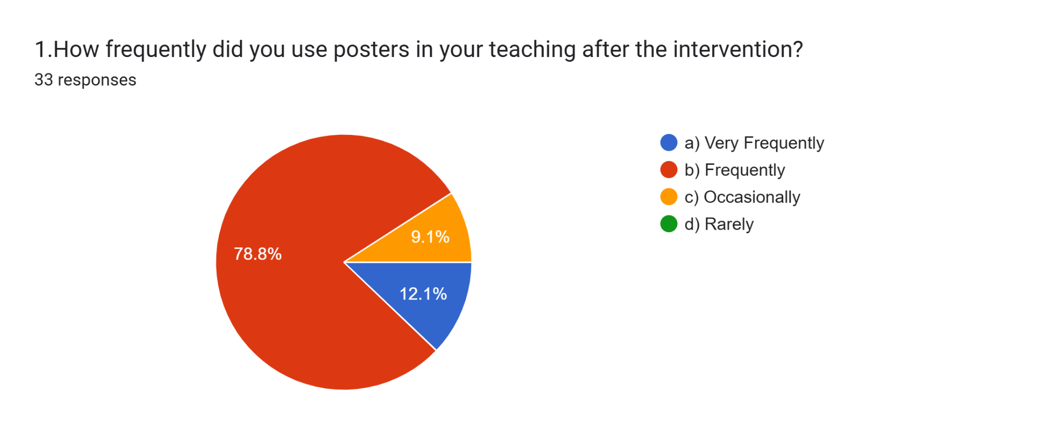
- 78.79% of teachers reported using posters frequently in their teaching after the intervention.
- 12.12% of teachers used them very frequently, while 9.09% used them occasionally.

2. Confidence in Canva Usage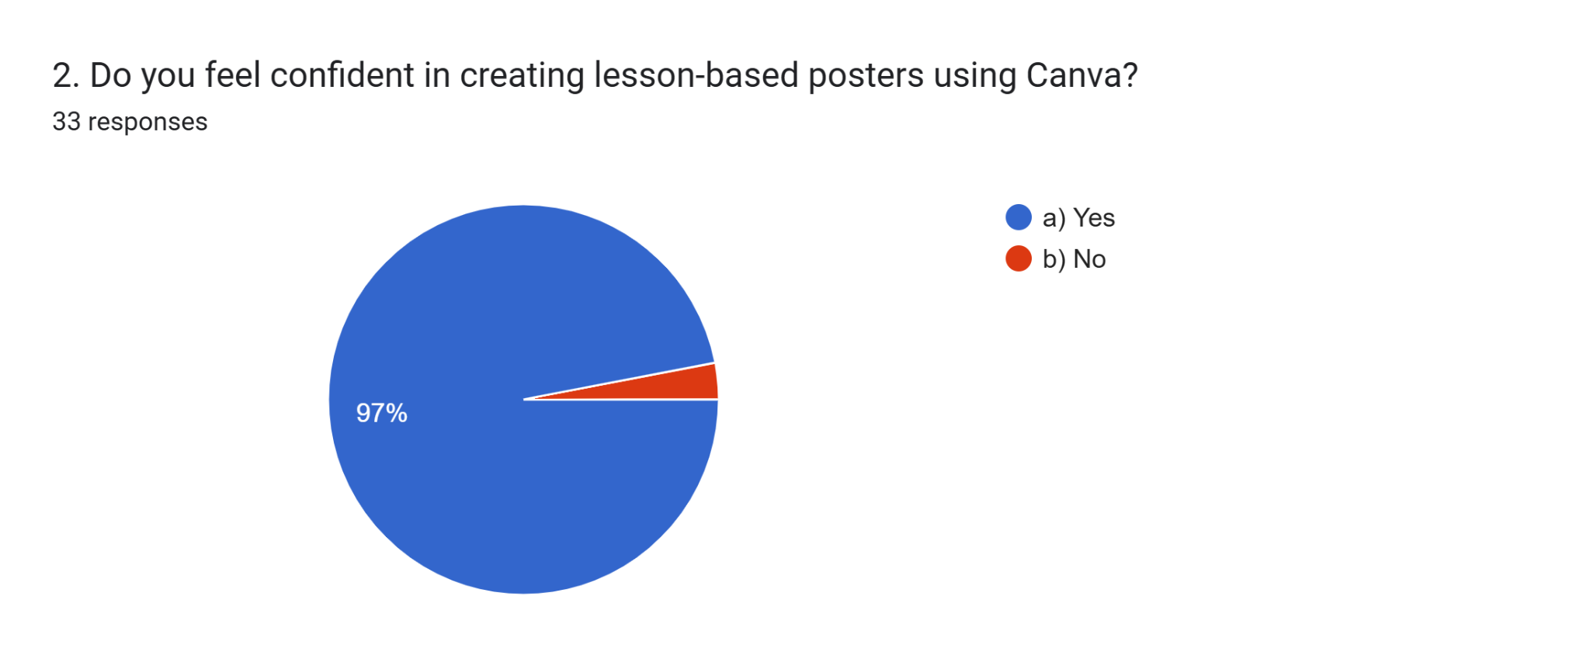

- 96.97% of teachers felt confident in creating lesson-based posters.
- Only 3.03% reported a lack of confidence in using Canva.

3. Impact on Student Engagement
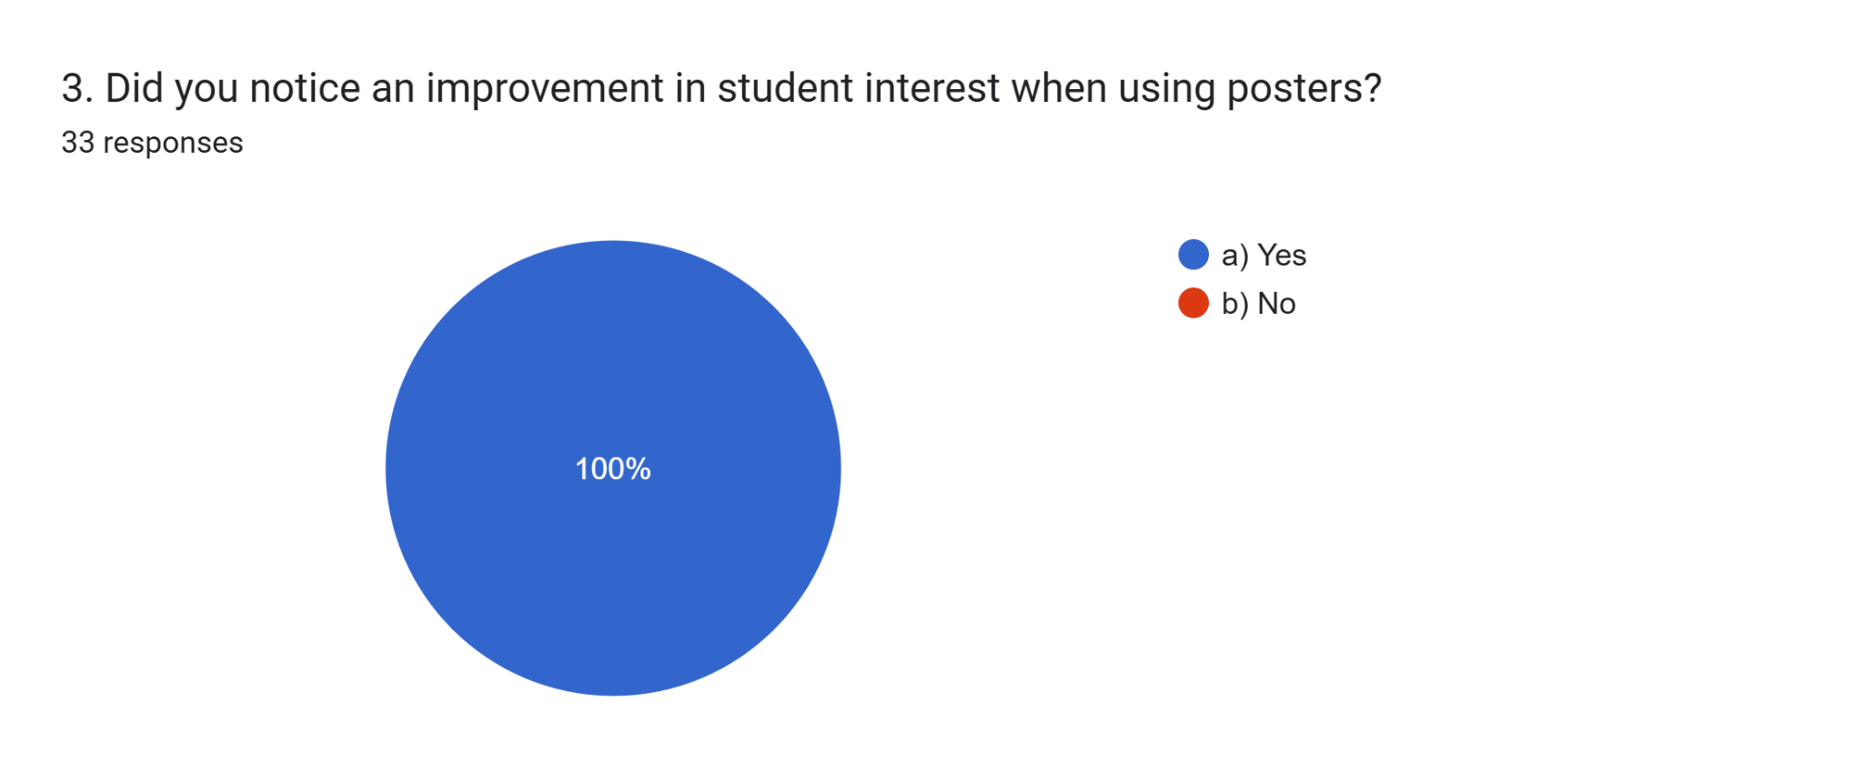
- 100% of teachers observed an increase in student interest when using posters.

4.Student Attention and Engagement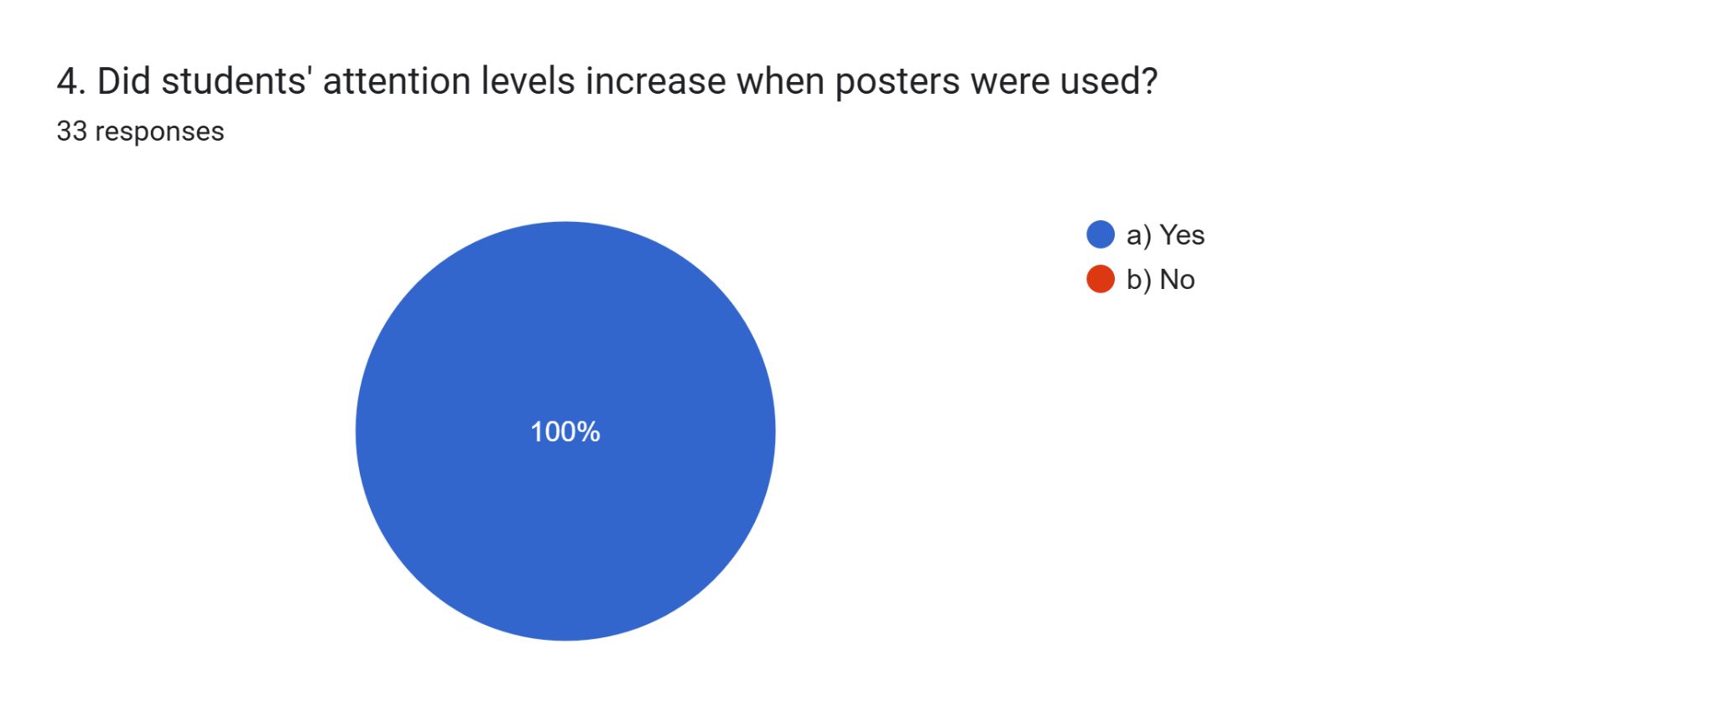
- 100% of teachers observed an increase in student attention when using posters.

5.Classroom Management
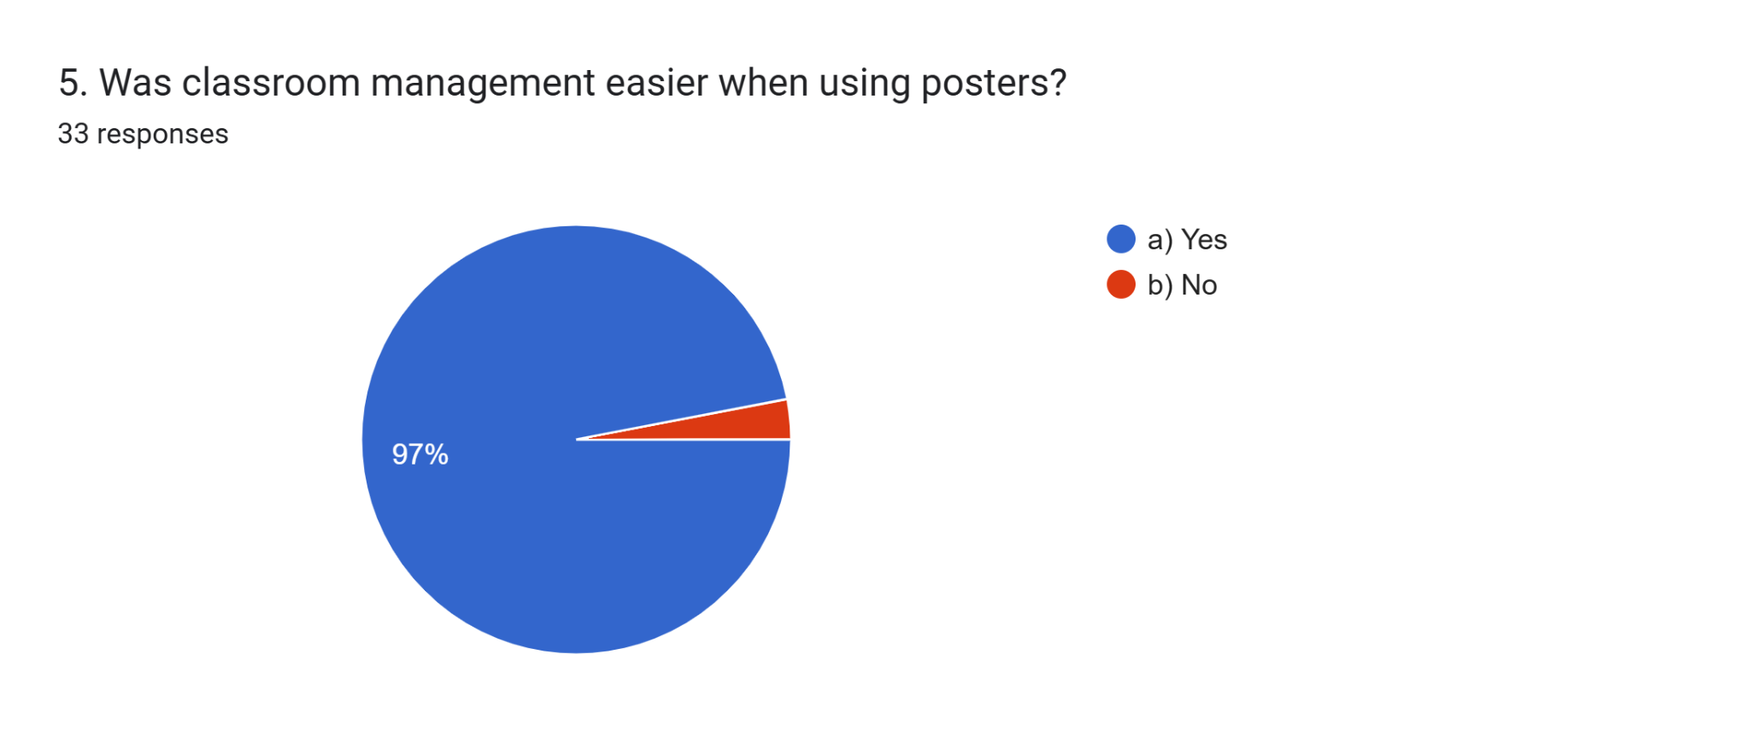
- 96.97% agreed that classroom management was easier when using posters.

6.Difficulty in creating posters
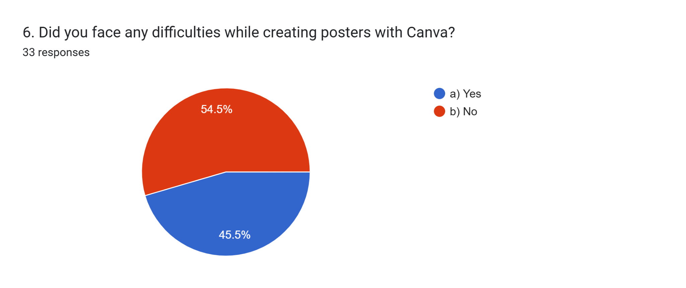
- 54.5% of teachers reported that they have faced difficulties. This was due to lack of Tamil typing skill, low refresh rate of their mobile phone, availability of internet in their school.
- 45.5% did not face difficulties.

7.Effectiveness of Canva
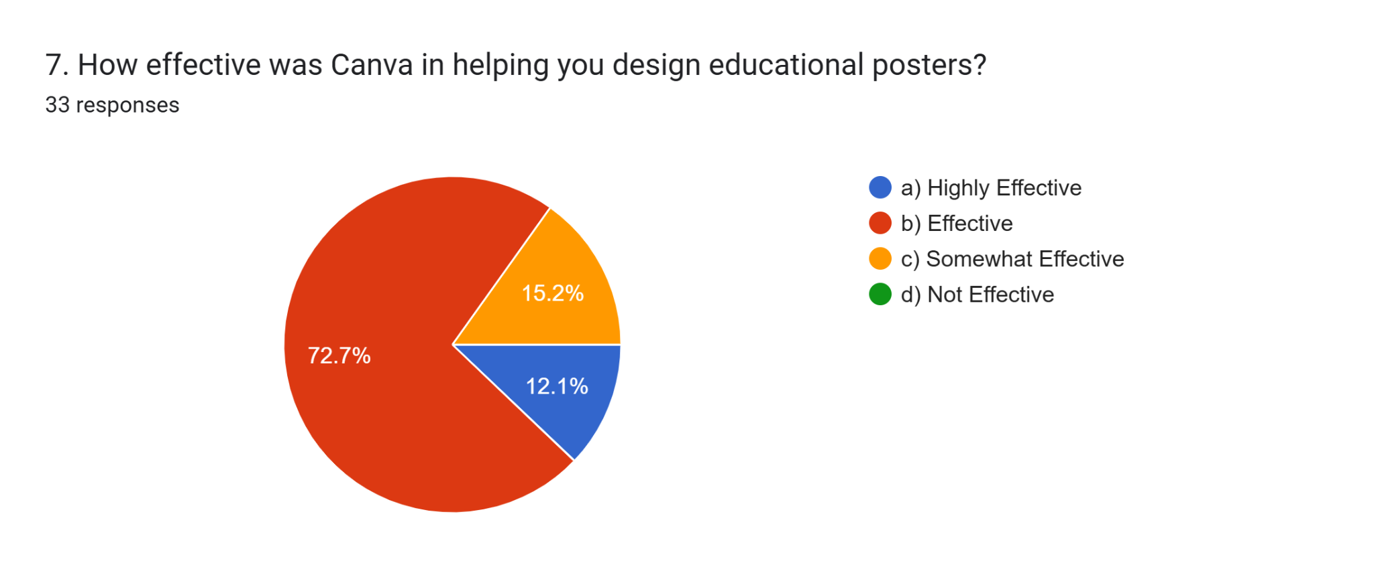
12.1 % of teachers reported Canva was highly effective to design posters, 72.7% of teachers reported that Canva was effective, 15.2 % reported somewhat effective.

8.Frequence of referring to module
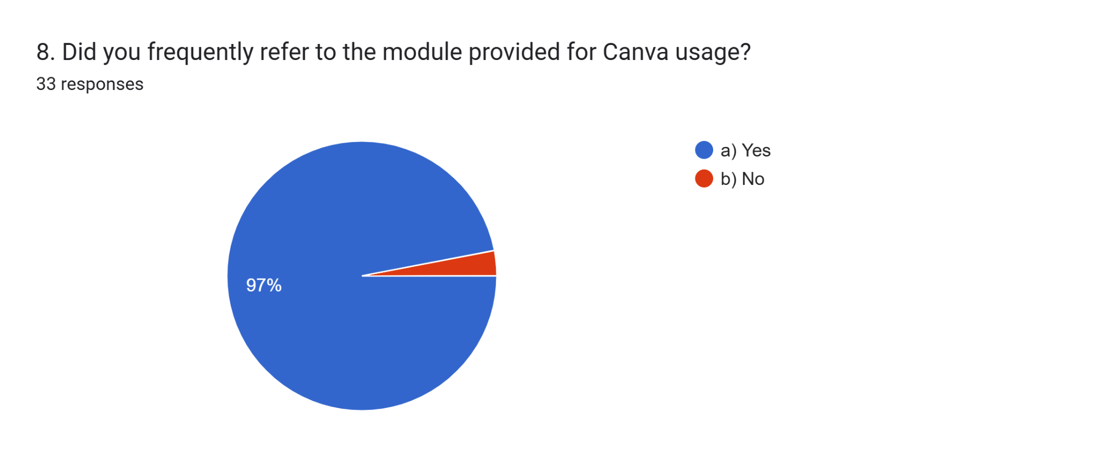
97% of teachers reported that they frequently referred the module provided for them.

9.Integeration of posters into different subjects
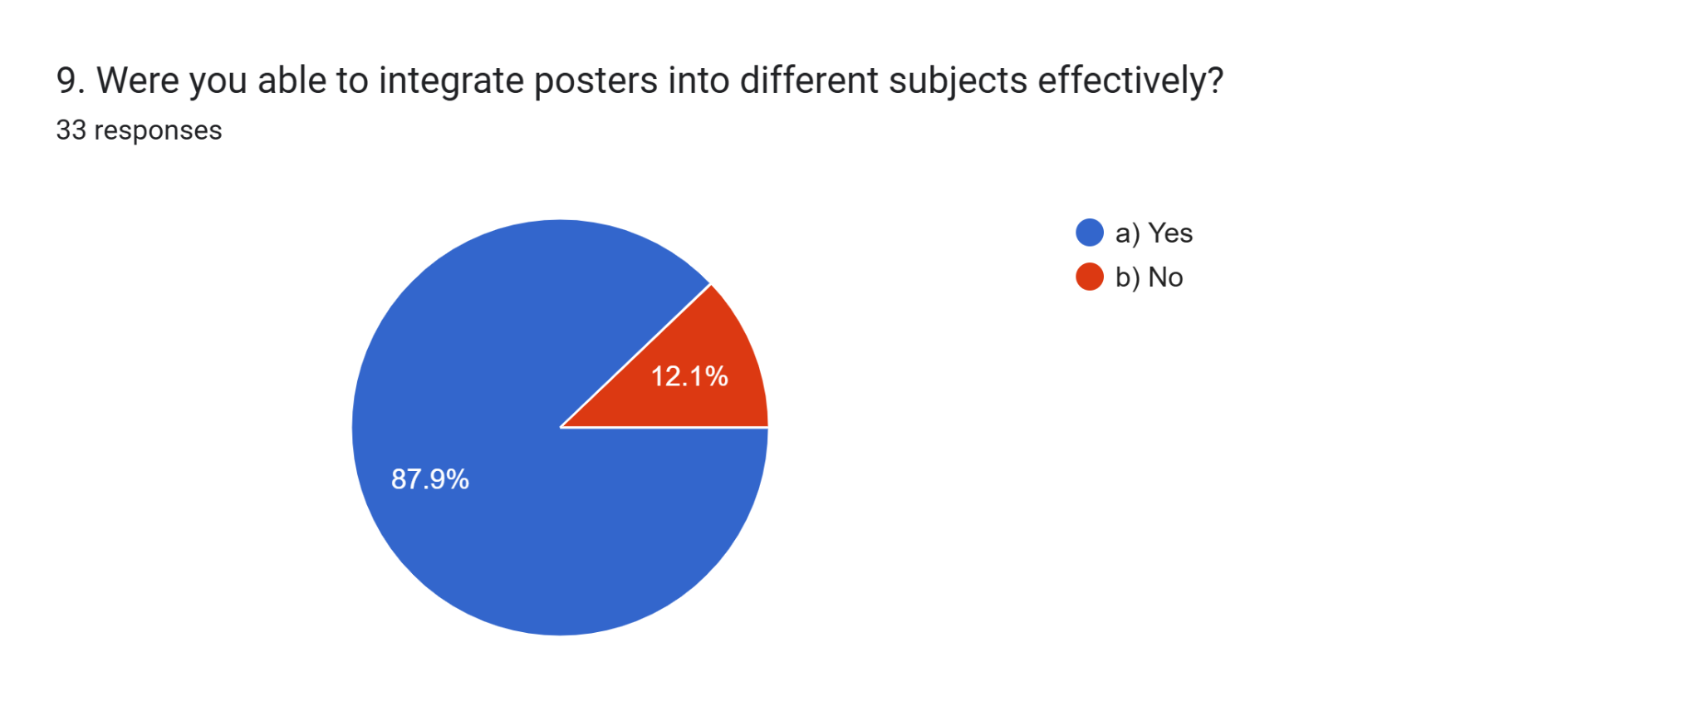
87.9% of teachers were able to integrate posters in to different subjects, while 12.1 % were unable to integrate posters in to different subjects.

10.Students’ response to posters
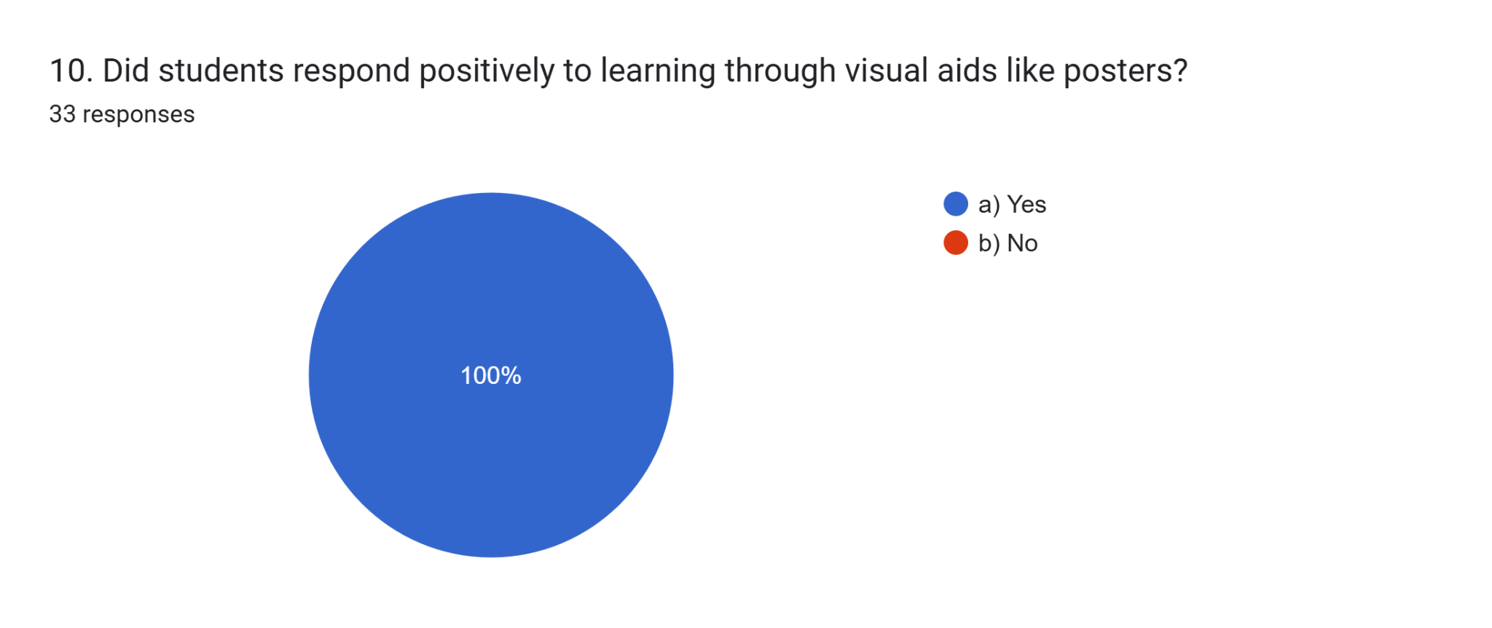

100% of teachers observed positive student responses, supporting visual learning benefits.

11.Improvement in student’s understanding
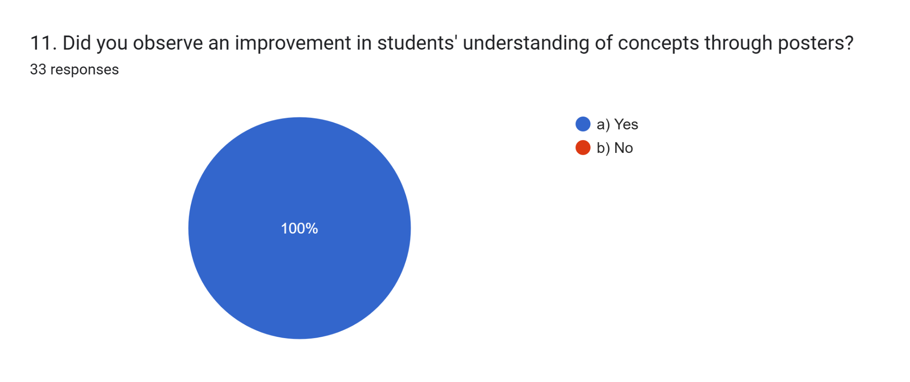
100% of teachers agreed that posters enhanced student understanding.

12.Comfortablility of using of using posters
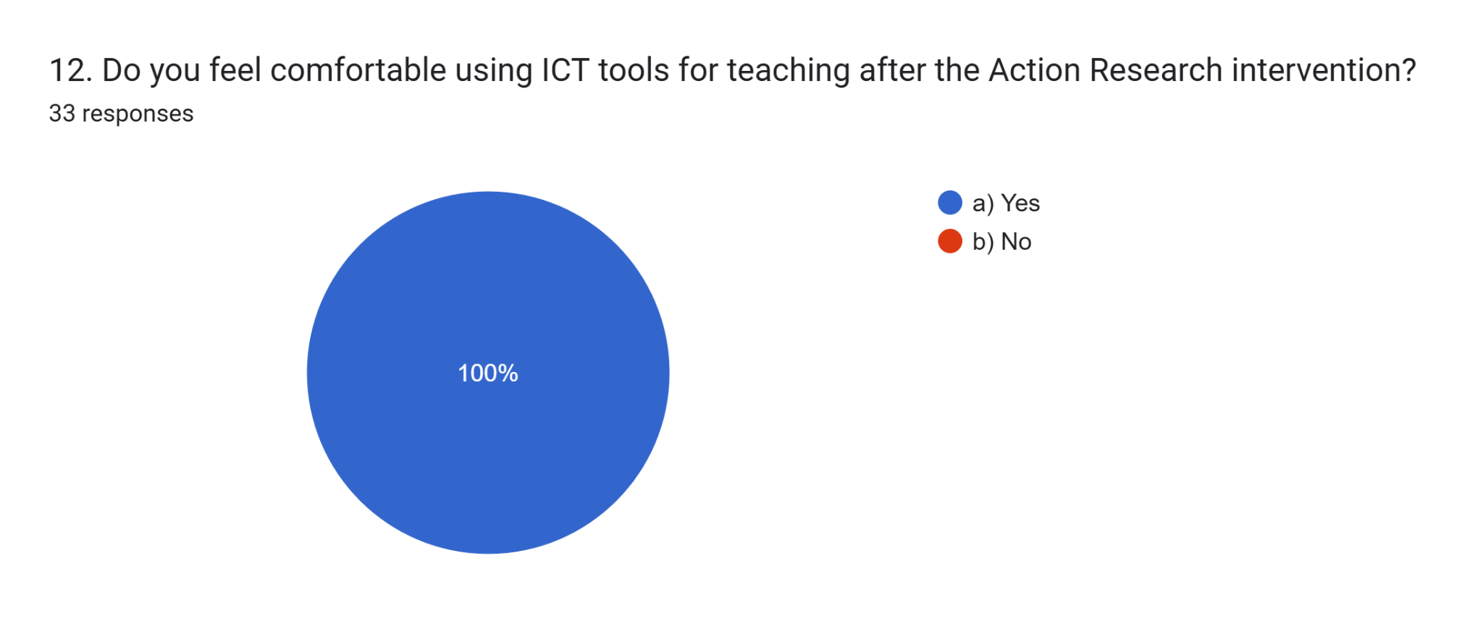

All teachers felt comfortable with ICT tools, reflecting successful skill enhancement.

13.Time spent on creating posters
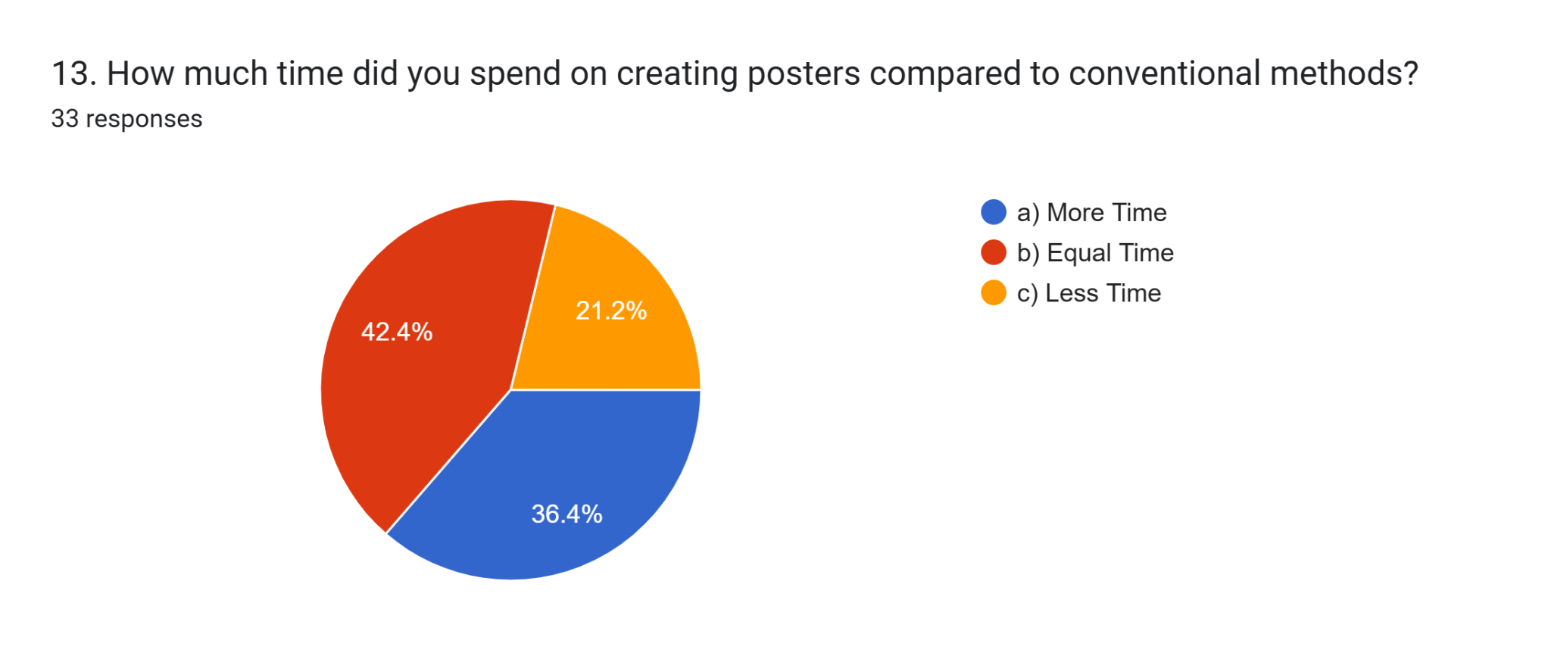
21% of teachers have spent less time on creating posters, 42.4% of teachers have spent equal time and 36.4% of teachers have spent more time when compared to conventional methods.

14.Challing aspect of poster creation
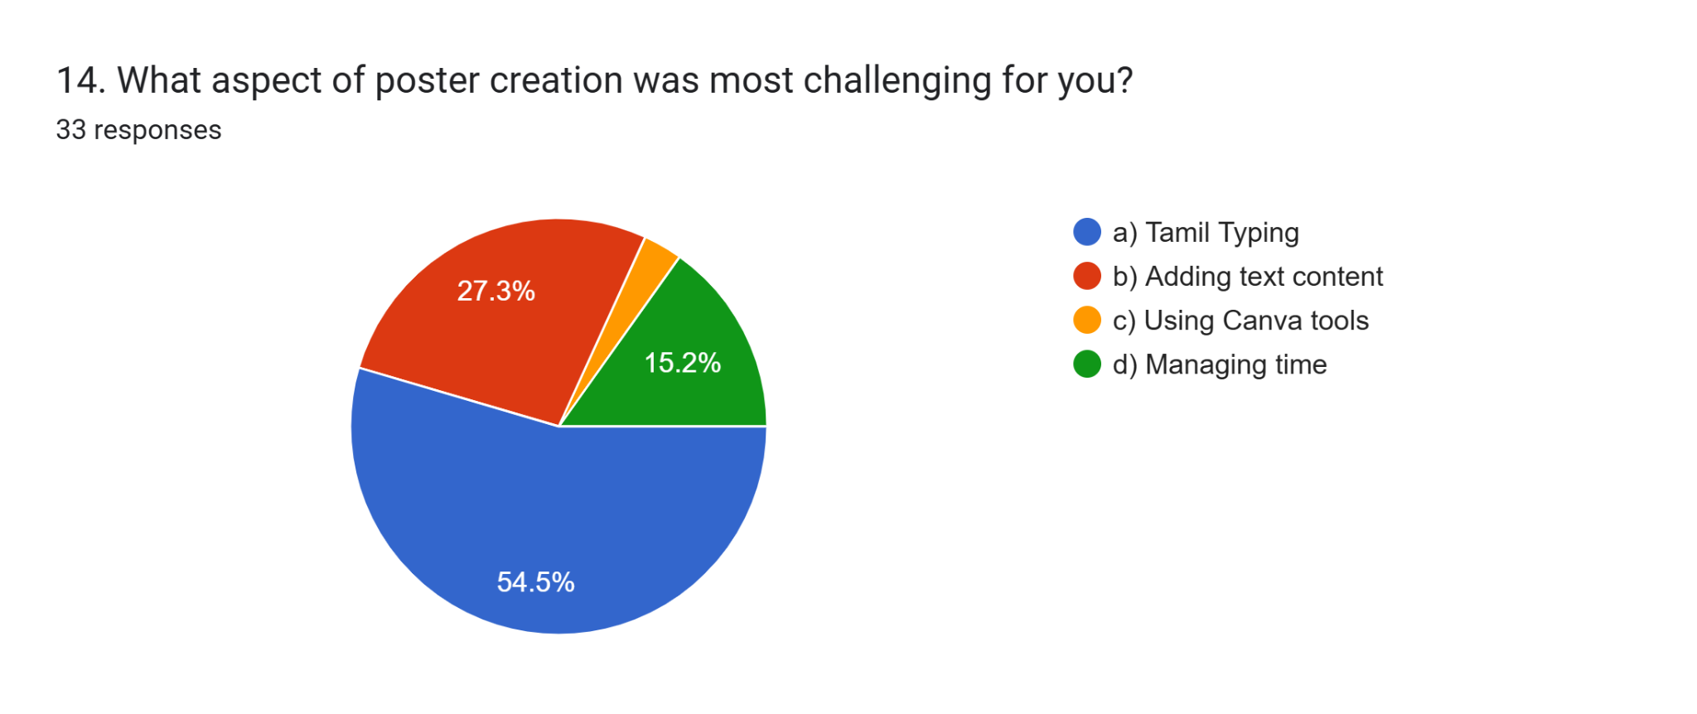
54.5% of teachers found Tamil typing the most challenging.
15.2% struggled with managing time.
27.3% faced issues with adding text content.
3% found using Canva tools challenging.

15. satisfaction of support and onsite training
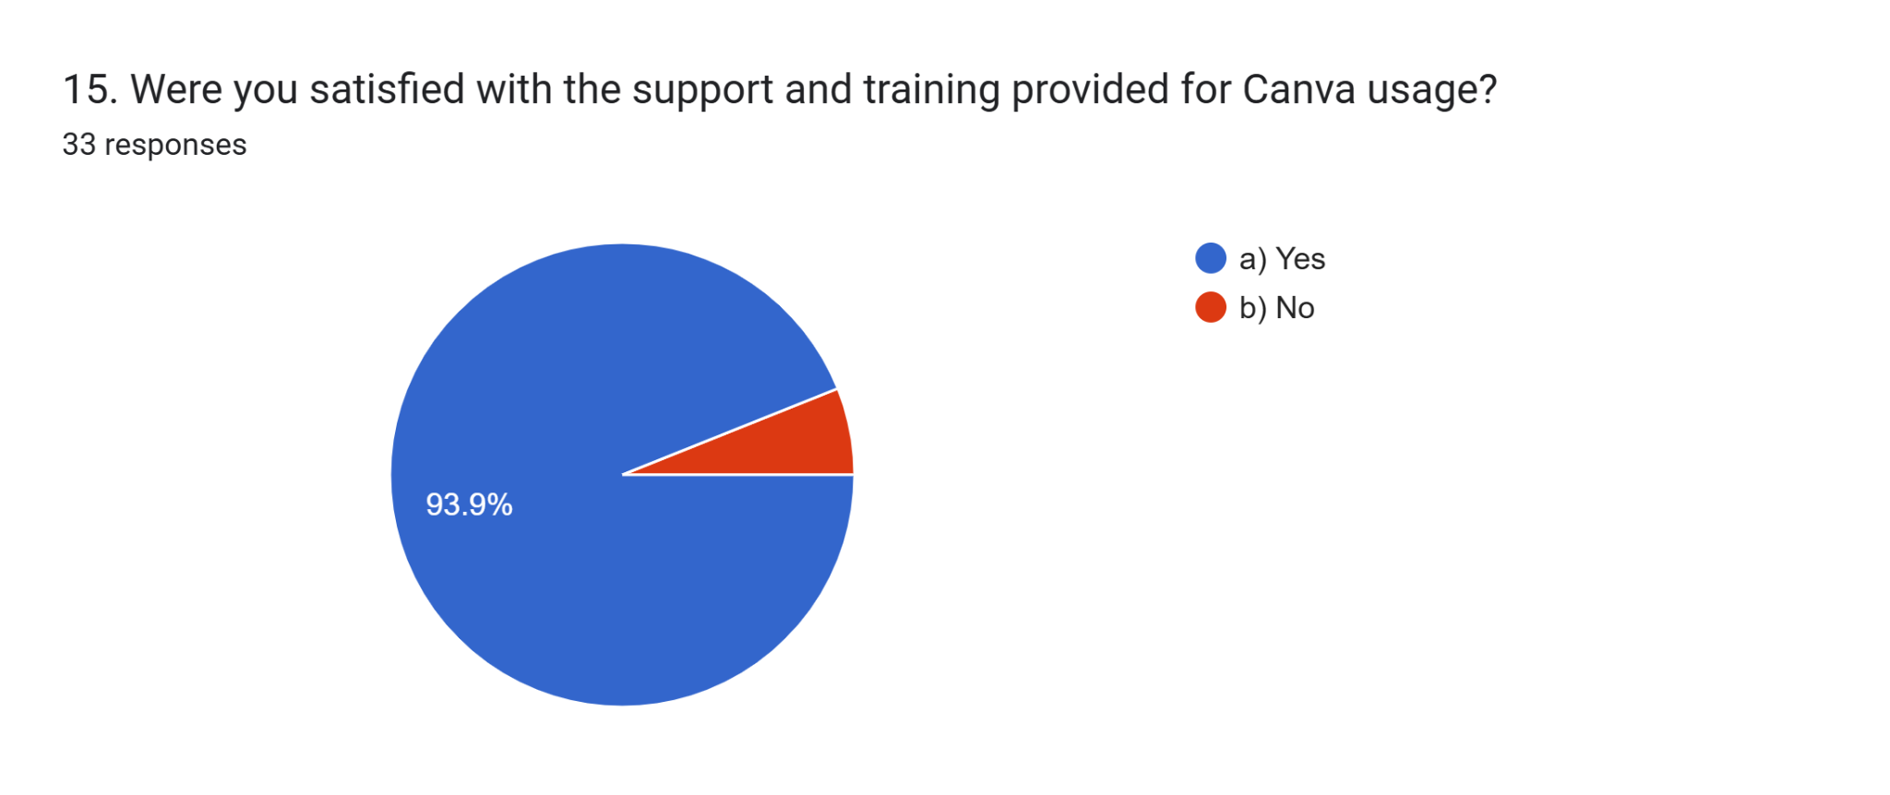
93.9% of teachers were satisfied with the support and training provided and 6.1% of teachers expressed that they are not satisfied.

16.Usage of poster in future teaching
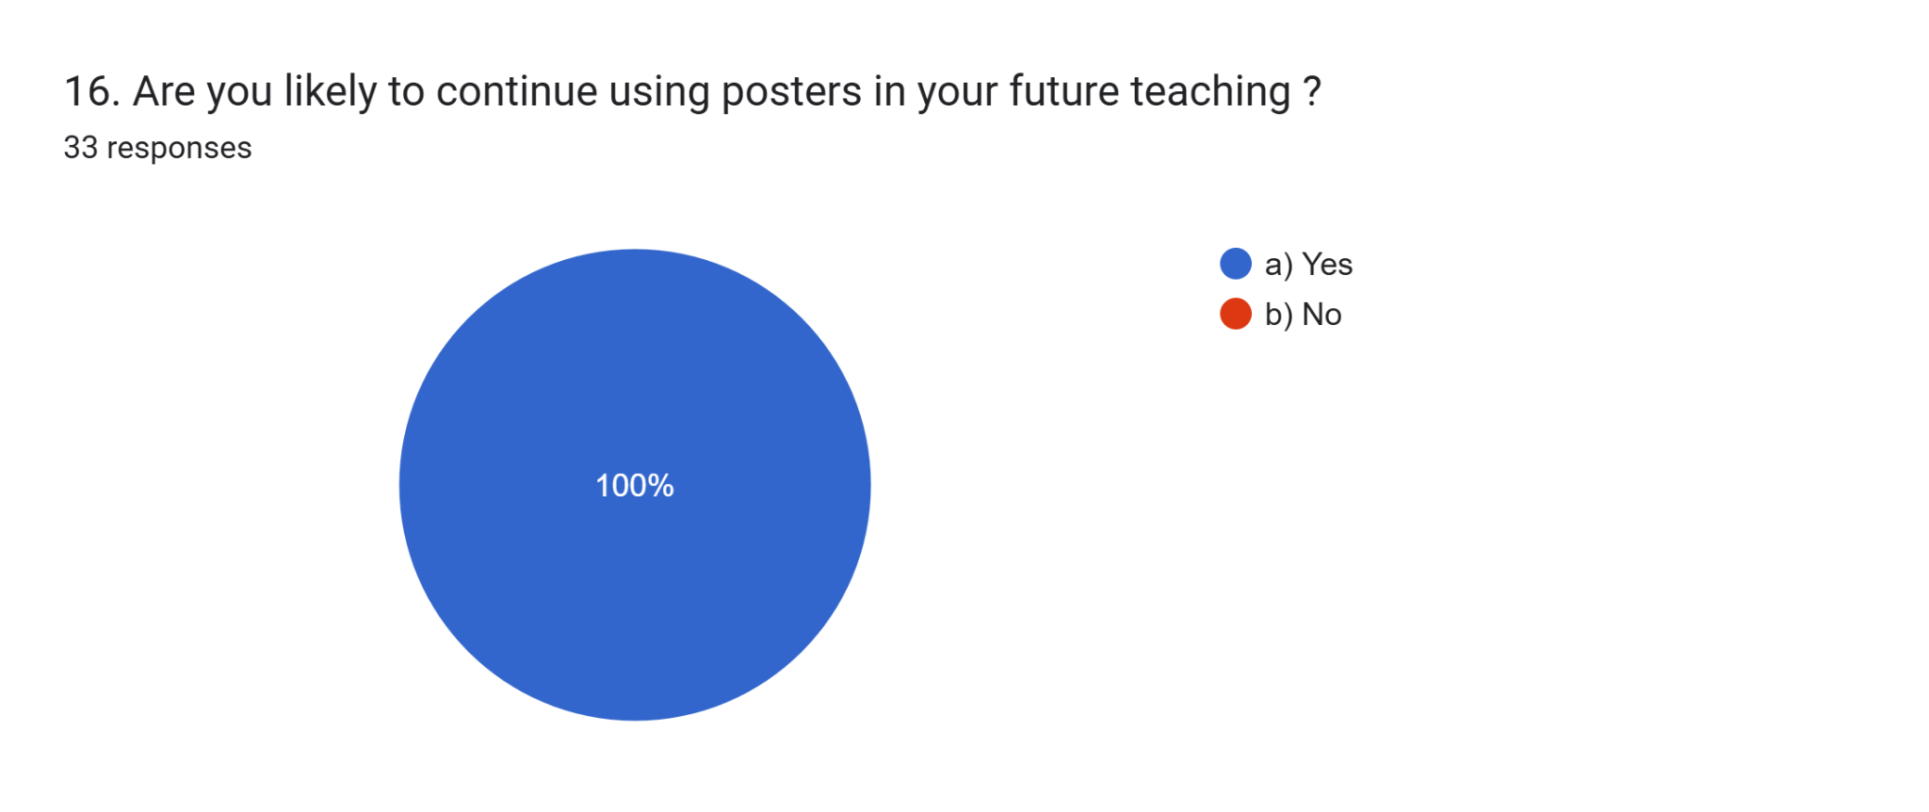
100% of teachers indicated they are likely to continue using posters in their teaching.

17.Help of posters to explain complex concepts
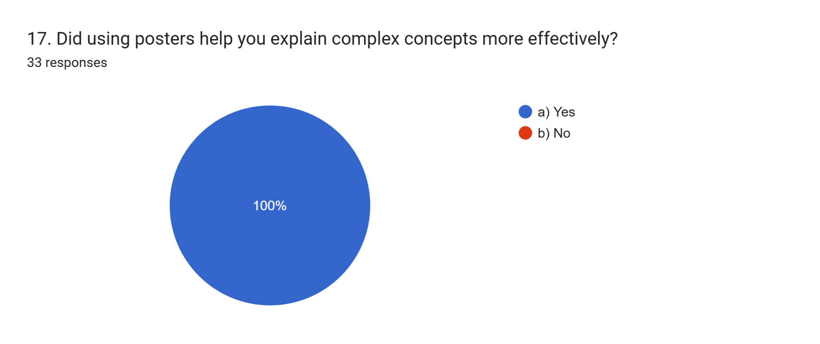
100% of teachers agreed that posters helped explain complex concepts more effectively.

18.recommendation of usage of posters
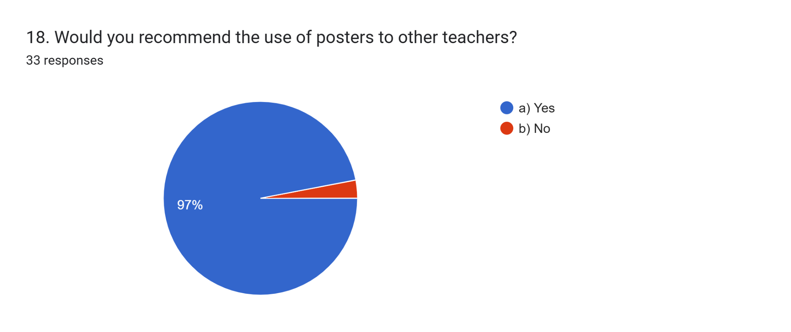
97% of teachers agreed that they would recommend to use posters to their colleagues, while 3% of teachers did not agree to recommend.

Conclusion of post analysis
The analysis of the post-analysis clearly indicates a positive impact of using lesson based posters in classroom teaching. The majority of teachers found the approach effective in improving student engagement, understanding, and classroom management. Challenges such as typing in Tamil language and time management were reported, but these did not significantly hinder the adoption of the method. With high satisfaction rates and a strong intent to continue using posters, the intervention followed in the action research has proven to be a valuable tool for enhancing the teaching learning process and the ICT skills of teachers.

11.Findings of the Action Research
- Increased Poster Usage: A significant percentage of teachers (78.8%) used posters frequently in their lessons after the intervention, indicating successful adoption of the technique.
- High Confidence in Canva Usage: About 97% of teachers reported confidence in designing educational posters using Canva, demonstrating effective skill acquisition.
- Improved Student Engagement: All teachers (100%) observed increased student interest and attention when using posters, proving their effectiveness as a visual learning tool.
- Enhanced Classroom Management: The majority of teachers (97%) found that posters contributed to easier classroom management, showing the potential of visuals in organizing learning activities.
- Canva Effectiveness: More teachers (72.7%) found Canva effective for educational poster creation. , while 12% rated it as highly effective.
- Frequent Reference to Training Materials: Majority of teachers frequently referred to the Canva module, indicating its relevance and utility in the training.
- Integration Across Subjects: Most of the teachers were able to integrate posters across different subjects, showing the versatility of this teaching method.
- Positive Student Response: All teachers reported a positive reaction from students when learning through visual aids, confirming their impact on student motivation and understanding.
- Improved Learning Outcomes: Teachers unanimously agreed that posters helped improve student understanding of complex topics.
- Increased ICT Confidence: Every teacher felt more comfortable using ICT tools after participating in the action research, highlighting the success of digital learning integration.
- Satisfaction with Training: All participants were satisfied with the training and support provided, reinforcing the effectiveness of the professional development program.
- Commitment to Continued Usage: Every teacher expressed their intention to continue using posters in future lessons, ensuring long-term sustainability of the approach.
- Effective for Complex Concepts: Most of the teachers found posters useful in explaining difficult concepts, emphasizing their role in simplifying abstract ideas.
- Widespread Recommendation: Most of the teachers reported that they would recommend the use of posters to other educators, demonstrating a high level of endorsement for this approach.
- Challenges in Poster Creation: While most teachers found Canva useful, some faced some challenges, primarily in Tamil typing, time management, and using Canva tools.
12.Net gain of the Action Research
The findings confirm that integrating lesson based posters in teaching positively impacts student engagement, understanding, and classroom management. While minor challenges exist, overall satisfaction and adoption rates are extremely high. Teachers are confident in their ability to continue using visual aids in their pedagogy, making this intervention a success.
13. Educational Implication of Action Research
The educational implications are given below.
- The action research highlighted challenges such as time constraints and the need for adequate ICT resources. It recommends ongoing professional development for teachers to effectively integrate poster creation into their teaching practices.
- Improve Understanding of Visual Learning
Teachers will understand the principles of visual learning and how posters can enhance student engagement and retention of information.
- Develop Design Competence
Teachers will learn to apply design principles, such as layout, color theory, and typography, to create effective and visually appealing lesson-based posters.
- Facilitate Effective Content Presentation
Teachers will be able to distill complex lesson content into concise, clear, and engaging text and visuals for their posters, promoting better student comprehension.
- Encourage Integration of Technology
Teachers will gain proficiency in using digital tools like Canva to create posters, integrating technology into their lesson planning and delivery.
- Promote Collaborative Planning
Teachers will learn to collaborate with colleagues to design posters that complement lesson objectives, fostering a culture of shared resources and ideas.
- Enhance Assessment Strategies
Teachers will develop methods for using posters as assessment tools, evaluating student understanding and engagement through visual presentations.

- Foster Creativity in Teaching
Teachers will explore innovative ways to represent lesson content visually, encouraging creative approaches that can inspire students.
- Reflect on Instructional Practices
Teachers will engage in reflective practices to assess the effectiveness of using posters in their lessons, identifying areas for improvement and adaptation.
- Share Best Practices
Teachers will collaborate to share successful strategies and examples of lesson-based posters, building a community of practice focused on continuous improvement in teaching methods.
- Improved Learning Outcomes
By equipping teachers with better poster creation skills, the research hopes to improve students' learning experiences and outcomes. More engaging and visually appealing posters are expected to enhance student understanding, retention, and motivation.
- Exposure to 21st-Century Skills
As teachers integrate ICT tools and poster creation into their teaching, students will likely gain exposure to 21st-century skills like digital literacy, creativity, and visual communication. These skills are essential for success in a technology-driven world.
- More Engaging Learning Environment
The use of posters and other visual aids can contribute to a more stimulating and dynamic learning environment, potentially increasing student interest and participation in upper primary classrooms.
The action research focuses on empowering teachers, with the understanding that improved teaching practices can ultimately lead to enhanced learning experiences among upper primary students.
14.Recommendations
This action research recommends the usage of ICT tools in classrooms to improve the attention of students in the classroom in order to have an improved classroom management. The ICT tool used for the action research “Canva” has supported the teachers in the teaching learning process, hence the usage of such other ICT tools may be introduced among the teachers. Moreover, the usage of ICT tools required certain basic ICT skills, this action research has revealed few teachers need the basic ICT skills and Tamil typing skill. A training on basic ICT skills and Tamil typing may be given to the teachers who are in need of them.
15.Conclusion
The research confirms that teaching through lesson based posters is a viable and sustainable instructional strategy. With targeted training, resource development, and ongoing peer collaboration, its effectiveness can be further maximized. The findings provide a strong foundation for integrating posters into regular teaching methodologies, ensuring long-term benefits for both educators and students. The findings of this action research indicate that integrating posters in teaching significantly enhances student engagement, comprehension, and classroom management. Despite some challenges in poster creation, the overwhelmingly positive response from teachers suggests that this approach is both effective and sustainable.
Bibliography
Erdem, M., & Sari, H. (2014). "Using posters as an educational tool: A qualitative analysis." Journal of Educational Research, 107(5), 370-380.
Mayer, R. E. (2009). "Multimedia Learning." Cambridge University Press.
Mikroyannidis, A., & Gounaris, K. (2015). "Using posters in teaching: An action research project." Journal of Educational Technology & Society, 18(2), 200-212.
Plass, J. L., & Pawar, S. (2012). "Cognitive and Emotional Processes in Learning with Visual Representations." Educational Psychologist, 47(3), 115-126.

Research Tool
Pre-analysis tool
1. What is your current level of experience with creating posters for lessons?
(a) No experience
(b) Some experience
(c) More experience

2. Have you ever used Canva or similar graphic design tools for creating educational materials?
(a) Yes
(b) No
3. How often are you using ICT in your teaching?
(a) Never
(b) Occasionally
(c) Frequently

4. How often do you incorporate visual aids, such as posters, in your lesson plans?
(a) Never
(b) Occasionally
(c) Frequently

5. Do you believe that using posters in lessons can enhance student engagement?
(a) Yes
(b) No
(c) Unsure
6. How important do you think visual learning is for students?
(a) Very important
(b) Somewhat important
(c) Not important

7. What challenges do you face when creating posters for your lessons?
(a) Lack of training
(b) Time constraints
(c) Access to technology

8.What resources do you currently use to create posters?
(a) Digital tools
(b) Hand-drawn materials
(c) Printed materials

9.How often do you seek out new methods or tools for enhancing your teaching practices?
(a) Rarely
(b) Occasionally
(c) Frequently

10. Which of the following would you find most beneficial in improving your poster creation skills?
(a) Workshops
(b) Online tutorials
(c) Peer collaboration
Post-analysis tool
- How frequently did you use posters in your teaching after the intervention?
a) Very Frequently
b) Frequently
c) Occasionally
d) Rarely
- Do you feel confident in creating lesson-based posters using Canva?
a) Yes
b) No
- Did you notice an improvement in student interest when using posters?
a) Yes
b) No
- Did students' attention levels increase when posters were used?
a) Yes
b) No
- Was classroom management easier when using posters?
a) Yes
b) No

- Did you face any difficulties while creating posters with Canva?
a) Yes
b) No
- How effective was Canva in helping you design educational posters?
a) Highly Effective
b) Effective
c) Somewhat Effective
d) Not Effective
- Did you frequently refer to the module provided for Canva usage?
a) Yes
b) No
- Were you able to integrate posters into different subjects effectively?
a) Yes
b) No
- Did students respond positively to learning through visual aids like posters?
a) Yes
b) No

- Did you observe an improvement in students' understanding of concepts through posters?
a) Yes
b) No
- Do you feel comfortable using ICT tools for teaching after the intervention?
a) Yes
b) No
- How much time did you spend on creating posters compared to conventional methods?
a) More Time
b) Equal Time
c) Less Time
- What aspect of poster creation was most challenging for you?
a) Tamil Typing
b) Adding text content
c) Using Canva tools
d) Managing time
- Were you satisfied with the support and training provided for Canva usage?
a) Yes
b) No
- Are you likely to continue using posters in your future teaching practices?
a) Yes
b) No
- Did using posters help you explain complex concepts more effectively?
a) Yes
b) No
- Would you recommend the use of posters to other teachers?
a)Yes
b) No

Photos
Onsite hands on training to teachers
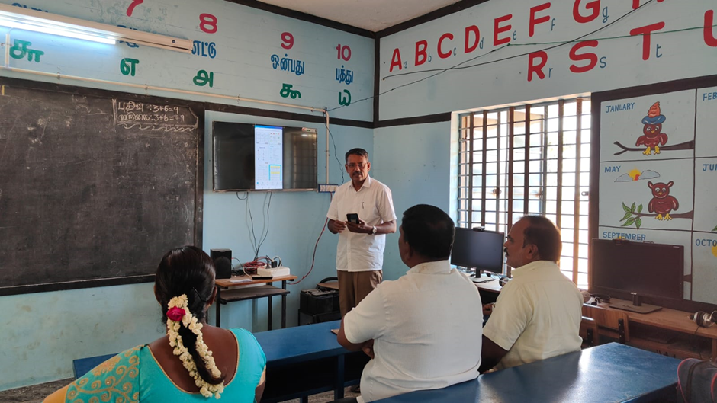
Onsite hands on training to teachers
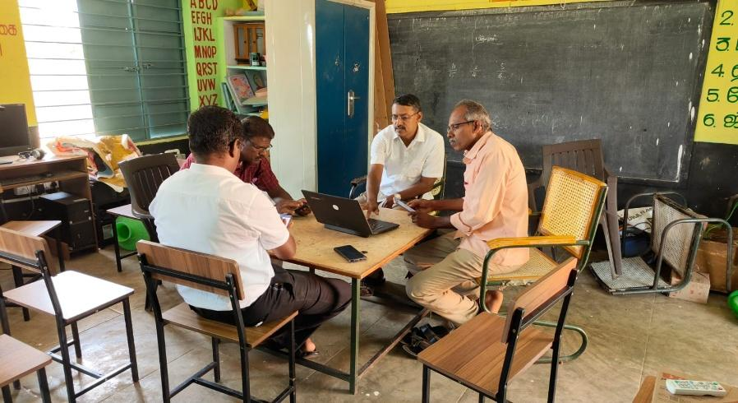

Intervention in the class room
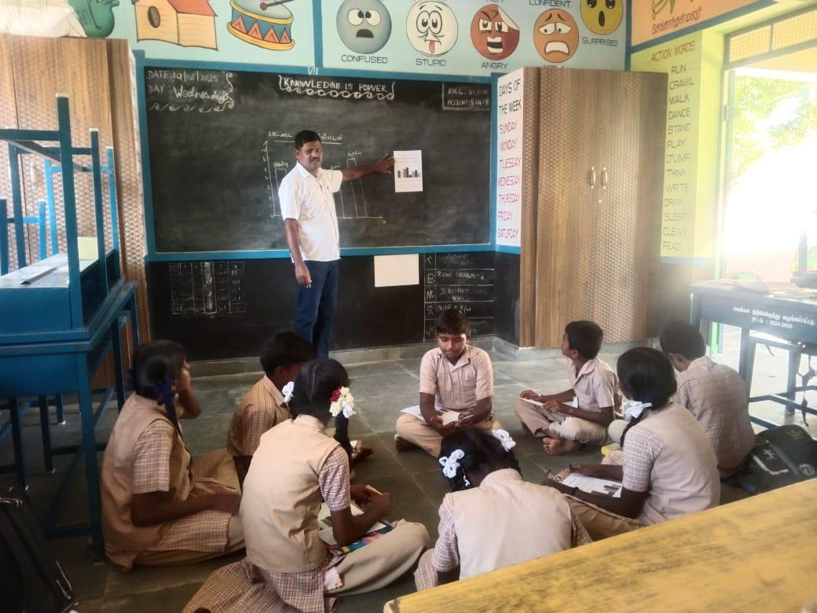
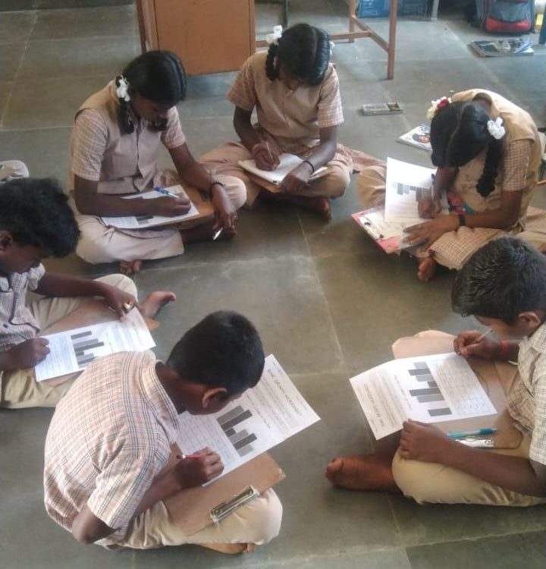

Work sheet for finding the value of missing angles
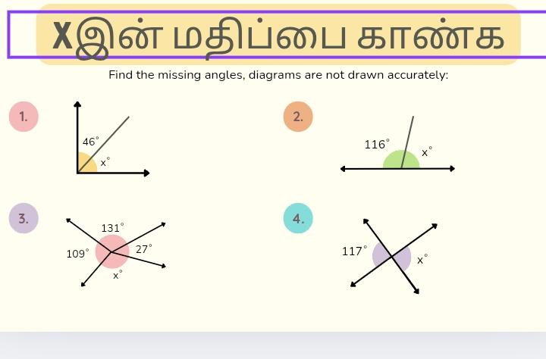

Worksheet poster on water conservation


Work sheet poster
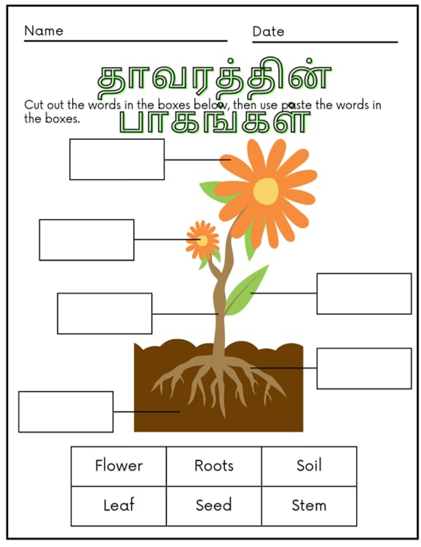

Work sheet poster
